1. Check the version of your Visual Studio. If it’s a licensed Visual Studio 2015, please skip the following step 2 and 3.
2. If you don’t have an installed Visual Studio 2015, please upgrade Microsoft Visual Studio to 2015 by running Z:\FTP Users\Jessie\vs_community_ENU.exe
3. After install, check the license (Help -> About Microsoft visual Studio). If it’s a 30-day trial version, please register as an MSDN user for free.
4. Install Selenium following the guide - <http://www.c-sharpcorner.com/UploadFile/093731/introduction-to-selenium-webdriver-with-C-Sharp-in-visual-studio/>

Note: Please make sure the packages were updated with latest version for all three projects.

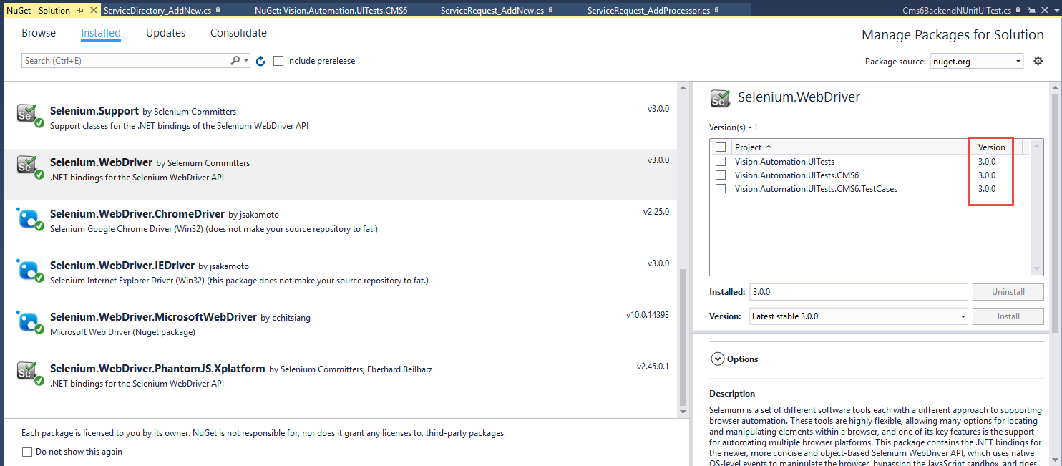

1. Download and Install “Nunit 3 Test Adapter”

* In Visual Studio 2015 -> Tools -> Extensions and Updates
* Search with Nunit
* Download and Install it.

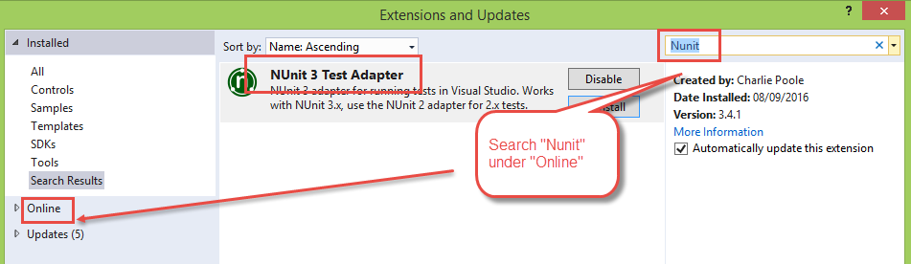

1. Map project to local folder and check out the current Automation kit from TFS

(Note: To achieve a fast testcase running, it’s recommended to checkout kit to your C:\)

1. Configure the site configurations in localhost.runsettings

<TestRunParameters>

<Parameter name="Browser" value="firefox" />

<Parameter name="SiteURL" value="http://localhost/CMS6_QA0809/"></Parameter>

<Parameter name="BackendUserName" value="SysAdmin"></Parameter>

<Parameter name="BackendPassword" value="Blu3()Four"></Parameter>

<Parameter name="WebSiteUserName" value="softwaredevelopment@visioninternet.com"></Parameter>

<Parameter name="WebSitePassword" value="Vision222!"></Parameter>

</TestRunParameters>

1. Read the Readme.text

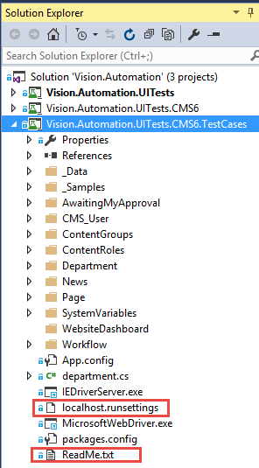

1. Select test setting file in Visual Studio

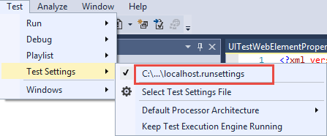

1. To process Browser Upload window, please add System.Windows.Forms into Reference folder under testcase project.

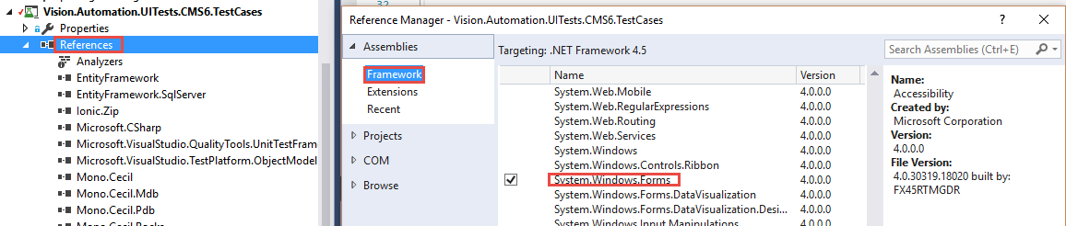

1. To transfer dynamic data, Microsoft.CSharp.dll should be added into Vision.Automation.UITests.CMS6

