Manual Content Migration Standards

SITEMAP:

With each project, you will receive a sitemap that will communicate where content should be

placed in the new site. There is a specific structure that we will need for you to follow when

reviewing the sitemap, and marking your work completed (see below).

* 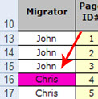Column A (Migrator): Locate your name in this column under the “Migrator” heading. All pages with your name seen here have been assigned to you for completion. *(Be sure to check the whole sitemap as they may not all be grouped together)*. If for ANY reason a page takes you longer than 1 hour to migrate, please mark this cell Pink. (This is optional, if there is multiple migrators working a single site.)
* Column B (Navigation Name/Level): Here is where you will find the name of the page you need to create, as well as the level of which it is placed. A legend appears at the top of the page for reference. This section is both color organized, and displays indentation to communicate which pages are “parent” pages and which ones are “children” (subpages). If the project manager has not built the pages ahead of time, you will have to be intentional about placement and location as you create these pages from scratch.
* 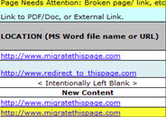Column C (Location): In this cell, you will find the location of the page you need to migrate. This cell should always have some information in it. It will either have:
* A Link to a URL (you would need to either migrate or link off to)
* Text saying **“Document name.docx”**
* Text saying **“Intentionally left Blank”** (This is when you would build a page for the structure only, if this also includes a 1 in the H Column).
* Column D (Sitemap notes): should only contain notes about the existing page. This is filled in by the person creating the sitemap.
* Column E (Client Migration notes): This is where the client/PM will specify notes about how to migrate, or any additional special instruction for this particular page on this row.
* 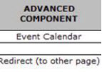Column F (Advanced Component): *This column may not be present and replaced with Column G below.* Occasionally, instead of a standard page action, the PM will mark a specific “advanced component” to exist on a particular page. In most cases the PM will build these advanced components so you do not have to. However, in the case that you need to build the page, take close attention to what must be done here, as it will deviate away from a simple standard page. There will be directions to *redirect*, or *connect* pages here, as well as other component instructions.
* Column G (Content Group): Every page, image, and document is owned by 1 Content Group. The PM will have selected a group here that this page should be built with (and all corresponding images and documents). When creating the page, or adding image/documents to the CMS, make sure to select this visible group here under the “content groups” area in the CMS.
* Column H (Vision to migrate): If the client has specify a number 1 on the row of that page, the migrator should migrate the content. If there is a zero (0), x, or blank the migrator should not migrate this page.
* Column I (Migrator Notes): Read this section to look for any specific instruction regarding the page migration. As mentioned above, if the page was not fully completed, insert a short summary of what was missing in this column so the PM will know why without reviewing the actual content. (i.e. “MISSING: 2 PDFs & 1 Image” or “MISSING: Links to Pages not in Sitemap” etc.…)

Also, once you have dealt with that specific page you must then mark the sitemap appropriately so we know what has been done. We have a simple Green Yellow Red system for the sitemap to help keep things organized. Mark this Cell (Column I) with one of the three colors upon completion:

* 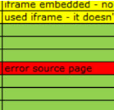Green = Completed, nothing was missing or incomplete.
* Yellow = Partially Completed, perhaps missing photos, documents, links to pages, etc … All that could be completed was, but something was incomplete. In this case, write in the COMMENT column a summary of what was missing.
* Red = Incomplete, nothing was migrated (content missing, or could not be migrated). In this case, write in the COMMENT column a summary of what was missing.

* Column J (Migration QA Notes): this should be filled in by the migration lead and should be provided back to the migrator upon completion.
  + Green – This passed QA and was done to standards. No additional commentsrequired.
  + Yellow – This was completed with errors which should be corrected. This must be accompanied with notes about why this has been marked yellow in column J.
  + Red – This was completed incorrectly, and should be re-done. This must be accompanied with notes about why this has been marked red in column J.

Once the Migrator has corrected the issues, column I should be updated with final comments and send back to migration lead.

Sitemap Summary: Migrate the pages assigned to you (A) as specified (B) using the correct content (C), and content group (G). Mark the Column (I) Green, Yellow, or Red depending on the results of the completed page. Make sure to leave any relevant notes (I) if the page was not fully completed. (J) Migrator Lead should QA, and use the color code to specify all of the status of the pages. All QA’d sitemaps with specific instructions on column (J), should be provided to the migrator to adjust and address any mistakes made. Migrators made the changes requested, update column (I) and send it back to content migration lead.

**FORMATTING:**

Every project will have variants from page to page of the way content is formatted and styled. Your job is to create a standard, so that our end product looks as consistent as possible. There will be times that you must deviate from the client’s method of formatting in their content so that things will remain consistent to what we have implemented. Below is a list of different guidelines we would like you to follow when doing migration. These items are general tips, and sometimes the content requires a different approach. You will need to be flexible, and always try to migrate in a way that looks good (so long as it remains consistent). Make sure to balance good time per/page completion, while making a page look as good as possible.

1. In general, remove formatting (use Paste as Plain Text option in editor), and then reapply using our editor to ensure that it is WCAG 2.0 compliant (If Applicable).
2. Italic: So long as this is not excessive in use, Italics is fine. If excessive, then use no formatting (or possibly use bold depending on the circumstance).
3. Underline: Really try to not use underline if not a link, replace with bold, possibly the "Subtitle Class", or nothing.
4. Bold: So long as this is not excessive use, Bold is fine.
5. Capitalization: If a single word is in all capital letters is fine. But if Titles/Subtitles, or whole sentences, or paragraphs are all caps, convert to Capitalized Case: <http://www.convertcase.net/>
6. Font color/family: Strip out all font colors and other font families, even if they specify one, use the standard fonts & colors we have implemented. This includes instances in which the source content uses an intentionally different font color such as red for emergencies, replace with Bold instead.
7. Headings: Use the Paragraph Style dropdown in the editor to choose Heading 2 or Heading 3. All headings should be followed by a Paragraph break before any following content.
8. Alignment: Occasionally, a page the client provides will be center aligned, in general we do not want to duplicate this (as it will look different than the rest of the website). It is ok to center align images, and tables, but in general avoid center aligning text (even if the content is center aligned) instead use the standard left align on that page.
   * Justify: Do not justify text. You should not have to set left align (it will be automatic), but make sure to remove the Justify class from the HTML (if you pasted it in directly).
9. Use paragraph breaks between paragraphs as opposed to 2 line breaks.
10. If information needs to be spaced in an exact way between lines, create a table or use a different way to present the information as opposed to numerous spaces in a row. This interferes with the responsiveness of the page.
11. Whenever you encounter a questionable page please contact the Content Migrator Lead before spending any time on the page. Please note the page and move on with the other pages in the meantime to minimize delays.
12. If you encounter a page that you feel could be better presented utilizing one of our components (see component reference page), please make the suggestion to the content migration lead and await instruction before spending any time on the page. Please note the page and move on with the other pages in the meantime to minimize delays.
13. Basic page templates will be used unless otherwise denoted in the migration instructions column (E).
14. If there is content on the page that is unclear, for example: additional content on the right or left side of a page in the original site, please check with the content migration lead about whether or not to include this information.

Links:

1. External links must open a new browser (Target = “New Window”).

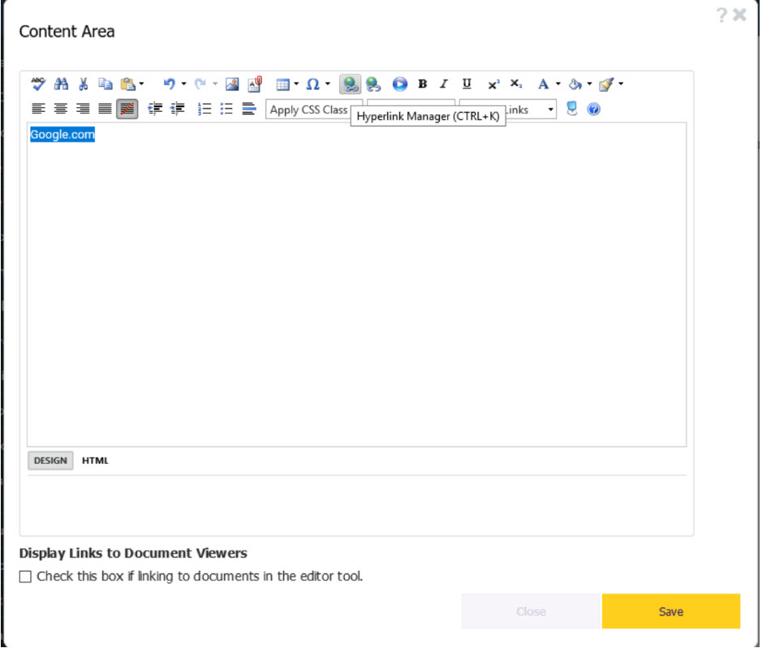

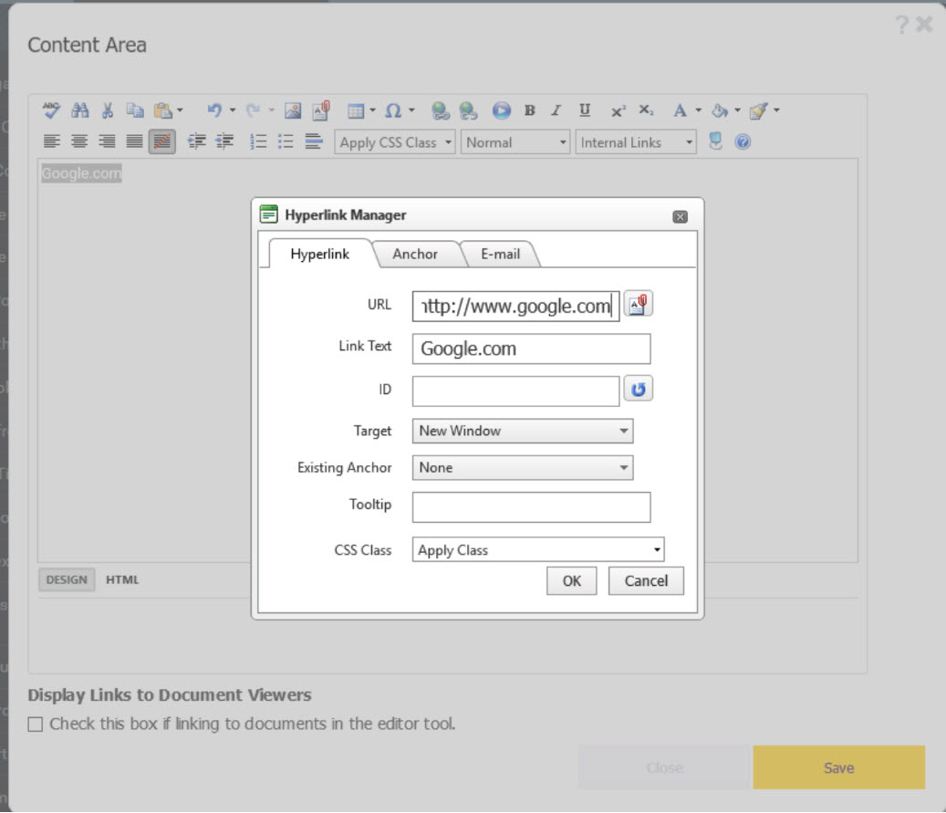

Documents:

* 1. If linking to documents from document central:
     1. First create the text which will be linking
     2. Select the Document Central icon to reveal the document popup window
     3. Select the folder which contains the document you are wanting to link to.
     4. In the middle documents, select the document you are going to link to.
     5. Click insert to create the link
     6. Check the box within the editor which displays the additional links to the readers. (Check this box if linking to documents in the editor tool)

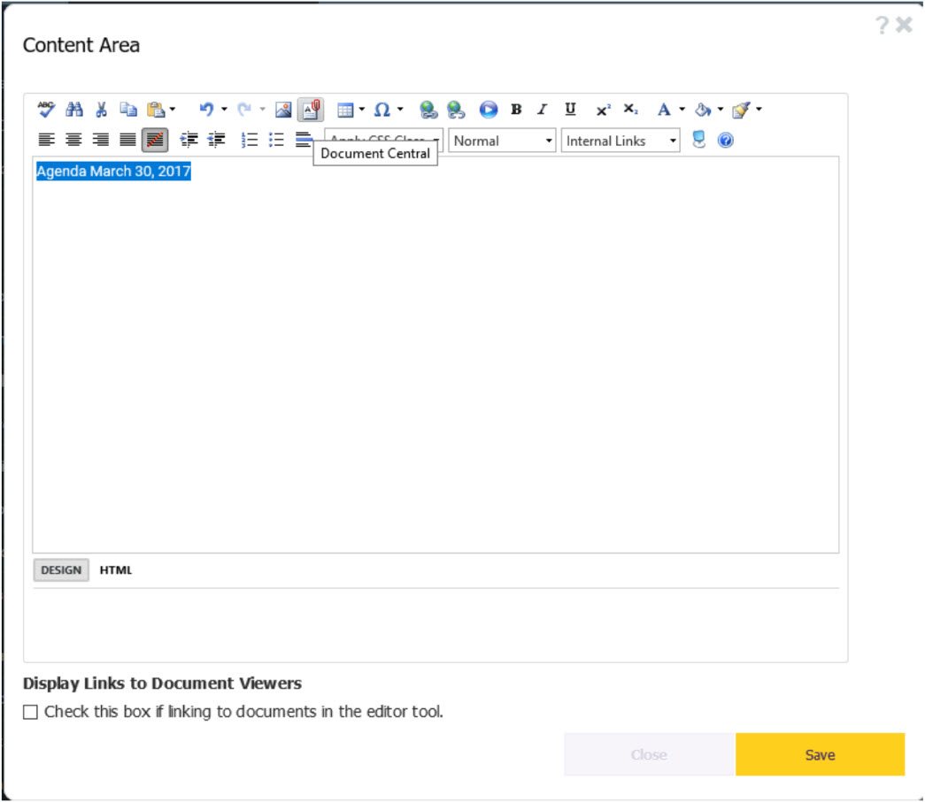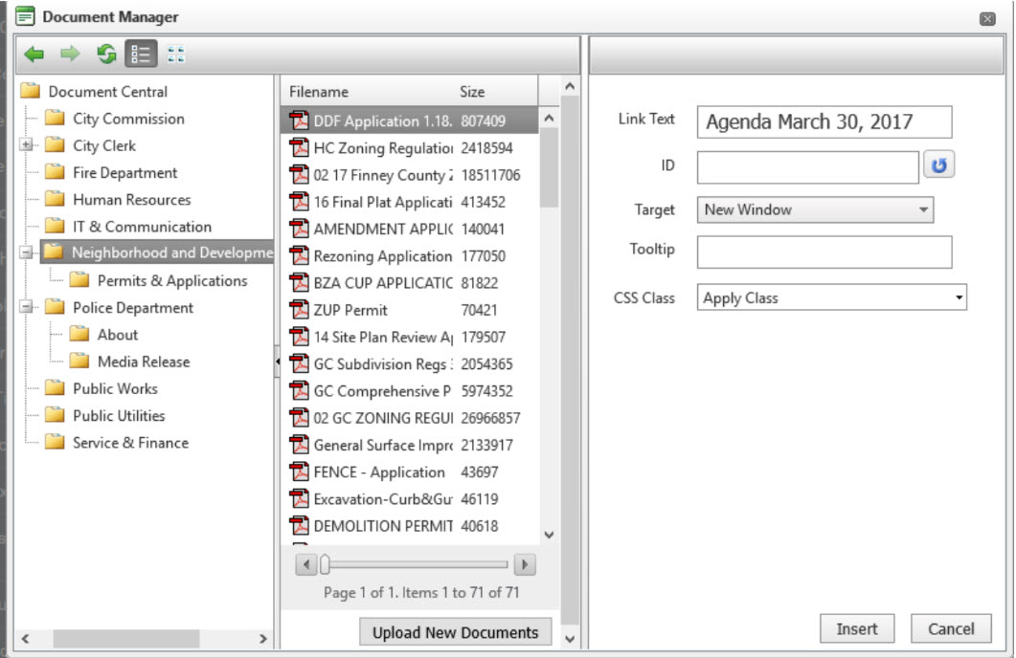

1. If icons are used on the old website, such as a PDF icon next to the link, do not migrate the icons.
2. Make sure to check the links viewer tool checkbox at the bottom of the content editor when linking to documents.

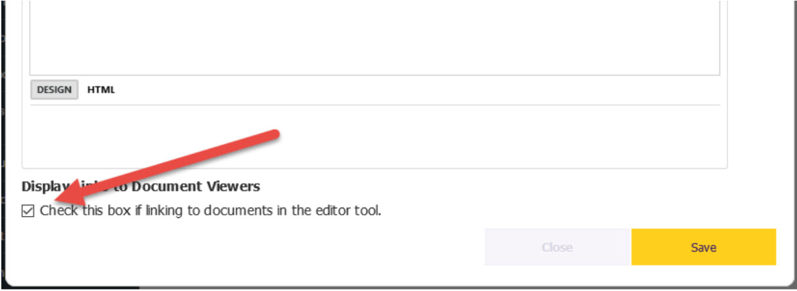

1. Accessibility:

* Include context/purpose in links. Users need to be able to figure out the link destination and its meaning without having to read all of the text around it
  + Example:
    - Bad: Click Here to see more information on water restrictions
    - Good: Click Here for more information on water restrictions
* Use the Title attribute. The title is used to provide additional text to describe a link, and helps to clarify or further describe the purpose of the link. However, keep in mind that if title attribute is something the user should know before following the link, such as a warning, then it should be provided in the link text rather than in the title attribute:

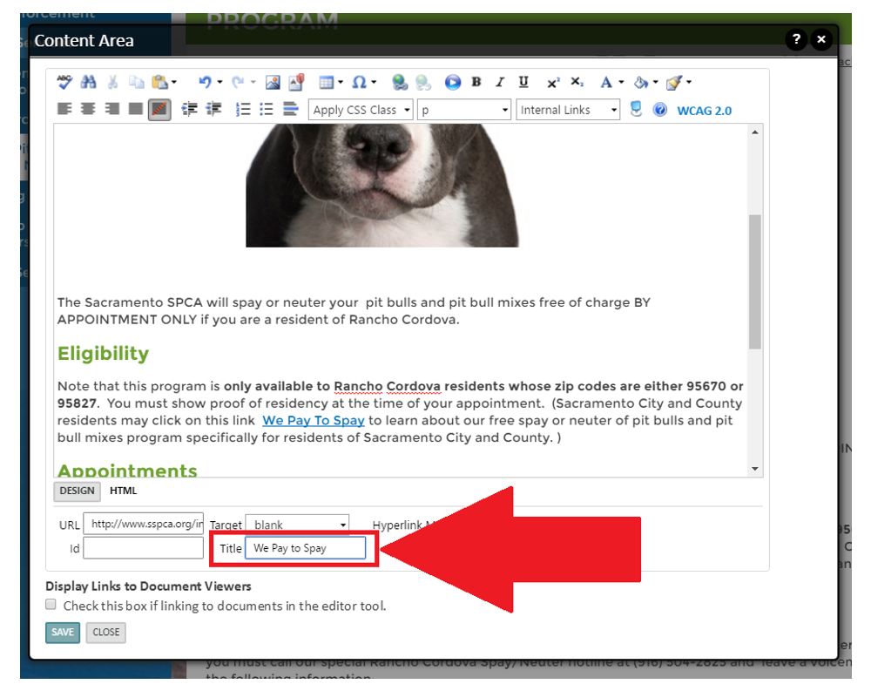

**Images:**

1. Do not resize images. Use the editor to adjust the size of the image.

* Images should be migrated the way they currently exist.
* Should not use any borders, or shadows unless included within the image already.

1. When uploading images to the image library, use the alt text or a portion thereof as the image name so the image can be easily identified by the client.

* Alt text should be a one line description of the image. If no description is available in the content, describe the image as you would to someone who can’t see it (e.g., “Girl in a red sweater”, “Officials at a groundbreaking”)
* If WCAG 2.0 Migration, for decorative images, the alt text should be removed.

1. Image Properties: *(Right Click the image, select image properties)*

* Alignment: Depending on the type of image, set an alignment *(left, center, or right)*
* Horizontal Spacing = 10px
* Vertical Spacing = 10px
* If there is text around the image, the side with text should have the appropriate padding
* Borders should not be used
* If a client is already using a photo gallery, or various photos on a page, it would be best to utilize the photo gallery component.
* If an image needs to span the entire width of the content area, an image rotate widget should be use. Please contact migration lead for help.

Tables:

* Use percentage widths when size adjustment makes sense
* All the tables most have a width of 100%, so they take up all the content area. The website will be responsive so we need to make sure the content is adjusting accordingly.
* If the table you are migrating is a “*data table*” you should use the “*TableData*” CSS option.

If it is not, try either the *TableBox*, or if required, no table formatting at all.

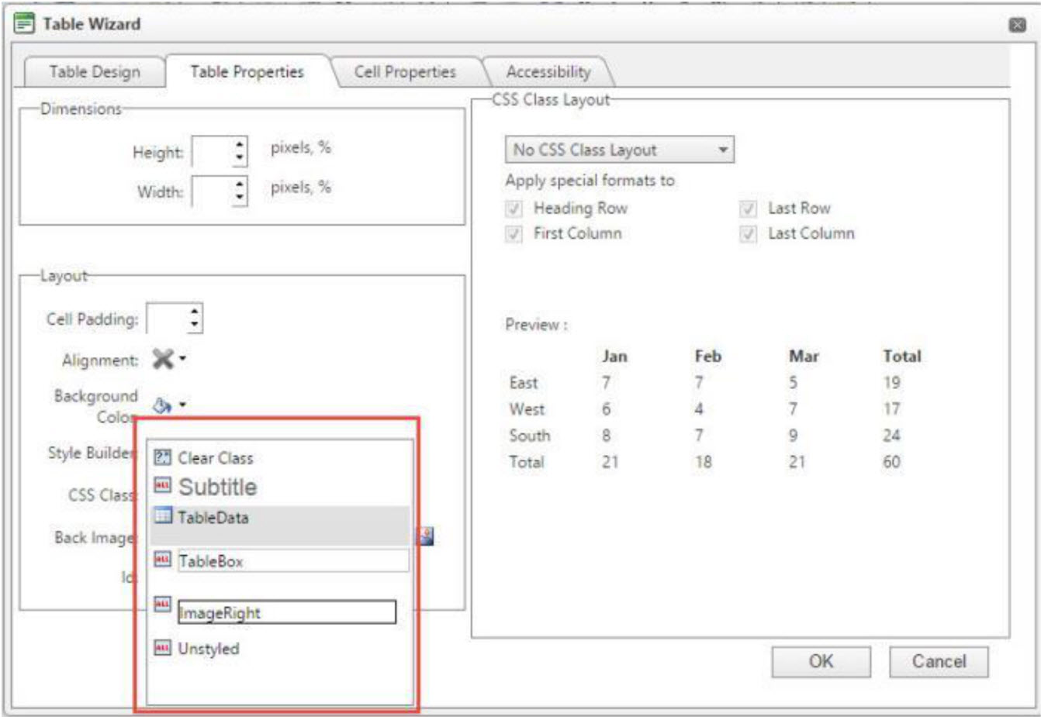

* Set Table Properties by right-clicking over a table. (Select Table Properties)
  + Set the table CSS style to “*TableData*” in the Table Properties tab
  + Finally use the Accessibility tab to set the Section 508-compliant properties – a typical table will need heading rows set to “1”, columns “0” and check “Associate cells with headers” *(see below).*
  + If the table does not already have a heading row or column already, please add them. Use your best judgment.

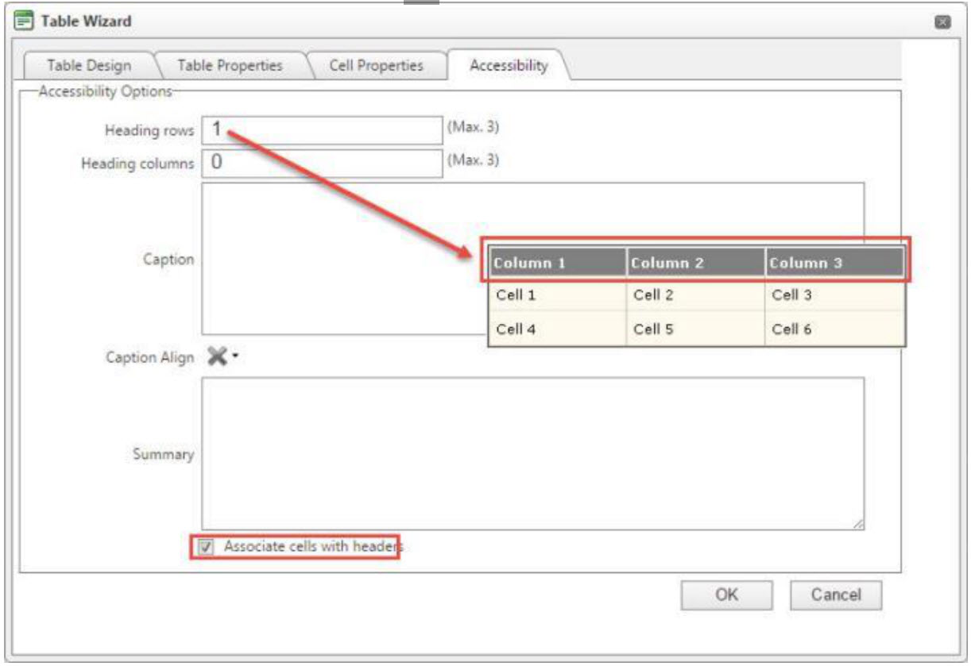

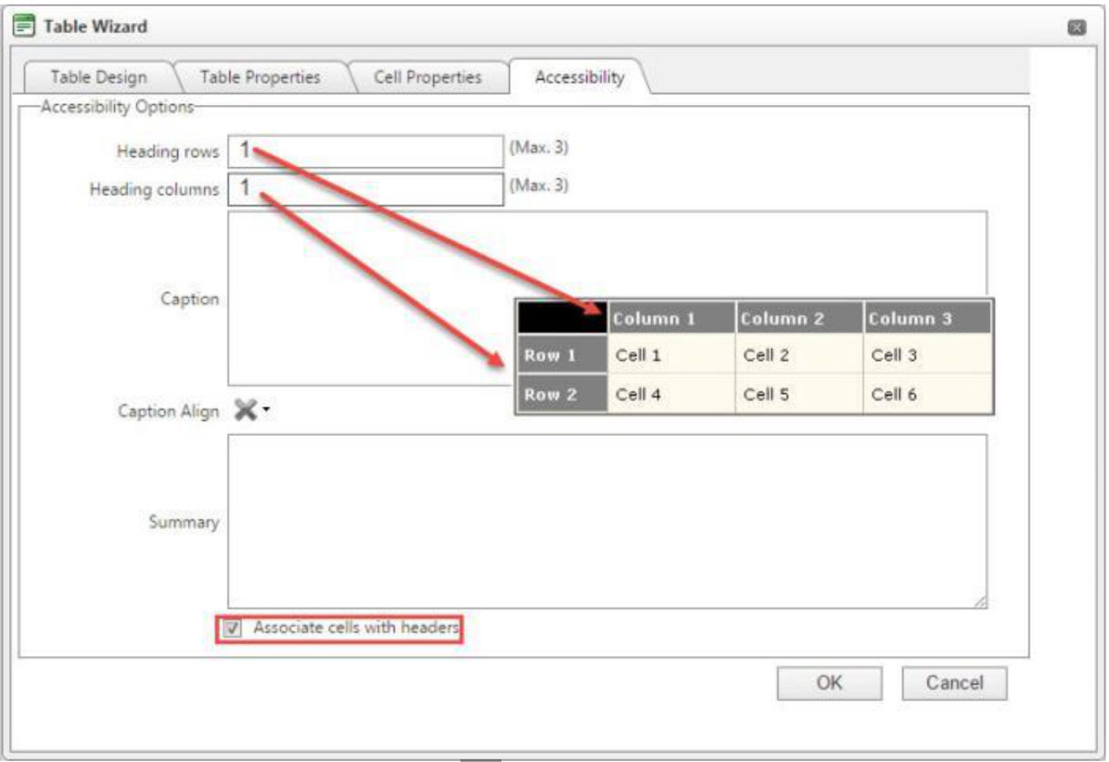

* Do not place images in tables, Firefox does not interpret this well, preferably, if images have to be side by side, resize all images, then upload them and insert them. *(This can be done if necessary, however not preferred).*
* Missing Content/Broken Links:

While migrating a page of content there will be times that a link will be broken, or a PDF or image will not be provided (etc…). At the top of this page we specify how to mark the sitemap, but you must also mark the content on the page as well *(so we can easily spot the trouble page).*

* + Highlight the link in Yellow. (Example Below):

Download the Job Application

Check out our Farmers Market

IMAGE AND DOCUMENT ORGANIZATION:

If a folder structure already exists, please adhere to it.

If there are no folders, sort documents and images into folders based on Content Group. Create subcategories (folders) as necessary to intuitively organize the information.

* Organize files similar to page structure to two levels, third level should be used document-heavy pages
* Use the image alt tag or portion thereof for the image title. Alt text should be a one line description of the image. If no description is available in the content, describe the image as you would to someone who can’t see it *(e.g., “Girl in a red sweater”, “Officials at a groundbreaking”)*
* 20 files/20 Images = 1 page this would also be mention on the sitemap, and highlighted
* Note all pages which exceed 20 images or documents or both on a single page. This should be noted on the sitemap by the migrator if not already in the Site Map Comments column.
* Documents/images should never be linked from an external source, instead they should be uploaded to the document central*. (Images/Documents can be uploaded 20 at a time, one content group at a time, with a maximum of 30MBs per file. And 15MB for images)*
* To insert an image:
  + Click on the area within the content editor where you wish to place your desired image
  + Then click on the image library icon to insert your image:

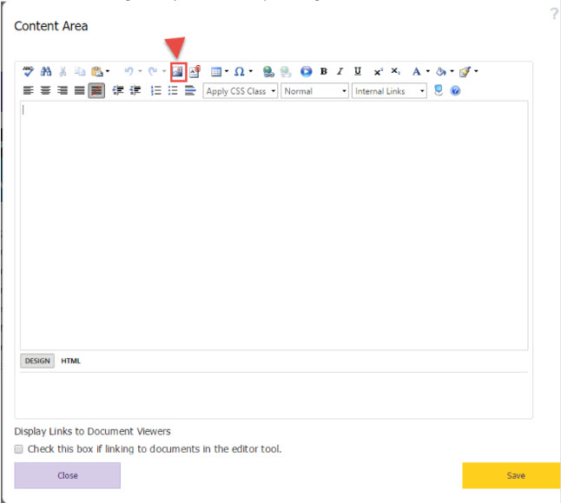

* + Select your image and click “Insert” in the bottom right corner
* To apply a link to images:
  + In the content editor window, click on the image you just inserted so that you have it selected/ highlighted
  + Then click on the Hyperlink Manager

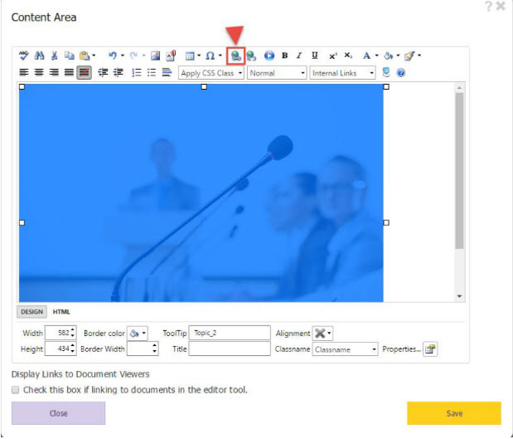

* In the Hyperlink Manager window enter the URL you wish to link your image to and then click “OK”

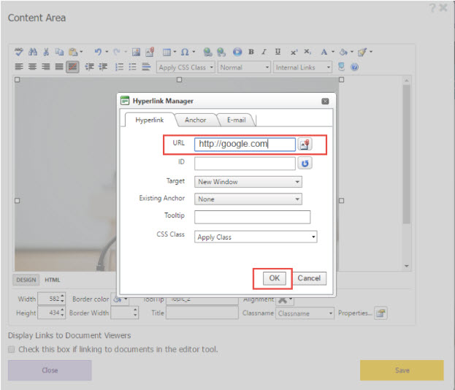

* To apply an internal link to the image you uploaded:
  + Click on the image to select it
  + Then choose the link you desire in the “Internal Link” dropdown menu

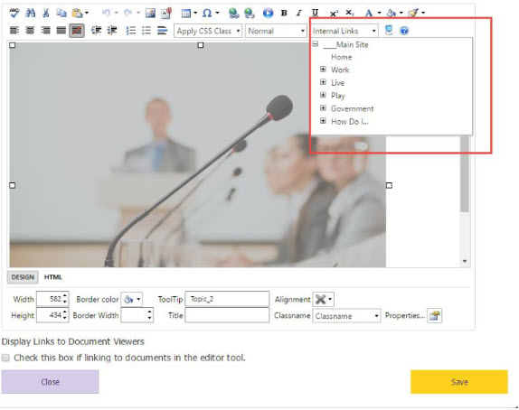

In conclusion, the migration should be completed to the best of your ability, if you are unable to migrate certain content, please confirm with the CMLead for further instructions.