Active Directory Notes

# Third Party Setup

1. Internal Domain

Don’t need any third party for the internal domain. But we need provide a domain account for syncing the users and members.

1. External/Remote Domain

We need setup an Active Directory Service site in the Remote Domain.

1. Get the latest zip file for the Service site: Released_ActiveDirectory.zip
2. Install the Service site on a Server in the Remote Domain.

App Pool Settings: .NET 4.0, Network Service.

1. 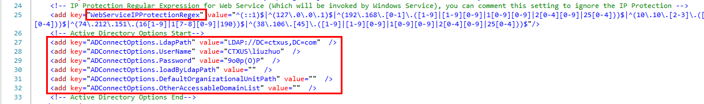Configure the Active Directory Account information in web.config:
2. Configure the Web Service authentication information in

~/App_Data/IocConfig/WebServices.ioc:



# IP Range

Primary- DR-

173.203.21.69 209.61.148.241

173.203.21.72 209.61.148.242

173.203.21.73 209.61.148.243

173.203.21.74 209.61.148.244

173.203.21.76 209.61.148.247

173.203.35.193 209.61.148.248

173.203.35.194 209.61.148.251

173.203.35.195 209.61.148.252

173.203.35.202 209.61.148.253

173.203.35.203 209.61.148.254

Regex Version Regex Version:

^173\.203\.21\.(69|7[0-6])$ ^209\.61\.148\.(2(4[1-9]|5[0-4]))$

^173\.203\.35\.(1(9[3-9])|2(0[0-3]))$