**Contents**

Open Items From Feb 4 Meeting 2

What is accessibility? 4

Accessibility definitions 5

Is visionCMS accessible? 5

Questions you can ask about accessibility 7

Background information on Americans with disabilities 8

WCAG 2.0 practical guidelines for web content owners 9

Technical changes made to visionCMS code for WCAG 2.0 compliance 10

Scoping and pricing to support launching WCAG 2.0 sites - External 11

Scoping and pricing to support launching WCAG 2.0 sites - Internal 12

Considerations and challenges when complying with WCAG 2.0 A, AA, AAA 14

What do we say about accessibility in proposals or on the website? 16

Nueces County 17

Run your own accessibility reports 19

VPAT (Voluntary Product Accessibility Template) 20

Where can I get more information on accessibility? 21

Content needed for training 22

Open Items From Feb 4 Meeting

Meeting with Tom, Ashley, Denise, Jake, Sherry and Maria

Here are the open items I noted from our meeting:

* Legal contract wording – Katrina
* Proposal wording – Denise/Ashley
* List of technical changes in CMS – Denise/Jake
* Rancho Cordova Questionnaire – Sherry, if she still has it?
* Accessibility webpage standard – Tom
* Practical guidelines for accessibility – Tom/Denise
* FAQs – Denise
* Considerations, examples and trade-offs – Denise (by 2/11)
  + High level for clients
  + In the weeds version
* Accessibility consulting packages?
  + Scoping and pricing for WCAG A and AA level sites – Ashley/Dave N. (if we decide to do it or if the risk is not worth it)
* Schedule Q&A call with RSMs/PMs
  + Describe experiences
  + Guidelines for what we should say and share about accessibility
  + FAQs

Yuliang said that we could push a standard accessibility page to all hosted customers

Natalia now testing all designs for WCAG color contrast and fonts

We talked about federal VPAT (Voluntary Product Accessibility Template) which is a tool that is used to document a product’s conformance with accessibility standards under Section 508

* VPAT - <http://www.itic.org/policy/accessibility/>
* Vendor Accessibility Resource Center - <http://www.section508.gov/content/VARC>

Next steps – schedule a Q&A call and/or meeting for the week of February 29th with RSMs and PMs

**Topics for 2/25 Meeting with Denise and Jake**

FAQs – come up with a list of typical questions and answers

Practical Guidelines – list out how our CMS makes it easier to be accessible

Considerations, examples and trade-offs – high level for clients and in the weeds for PMs

Accessibility Policy

What is accessibility?

Accessibility can best be summed up in this quote:

“Removing barriers that prevent the interaction with or access to websites by people with disabilities”

Recognized disabilities that impact websites include:

* Visual (blindness, low vision and color blindness)
* Motor and Mobility (can’t use a mouse)
* Auditory (hearing)
* Seizures (1 in 26 have epilepsy)
* Cognitive and Intellectual

Accessibility definitions

Here are definitions of common accessibility terms:

|  |  |
| --- | --- |
| Term | Description |
| ADA | Americans with Disabilities Act is a civil rights law requires that State and local governments provide qualified individuals with disabilities equal access to their programs, services, or activities (whether or not they receive Federal funds) |
| DoJ | Department of Justice; the DoJ’s Civil Rights division is responsible for ensuring legal compliance with the ADA |
| Section 504 | Is a part of the Rehabilitation Act of 1973 that prohibits discrimination based upon disability and applies to any organization that receives Federal assistance |
| Section 508 | A 1999 amendment to the Rehabilitation Act of 1973 that requires websites of Federal agencies to make electronic and information technology accessible to all users |
| WCAG | “W-CAG” – Web Content Accessibility Guidelines developed by W3C |
| WCAG 2.0 | Version 2.0 of WCAG guidelines which were adopted in 2008 |
| W3C | World Wide Web Consortium is an international community where Member organizations, a full-time staff, and the public work together to develop Web standards. |

Is visionCMS accessible?

In January 2016, we updated our entire visionCMS code base system-wide to comply with WCAG 2.0’s stringent AA requirements.

A few easily visible changes include:

* **Image Library (Alt Tags)** 
  + Screen readers for visually impaired people heavily rely on alt tags to describe the context of an image included on any given page. You can now customize these alt tags to best communicate image meanings site-wide directly from your image library.
* **Page Languages** 
  + Understanding what language is used on any given page helps residents better understand website content. You can now apply a language type to each individual page. By default the selection inherits the global site language.
* **RadEditor Tool Tip** 
  + Often it is difficult to remember all WCAG 2.0 guidelines. In every location where you can create content with the RadEditor, we have included a quick Tool Tip link. This link will open a help section via the Online Reference Guide to explain how to remain compliant.

For more information about technical changes made to comply with WCAG 2.0, please refer to the official WCAG 2.0 website.

The accessibility of a website is determined by the content. While visionCMS will generate pages that are compliant with WCAG 2.0, content editors can add content that is not compliant. The ultimate responsibility for compliance lies with our customers and their team that is adding and editing content on the website.

What we have in our CMS on WCAG:

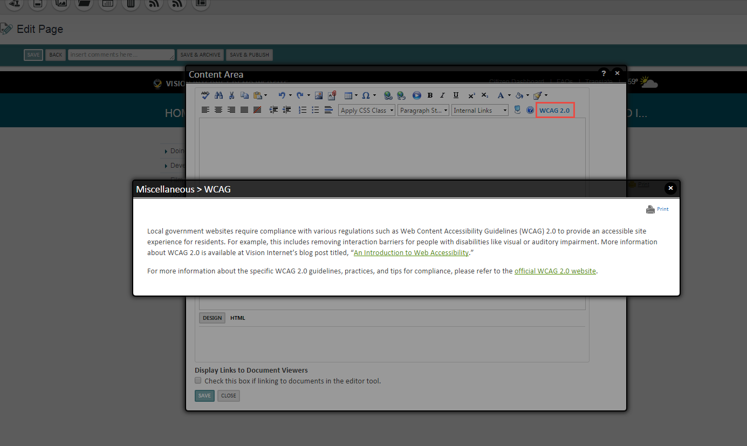

Questions you can ask about accessibility

[add some questions to set traps for our competition]

Background information on Americans with disabilities

Here is a summary of information on Americans with disabilities:

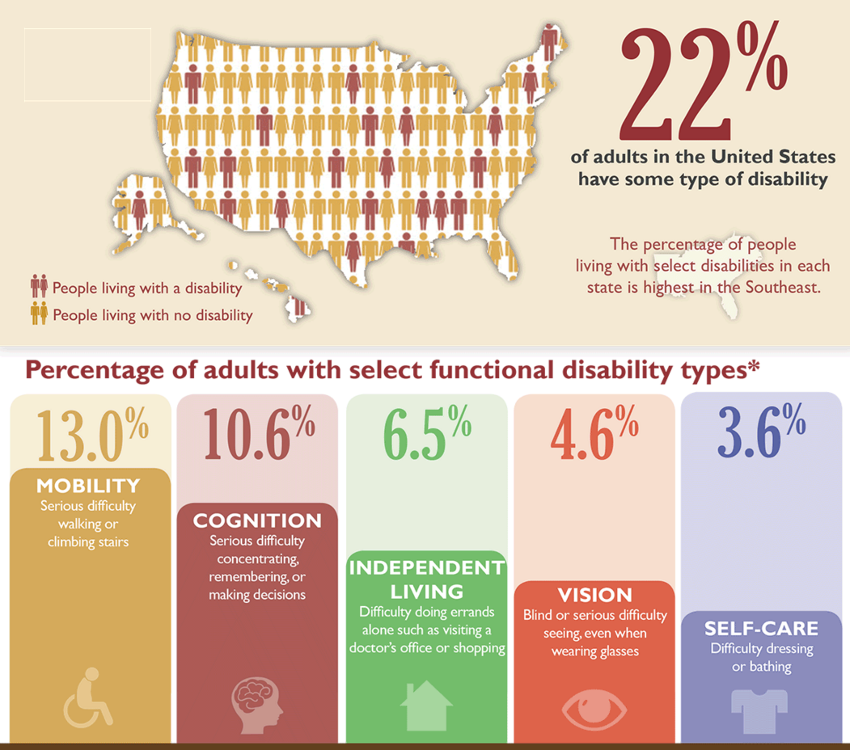

WCAG 2.0 practical guidelines for web content owners

Technical changes made to visionCMS code for WCAG 2.0 compliance

See Jake’s document

Scoping and pricing to support launching WCAG 2.0 sites - External

**WCAG 2.0 Service Offering ($25,000)**

* **WCAG 2.0 Consulting:** Education on requirements and implications for building and maintaining the site. Includes a workshop of 90 minutes, including Q&A. Results from a scan on client’s existing site will give important detail about what will need to change in the new site.
* **WCAG 2.0 Design Consulting:** Developing design in conjunction with WCAG 2.0 requirements to get desired balance between optimal design and WCAG 2.0 compliance. Additional iterations will be created as reasonably needed.
* **Manual and Automated Testing:** Testing of site on a development environment with third party tools (e.g. Sort Site), consulting to analyze the site scans with the client, and addressing issues that arise; manual and automated testing will occur at multiple stages throughout the process (manual testing starts during design phase, automated scan process starts on blank site and continues through launch).
* **User Accessibility Testing:** Testing of development site, after content migration, with panel of human testers with various disabilities, consulting to analyze the site scans with the client, and addressing issues that arise. Client will provide panel of testers as well as screen reader and any other necessary software for testing. Client will also be responsible for administering (on their site) and recording the testing (video and audio); Vision will record via WebEx as well; Vision will develop the test scripts. Testing for: Blind, deaf, inability to use a mouse. Up to 5 tasks (e.g., apply for a job, review meeting results, and submit a service request) will be included.
* **Training of staff (not to exceed 3 hours)**
  + WCAG compliance requirements
  + How to use our CMS to perform the requirements; includes exercises to complete tasks in the CMS

Additional Notes:

* Client will need to identify an Accessibility Lead and it is strongly recommend that they contract with an accessibility consultant
* Client will be responsible for addressing content issues identified in the scans and human testing
* We will flag issues in the content; client is responsible for addressing these issues if it is an upgrade
* Any changes created after launch are not included in this contract
* Require that the client purchases a license for site accessibility scanning software for purposes of the implementation
* It is strongly recommended that the client uses their own site accessibility scanning software to support maintenance of WCAG 2.0 compliance after launch
* WCAG 2.0 services only address the frontend site and do not include the backend functionality of the CMS
* Design and code, excluding third-party tools and software, are sufficiently compliant to WCAG 2.0 level A at launch to the extent validated by automated and human testing as described above; content is excluded and is the client’s responsibility

Scoping and pricing to support launching WCAG 2.0 sites - Internal

**WCAG 2.0 Service Offering (draft) ($25,000):**

* **WCAG consulting:** education on requirements and implications for building and maintaining the site. Includes a workshop of 90 minutes, including Q&A. Results from a scan on client’s existing site will give important detail about what will need to change in the new site. Time to prepare for and deliver: 2-4 days + 90 minute workshop ($3500)
* Owner (education content): Tom, Natalia
* Owner (scan analysis): Maria, Sherry
* Owner (Delivery): Maria, Sherry
* **WCAG Design Consulting:** Developing design in conjunction with WCAG requirements to get desired balance between optimal design and WCAG compliance. Additional iterations will be created as reasonably needed. Time estimate: 1 – 2 days ($2000)
  + Owner: Natalia
* **Manual and Automated Testing:** Testing of site on a development environment with third party tools (e.g. Sort Site), consulting to analyze the site scans with the client (by project manager?), and addressing issues that arise; manual and automated testing will occur at multiple stages throughout the process (manual testing starts during design phase, automated scan process starts on blank site and continues through launch). Time estimate: varies depending on the results; 6 weeks, 5 hours/week = 30 hours ($4500) (PM analyze the scan); Production/Products 20 hours; Design 5 hours ($4000 for Production and Design)
  + Owner: Maria, Sherry
* **User Accessibility Testing:** Testing of development site, after content migration, with panel of human testers with various disabilities, consulting to analyze the site scans with the client (by project manager?), and addressing issues that arise (they provide panel of testers and screen reader and any other necessary software for testing); Vision will develop the test scripts; client will be responsible for administering (on their site) and recording the testing (video and audio); we can record via WebEx as well. Testing for: Blind, deaf, inability to use a mouse. Up to 5 tasks (e.g., apply for a job, review meeting results, and submit a service request) will be included. Time estimate: varies depending on the results; develop the test: 6 hours; 9 hours (PM analyze the scan); addressing issues is accounted for in Automated testing above ($2000)
  + Owner: Uriz
* **Training of staff**
  + WCAG compliance requirements; Time estimate: develop 2 – 4 days; actual training: 1 hour
    - Owner: Tom
  + How to use our CMS to perform the requirements; includes exercises to complete tasks; Time estimate: develop 2 – 4 days; actual training: 2 hours ($4000)
    - Owner (content): Tom
    - Owner (delivery): Maria, Sherry
* Additional PM coordination: $3000
* Add link to Accessibility policy page and a page to report accessibility issues

Additional Notes:

* Client will need to identify an Accessibility Lead and it is strongly recommend that they contract with an accessibility consultant
* Client will be responsible for addressing content issues identified in the scans and human testing
* We will flag issues in the content; client is responsible for addressing these issues if it is an upgrade
* Any changes created after launch are not included in this contract
* Hours noted below are in addition to the regular project work
* It is recommended that the client uses SiteImprove to support maintenance of WCAG compliance
* Require that the client purchases a license for SiteImprove (not Vision) for purposes of the implementation and maintenance
* Only for front end (ATAG is for backend)
* Design and code, excluding third-party tools and software, are sufficiently compliant to WCAG 2.0 level AA at launch to the extent validated by automated and human testing; content is excluded and is the client’s responsibility
* Question: How can we establish a partnership with SiteImprove

Considerations and challenges when complying with WCAG 2.0 A, AA, AAA

Rancho Cordova accessibility design comps from January 2016 – from Maria Setaro

For the AAA versions, we were keeping the buttons small like in the original design, but this gave us more restrictions  in the colors we could use, so we created a AAA version with bigger buttons and bigger text (18pt), so that we could have a little more freedom with the colors. However, this still changed the original color scheme quite a bit.

**WCAG 2.0 AAA**

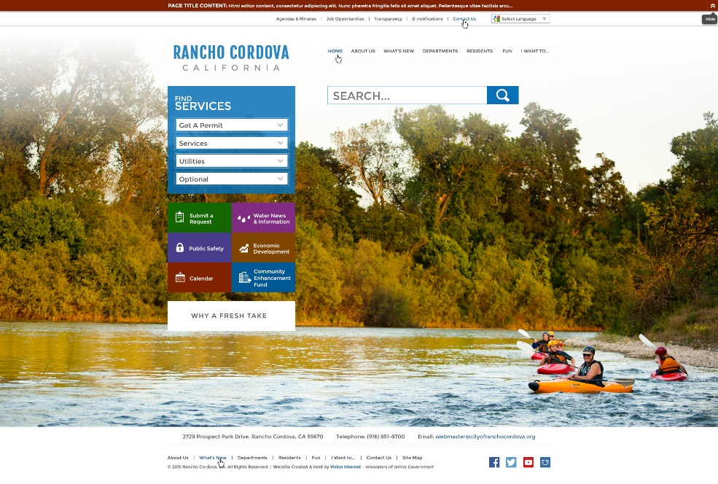

**WCAG 2.0 AAA Big Buttons**

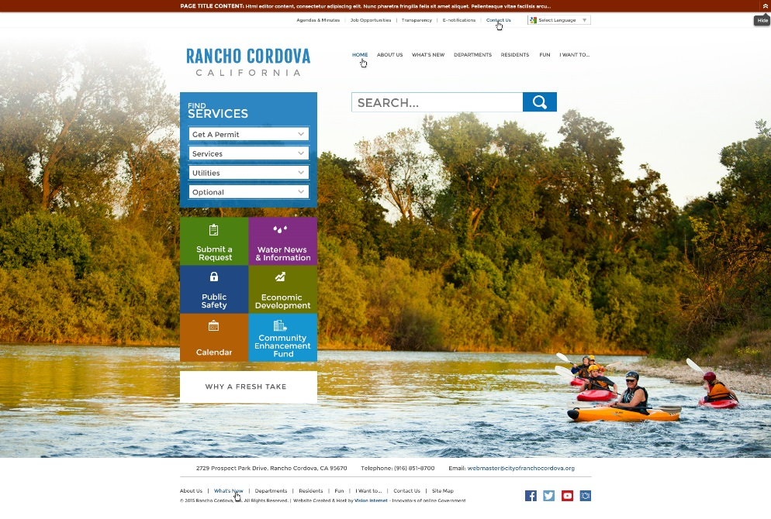

Then, we created the AA version with the big buttons and text, and this gave us even more freedom. However, the client was still not happy with the change in the colors, and this is why they opted to just be A compliant.

WCAG 2.0 AA

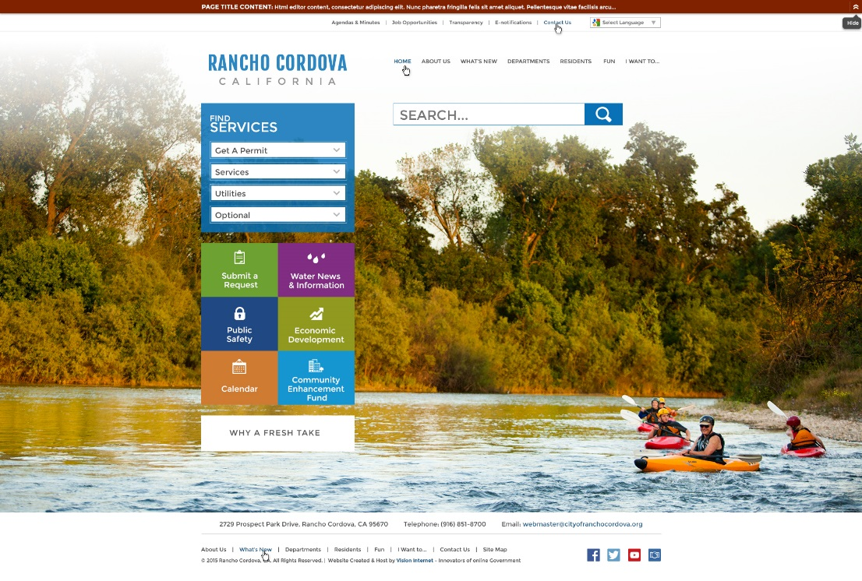

WCAG 2.0 A

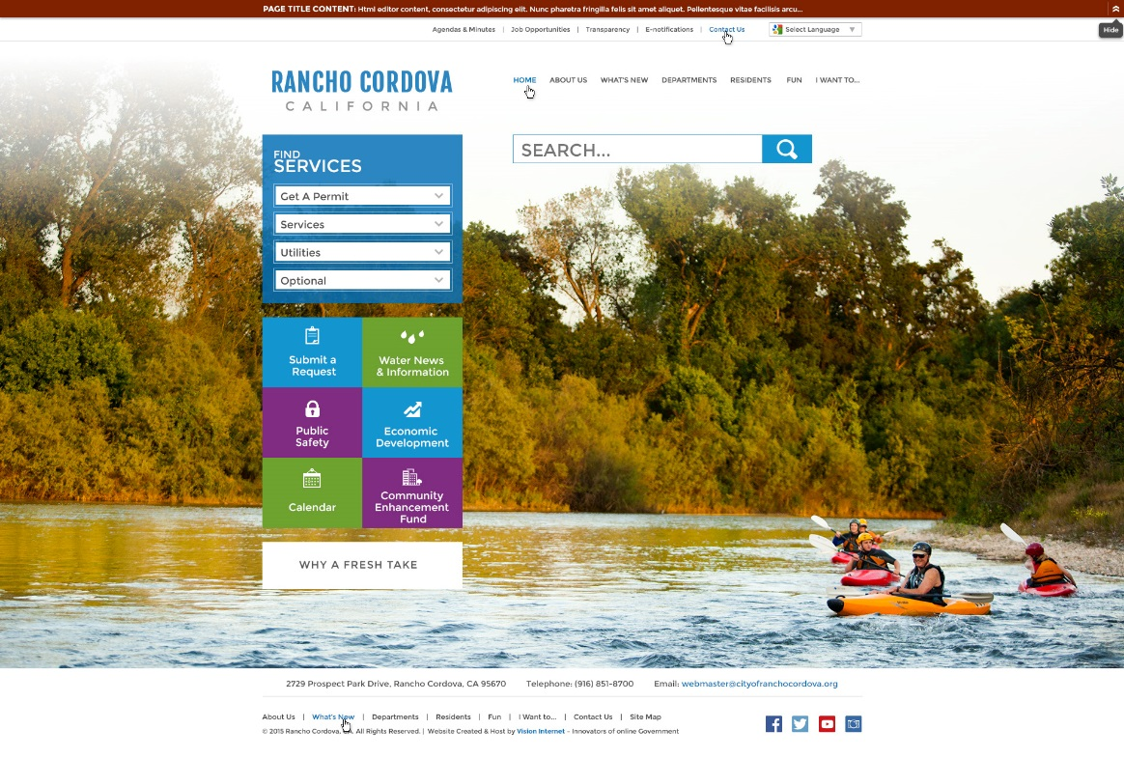

What do we say about accessibility in proposals or on the website?

This is the current information as of January 26th and needs to be refreshed and updated.

Proposal

Although the language of the ADA does not explicitly mention website accessibility, the Department of Justice has issued guidance on the ADA as applied to the websites of public entities. We are capable of fully complying with Section 508 and WCAG 2.0.

Website

[Nothing currently]

Nueces County

In 2012, Nueces County was selected for inspection through Project Civic Access. Project Civic Access is a wide-ranging effort to ensure that local governments comply with the ADA by eliminating physical and communication barriers that prevent people with disabilities from participating fully in community life. The ADA reviews include all physical and digital access to local government community life – which includes websites.

Their [final DoJ settlement was signed in January 2015](http://www.ada.gov/nueces_co_tx_pca/nueces_co_tx_sa.html) and cited hundreds of accessibility items that need to be corrected, including making their website compliant with WCAG 2.0.

Essentially, the Nueces County settlement agreement with the DoJ can be summarized as follows:

* Website accessibility coordinator – need to hire experienced coordinator
* Accessibility policy – adopt, post and share an accessibility policy annually
* Website accessibility notices – need notices to instruct visitors on how to request accessible information and how to provide feedback on improving website accessibility
* Accessibility training – train web content personnel on how to author accessible information
* Accessibility provisions in performance evaluations – add provisions that ensure accessibility of website and content into performance evaluations of anyone who creates content for the website
* Accessibility testing – perform accessibility testing with automated tools and with individuals who have different disabilities (blind, deaf and inability to use mouse at a minimum)
* WCAG 2.0 compliance – ensure that all websites, web content and online services are WCAG 2.0 AA compliant, or will be compliant within the next year or two

Project Details:

* **Deal** - Signed in May 2015 – kickoff was in December 2015
  + $57,890 for website redesign
  + $27,868 for ADA compliance
  + Sherry Eshrati is the project manager
* **CMS Product Review** - Nueces had a consultant look at our weknowgov.com demo site and we meet most of WCAG 2.0 already
* **Recommendations** - Consultant made recommendations and identified some modifications we need to meet WCAG 2.0 compliance include:
  + HTML formatting
  + Calendar grid view
  + Forms and surveys
* **CMS Product Requirements** - Product requirements have been developed, and updates will be made in the December and January sprints
* **Design Review** - Adriane will review the Nueces design when it is complete to identify any potential accessible issues

Another customer, [Bend, Oregon](http://www.bend.or.us/), was also part of an ADA settlement. Bend signed their ADA settlement agreement in 2004 and their [case was closed in 2014](http://www.bendsource.com/Bent/archives/2014/07/24/us-dept-of-justice-closes-ada-case-against-city-of-bend). They have an Accessibility/ADA Information page on their website at <http://www.bend.or.us/index.aspx?page=70>.

Run your own accessibility reports

WebAIM, a non-profit organization based at the Center for Persons with Disabilities at Utah State University, provides a free accessibility evaluation tool that provides a summary of errors and alerts relating to the accessibility of a website. You can find the evaluation tool at <http://wave.webaim.org/>.

Here is an example output from the tool:

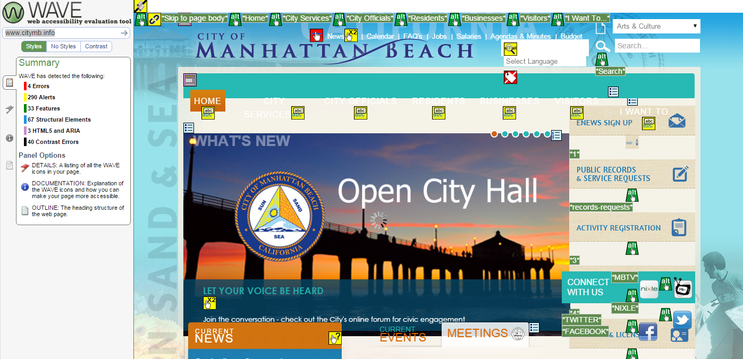

Color contrast is a key accessibility issue and WebAIM also offers a color contrast checker to analyze if specific colors pass the WCAG AA or AAA guidelines. The tool is located at <http://webaim.org/resources/contrastchecker/>

VPAT (Voluntary Product Accessibility Template)

VPAT (Voluntary Product Accessibility Template) is a tool that is used to document a product’s conformance with accessibility standards under Section 508:

* VPAT - <http://www.itic.org/policy/accessibility/>
* Vendor Accessibility Resource Center - <http://www.section508.gov/content/VARC>
* [Download Word version of VPAT](http://www.itic.org/dotAsset/5644ecd2-5024-417f-bc23-a52650f47ef8.doc)

VPAT™

Voluntary Product Accessibility Template®

Version 1.3

The purpose of the **Voluntary Product Accessibility Template**, or **VPAT™**, is to assist Federal contracting officials and other buyers in making preliminary assessments regarding the availability of commercial “Electronic and Information Technology” products and services with features that support accessibility. It is assumed and recommended that offerers will provide additional contact information to facilitate more detailed inquiries.

The first table of the Template provides a summary view of the Section 508 Standards. The subsequent tables provide more detailed views of each subsection. There are three columns in each table. Column one of the Summary Table describes the subsections of subparts B and C of the Standards. The second column describes the supporting features of the product or refers you to the corresponding detailed table, e.g., “equivalent facilitation." The third column contains any additional remarks and explanations regarding the product. In the subsequent tables, the first column contains the lettered paragraphs of the subsections. The second column describes the supporting features of the product with regard to that paragraph. The third column contains any additional remarks and explanations regarding the product.

|  |
| --- |
| Section 1194.21 Software Applications and Operating Systems |
| Section 1194.22 Web-based Internet Information and Applications |

Where can I get more information on accessibility?

* Vision Internet blogposts
  + [Introduction to Accessibility](http://www.visioninternet.com/Home/Components/News/News/590/1346)
  + [Why You Should Be Serious About Web Accessibility](http://www.visioninternet.com/Home/Components/News/News/620/1346)
  + [A Video Introduction to Digital Accessibility](http://www.visioninternet.com/Home/Components/News/News/596/1346?backlist=/our-vision/resources/blog/-npage-2)
* ADA Guidelines
  + <http://www.ada.gov/websites2.htm>
* Section 508
  + [www.section508.gov](http://www.section508.gov/)
* W3C Accessibility Resources
  + <http://www.w3.org/standards/webdesign/accessibility>
* WCAG 2.0
  + [www.w3.org/TR/WCAG20/](http://www.w3.org/TR/WCAG20/)
* Jim Thatcher (Accessibility Consultant and pioneer)
  + <http://jimthatcher.com/>
* Citizens Online
  + [www.citizensonline.org.uk](http://www.citizensonline.org.uk/)
* WebAIM
  + <http://webaim.org/resources/>
* Cornell Accessibility Resources
  + <http://www.it.cornell.edu/policies/accessibility/primer/wa1_intro.cfm>
* 18F – U.S. Government Design Agency
  + <https://pages.18f.gov/accessibility/checklist/>
* [Why Accessible Websites and Mobile Applications Matter](https://www.linkedin.com/pulse/why-accessible-websites-mobile-applications-matter-eric-lambert)

Content needed for training

* [Principles of Accessible Design](http://webaim.org/intro/index#principles) from WebAIM