Frequently Asked Questions

What is visionSearch? 1

Why is search so important? 2

How are we positioning visionSearch? 2

Where can I see visionSearch in action? 3

What and where is the collateral for visionSearch? 3

What about SearchBlox customers? 3

Can existing customers get visionSearch? 4

What are the technical details about visionSearch? 4

Updated visionSearch Proposal Information for Appendix II – Components 4

What does our visionSearch look like compared to our competition? 6

Listing of current SearchBlox customers 14

## What is visionSearch?

Search has always been an important part of our websites, and our latest usability studies have confirmed that Search is usually one of the top three functions that users select when they visit a website. Many of our clients opt for designs that are based on having a prominent search bar on their homepage.

visionSearch is the new search component for visionCMS, and replaces Google search and the discontinued SearchBlox for our implementations. Creating an in-house search component was an important step for us to enhance our CMS offering with a more robust search offering that we can customize over time. This also adds a competitive advantage for us as this feature gives us a better search story compared to our top competitors.

## Why is search so important?

Having a robust search function is imperative for customer-centric websites:

* Search is one of the top 3 website actions taken by most users (according to our usability studies)
* 90% of search users do not go past the first page

Other reasons that search is important are summarized in a [visionSearch blog post](http://www.visioninternet.com/Home/Components/News/News/1680/1346):

1. **Better User Experience** – About 87% of search queries are unique, one-time searches and over 90% of people that perform a search do not go past the first page. Many users will use the search box without even trying to figure out the navigation menu.
2. **Increased Time Spent on Site** –Users who have a great search experience are most likely to spend more time on the site because they can actually find what they were looking for.
3. **More Actions** –Users who managed to find what they were looking for when searching a website are more apt to complete the action on the website.
4. **Decreased Bounce Rate**– Bounce rate has been found to decrease on sites with a strong search option, and customers using the search function sometimes discover additional site information that attracts them to keep viewing more pages.

## How are we positioning visionSearch?

With visionSearch, we give web administrators a way to fine-tune search results and we deliver a better search experience for end-users. visionSearch also includes all of the functionality that end users have come to expect in an industrial-strength search engine.

* Fine-tuning search improves user experience
  + Create search synonyms to capture all possible phrases someone can use when they search (like garbage, trash, recycling, rubbish, waste, etc.)
  + Use keywords to promote specific pages to the top of the search results
  + Integrate search results across multiple domains
* Users get a better search experience
  + Users can sort results to quickly find key information
  + Users can filter results by content type to narrow results
  + Users can access advanced search options with a simple click

## Where can I see visionSearch in action?

The following customers have visionSearch on their sites today:

* [Fayetteville](http://fayettevillenc.gov/)
* [Shakopee](http://www.shakopeemn.gov/)
* [Baytown](http://www.baytown.org/home)
* [Santa Clarita](http://santa-clarita.com/)
* [Manhattan Beach](http://www.citymb.info/)

Plus all of the weknowgovernment demo websites have been updated with visionSearch. (i.e. [www.weknowgovernment.com](http://www.weknowgovernment.com) and [www.weknowgovernment.net](http://www.weknowgovernment.net)).

## What and where is the collateral for visionSearch?

The collateral for visionSearch can be found on the shared drive:

* Marketing one sheet for visionMobile Designer (attached)
* Internal Talking Points
* visionSearch User Guide – this provides an excellent overview of how to use visionSearch from an end-user and administrator standpoint
* [Updated website copy](http://www.visioninternet.com/our-solution/featured-components/visionsearchtm)
* Updated proposal copy (see later in this document)
* Blog Post – [Are You Delighting Customers with Search on Your Local Government Website?](http://www.visioninternet.com/Home/Components/News/News/1680/1346)
* Demo Script (for the Sales team)

## What about SearchBlox customers?

We will be reaching out to all SearchBlox customers and will migrate them to visionSearch for free. There is no time table for migrating the SearchBlox customers at this time. See list of SearchBlox customers later in this document.

## Can existing customers get visionSearch?

Yes. Existing visionLive customers can get visionSearch for a $1,000 implementation fee and a $500 annual increase in their visionLive subscription fee. We are currently working out the process details. Interested customers should contact Robert Schnelle from the Customer Success team.

## What are the technical details about visionSearch?

Here are a few technical details for visionSearch:

* **Core code** - The core code behind visionSearch is Solr, a popular open source search library which ensures fast, accurate results and intelligent indexing. This is an open source application and we can modify or extend the feature with additional functionality in the future.
* **Future enhancements** - Future enhancements for visionSearch may include the availability of search analytics to determine the most popular search phrases and accessed information.
* **Set-up** - visionSearch needs to be set up by our system admin team and it generally takes several hours to get it set up.

The indexing for visionSearch is currently refreshed weekly. See Yuliang or Denise for more information on the technical aspects of visionSearch.

## Updated visionSearch Proposal Information for Appendix II – Components

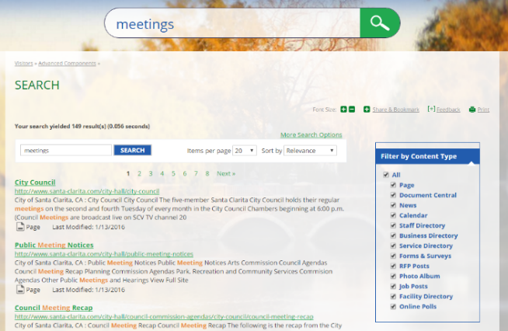Since many website visitors use search as the primary means of finding what they want and exploring your website, it is important to have a search tool that provides fast and accurate results. In addition to searching HTML pages and documents on your website, this powerful tool includes all of the functionality that visitors and administrators expect in an industrial-strength search engine.

Features for website visitors include:

* **Sorting** – Sort search results by Relevance, Last Modified, Title or Content Type which gives users the flexibility to access the results how they want to
* **Filtering**– Use the Filter by Content Type checkbox to quickly select the type of content to include in search results
* **Advanced Search Options** – Apply Boolean options to search criteria or filter by document type, such as HTML, Word, PDF, etc. for more precise search

For site administrators, visionSearch allows significant control over what content is indexed by search and how it displays. Configuration tuning options include:

* **Page Promotion** – Add keywords to promote a specific page higher in the search results
* **Search Synonyms** – Configure synonyms so the search results will consider the words or phrases to be exactly the same (for example, you can configure the visionSearch so if a user enters trash, rubbish, or garbage then any page containing any of these words will be returned)
* **Search Scope** - Define the scope of the search index, potentially allowing you to display results from multiple websites, or just for one specific department
* **Display Options** – Refine what search options are presented to visitors

## What does our visionSearch look like compared to our competition?

CivicPlus has a comparable search interface for end users, but they do not appear to have the ability to fine tune the administrative side of the search function. The other competitors appear to have simple basic search capabilities.

**Vision Internet** – New visionSearch Results - <http://fayettevillenc.gov/>

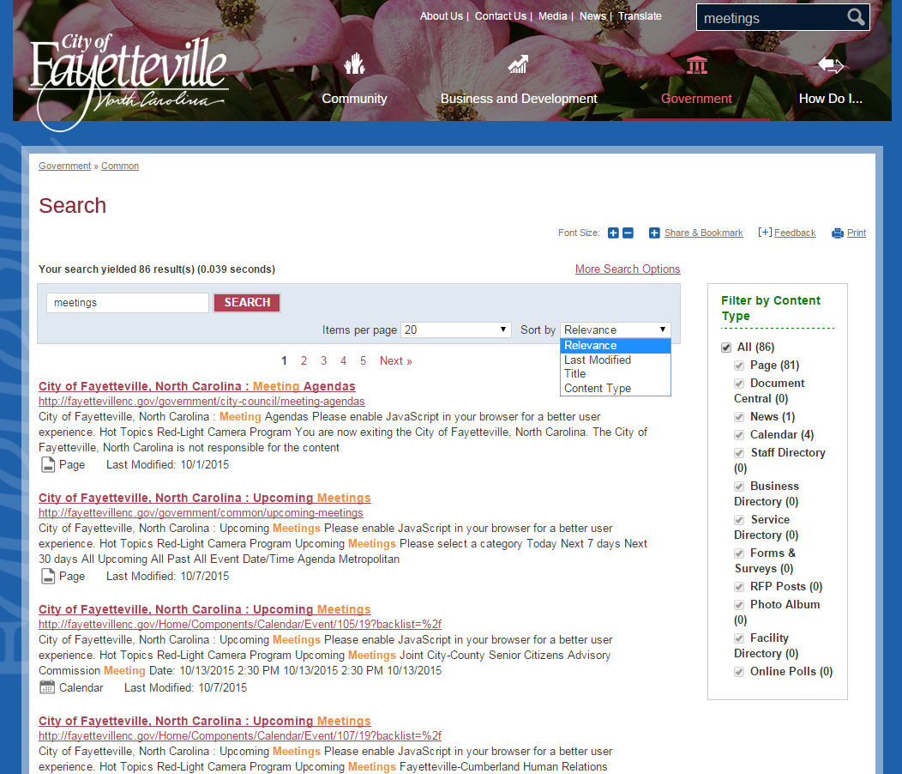

**Vision Internet** – New visionSearch Results – Advanced Options - <http://fayettevillenc.gov/>

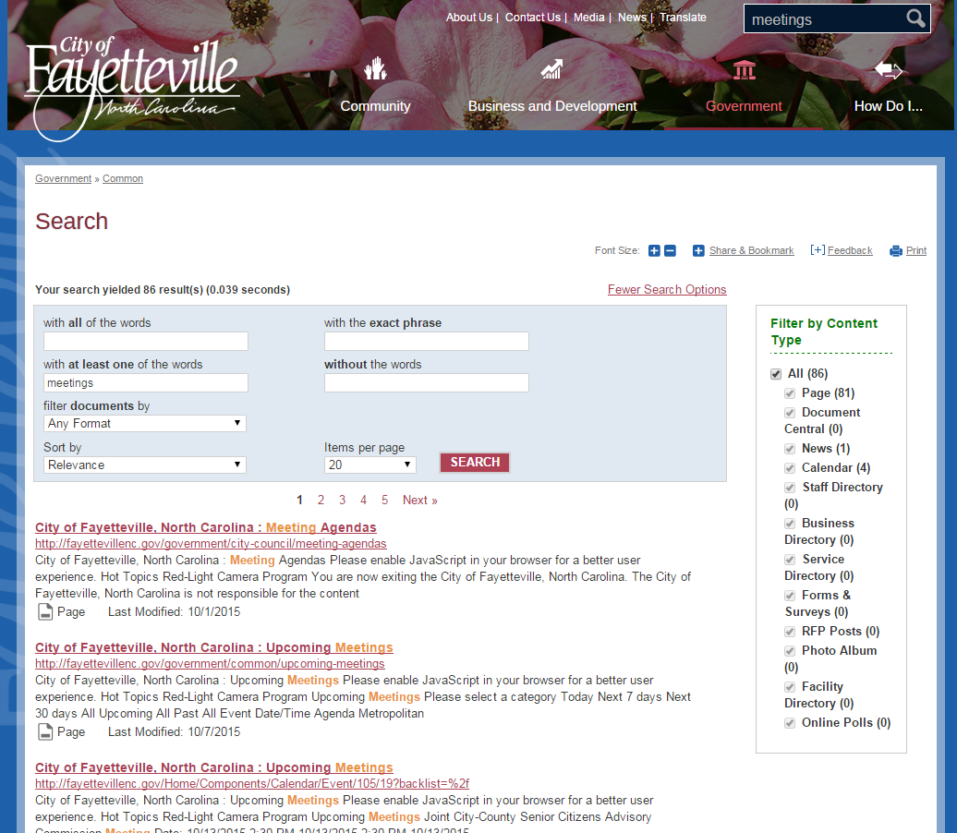

**Vision Internet** – Existing Custom Google Results - <http://www.cityofnorthport.com/>

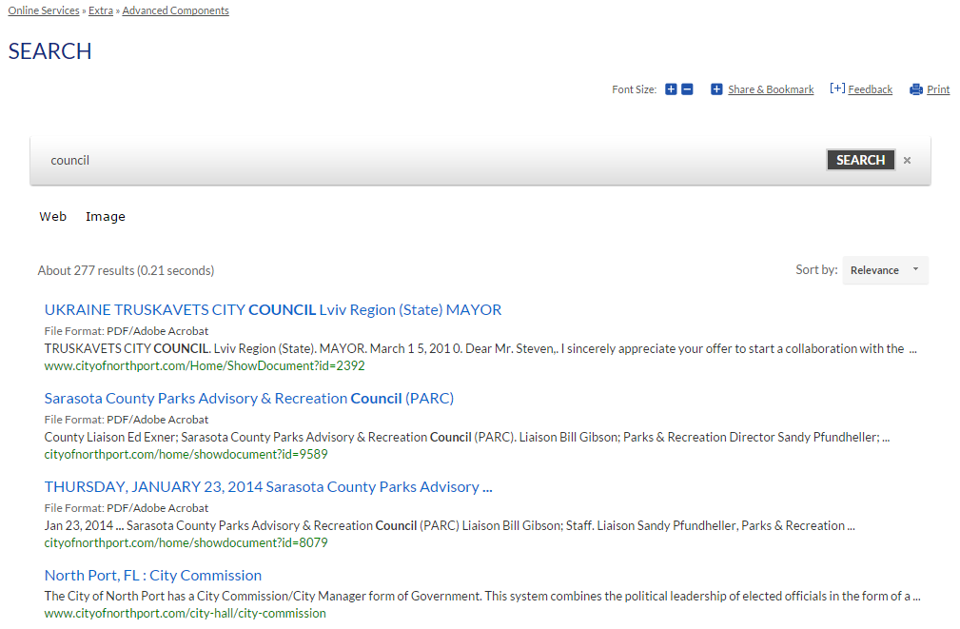

**CivicPlus Search Results** – Basic Search - <http://bellairetx.gov/>

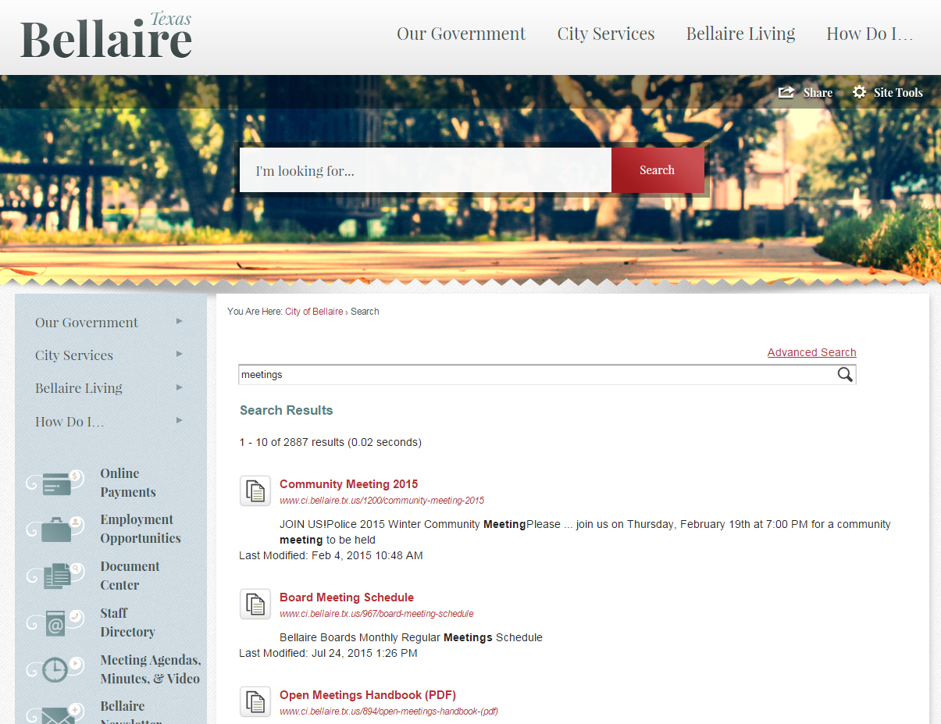

**CivicPlus Search Results** – Advanced Search - <http://bellairetx.gov/>

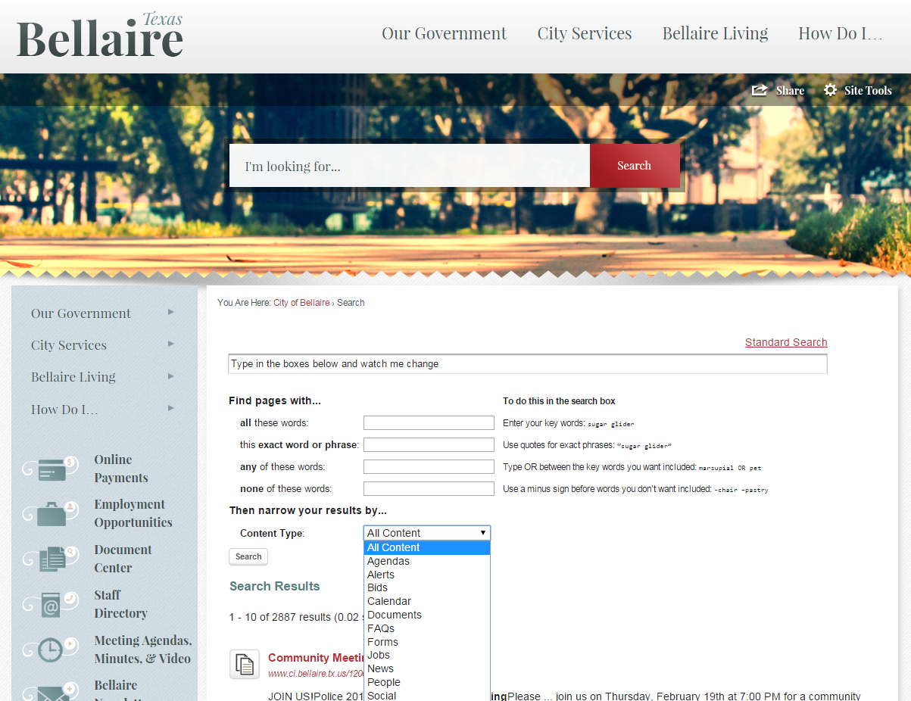

**CivicLive Search Results** - <http://www.knoxvilletn.gov/>

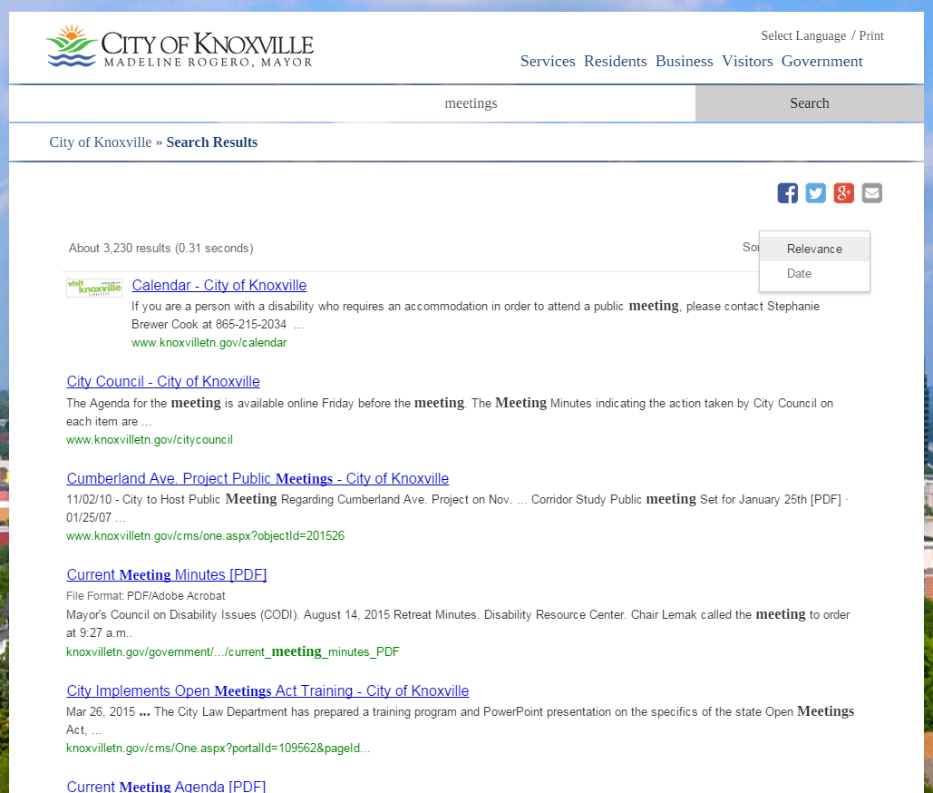

**Civica Software** - <http://www.santabarbaraca.gov/>

Civica Software integrates Google Search for their sites. Now that they are owned by Granicus, they are starting to talk about the ability to search across agendas and minutes uploaded through the Granicus meetings manager solution.

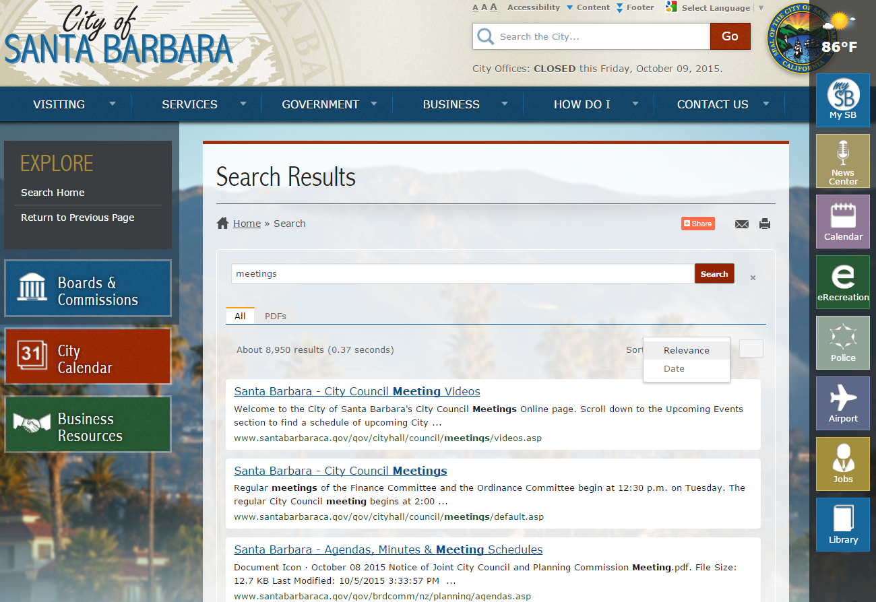

**Revize** - <http://www.cityofclawson.com/>

(check out the ads in their Google-powered custom search)

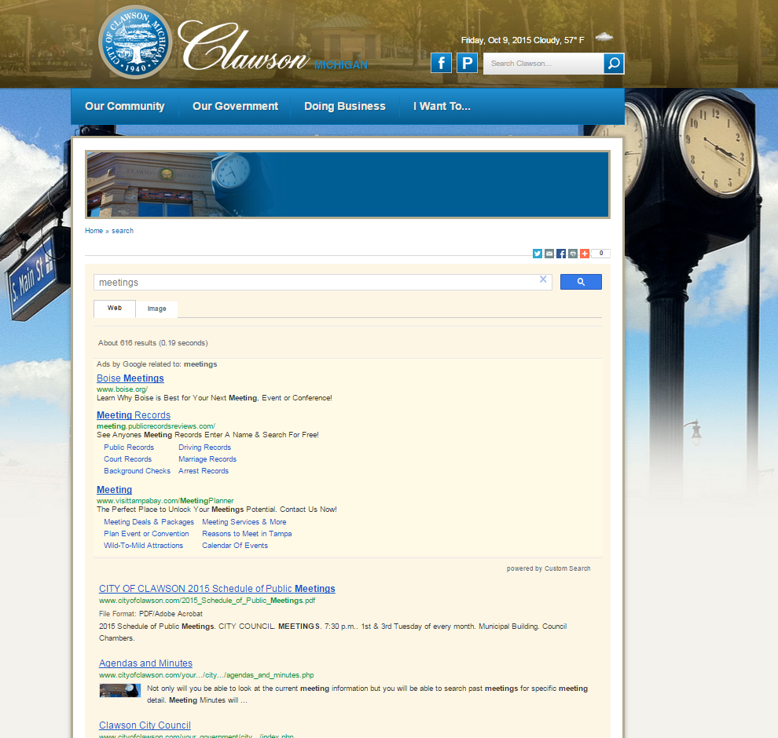

## Listing of current SearchBlox customers

|  |  |  |
| --- | --- | --- |
| Account Name | Site | Version |
| City of Baytown, TX | [www.baytown.org](http://www.baytown.org/) | CMS6, vLive |
| City of Chula Vista, CA | [www.chulavistaca.gov](http://www.chulavistaca.gov/) | CMS6, vLive |
| City of Shakopee, MN | [www.ci.shakopee.mn.us](http://www.ci.shakopee.mn.us/) | CMS6, vLive |
| City of Rock Hill, SC | [www.cityofrockhill.com](http://www.cityofrockhill.com/) | CMS6, Vision, Hosting Only |
| City of Yonkers, NY | [www.cityofyonkers.com](http://www.cityofyonkers.com/) | CMS6, vLive |
| Columbia Association, MD | [www.columbiaassociation.com](http://www.columbiaassociation.com/) | CMS6, vLive |
| Calcasieu Parish Police Jury | [www.cppj.net](http://www.cppj.net/) | CMS5, Vision Hosted, Hosting Only |
| City of Enid, OK | [www.enid.org](http://www.enid.org/) | CMS6, vLive |
| City of Lafayette, CA | lovelafayette.org | CMS6, vLive |
| City of Mankato, MN | [www.mankatomn.gov](http://www.mankatomn.gov/) | CMS6, vLive |
| City of Mankato, MN | mankatomn.swagit.com | CMS6, vLive |
| City of Mankato, MN | verizonwirelesscentermn.com | CMS6, vLive |
| Marion County, FL | [www.marioncountyfl.org](http://www.marioncountyfl.org/) | CMS6, vLive |
| City of Maryland Heights, MO | [www.marylandheights.com](http://www.marylandheights.com/) | CMS6, vLive |
| Monterey Peninsula College | [www.mpc.edu](http://www.mpc.edu/) | CMS6, Client Hosted, On-Premise vLive |
| Municipal Code Corporation (MCC Innovations) | [www.municode.com](http://www.municode.com/) | ? |
| City of Norwalk, CA | <http://www.ci.norwalk.ca.us/city-hall> | CMS6, vLive |
| Orange County Sanitation District | [www.ocsd.com](http://www.ocsd.com/) | CMS6, vLive |
| Panama City Beach, FL | [www.pcbgov.com](http://www.pcbgov.com/) | CMS6, vLive |
| City of Port Moody, BC | [www.portmoody.ca](http://www.portmoody.ca/) | CMS5, Vision Hosted, vLive |
| City of Rochester, MN | [www.rochestermn.gov](http://www.rochestermn.gov/) | CMS6, vLive |
| City of San Clemente, CA | [www.san-clemente.org](http://www.san-clemente.org/) | CMS6, vLive |
| San Bernardino County Special Districts | [www.specialdistricts.org](http://www.specialdistricts.org/) | CMS5, Vision Hosted, Hosting Only |
| Alliance for Innovation, AZ | [www.tlgconference.org](http://www.tlgconference.org/) | CMS5, Vision Hosted, Hosting Only |
| City of Tulare, CA | [www.tulare.ca.gov](http://www.tulare.ca.gov/) | CMS6, Vision Hosted, Hosting Only |
| Whatcom Community College | [www.whatcom.edu](http://www.whatcom.edu/) | CMS6, vLive |