Vision has rolled visionMobile Designer to all visionLive hosted customers, and it has been available since June 2015.

## What is Responsive Web Design (RWD)?

Responsive web design (RWD) is now the industry standard for mobile design, but it has limitations because content priority and element order is based on desktop design. Pages with responsive design do not always display page elements properly or where you want them on the page.

## What Are the Overarching Issues?

* Website traffic from mobile devices is growing rapidly and exceeds more than 50% of all traffic for many organizations
* From our own user analytics, we know that Mobile Web traffic now accounts for over 33% of all web traffic, and has increased by 27% from September 2014 to September 2015
* 25% of users only access the Internet using a mobile phone
* Google changed its search algorithm to favor “mobile-friendly” websites in 2015
* In our 2014 What’s Next survey, the respondents saw value in delivering mobile facing services including citizen convenience, expanded communications reach and time savings.
* Websites need to do be easy to use and navigate across all devices, especially on mobile

## What is our Solution and Positioning Points?

With our new visionMobile Designer, we take responsive design to the next level by giving you more control over the order and visibility for all of the elements on your web pages no matter what device is used for viewing.

The primary positioning points are that:

* Your visitors are mobile
  + 33% of all web traffic is from mobile (Vision customer statistics)
  + Mobile traffic has grown 27% in the last year (Vision customer statistics)
* A responsive website is not enough
  + Responsive has limitations
  + Element order is based on desktop design
  + Page elements are not always where you want them to be
* Design their experience
  + Move, hide and reorder content for your mobile site
  + Make changes on an individual page or an entire template
  + Preview and test changes across a wide number of devices

Additional positioning appears in the Mobile Strategy Infographic:

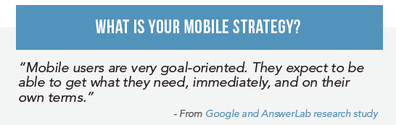

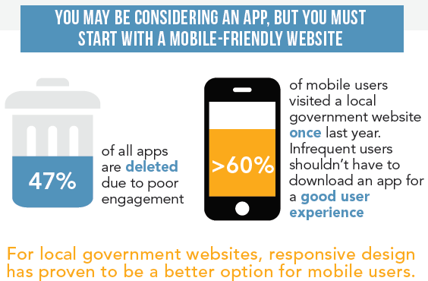

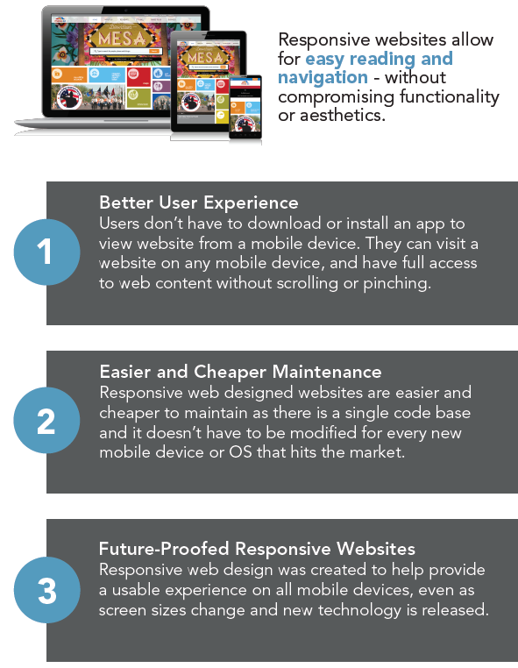

## What are Best Practices for Mobile?

This Mobile Friendly Checklist from the Infographic lists the characteristics that make a mobile friendly website:

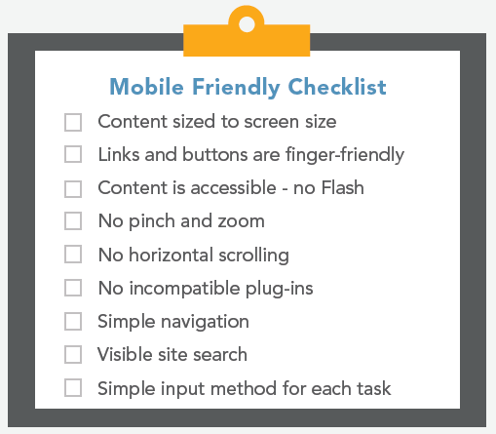

What are the Key Product Features of visionMobile Designer?

With Vision Mobile Designer, users have flexible and powerful control over how their pages appear. Web editors can:

* Apply design changes to individual pages or page templates
* Reorder elements on a page
* Hide elements on a page
* Expand or collapse Side navigation in the mobile view by default
* Preview in Portrait or Landscape mode for a variety of mobile devices
* Test and modify functionality across a range mobile devices

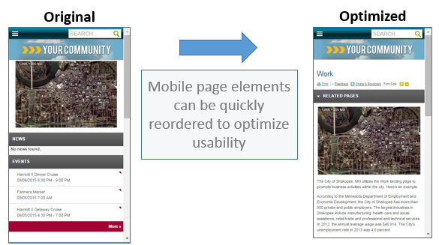

visionMobile Designer does not work on the homepage currently, but it is available for all other pages. The ability to update the mobile view of a homepage is on the product roadmap for Q3 2016.

## What are the Key Positioning Points for the Competition?

* CivicPlus, CivicLive, Civica and Revize all use responsive design in their latest versions of their CMS
* None of them appear to have the ability to easily modify the design to pages or templates to a specific device
* We provide a better mobile experience by being able to prioritize content and functionality on specific mobile devices
* This is another example of the flexibility and ongoing innovation we offer customers through our CMS

## Set a Trap for CivicPlus and Other Competitors

Look at some competitor websites in mobile view.

CivicPlus has responsive websites, but they don’t present very well in mobile mode. CivicPlus was late to the game with responsive design and it was hard for them to develop this functionality due to their older, not-so-flexible code base.

For example, check out this side-by-side view of a new CivicPlus site – Dublin, CA (<http://www.dublin.ca.gov/>)

Most of the branding goes away, and the search, social media, share and tools take up half of the homepage screen.

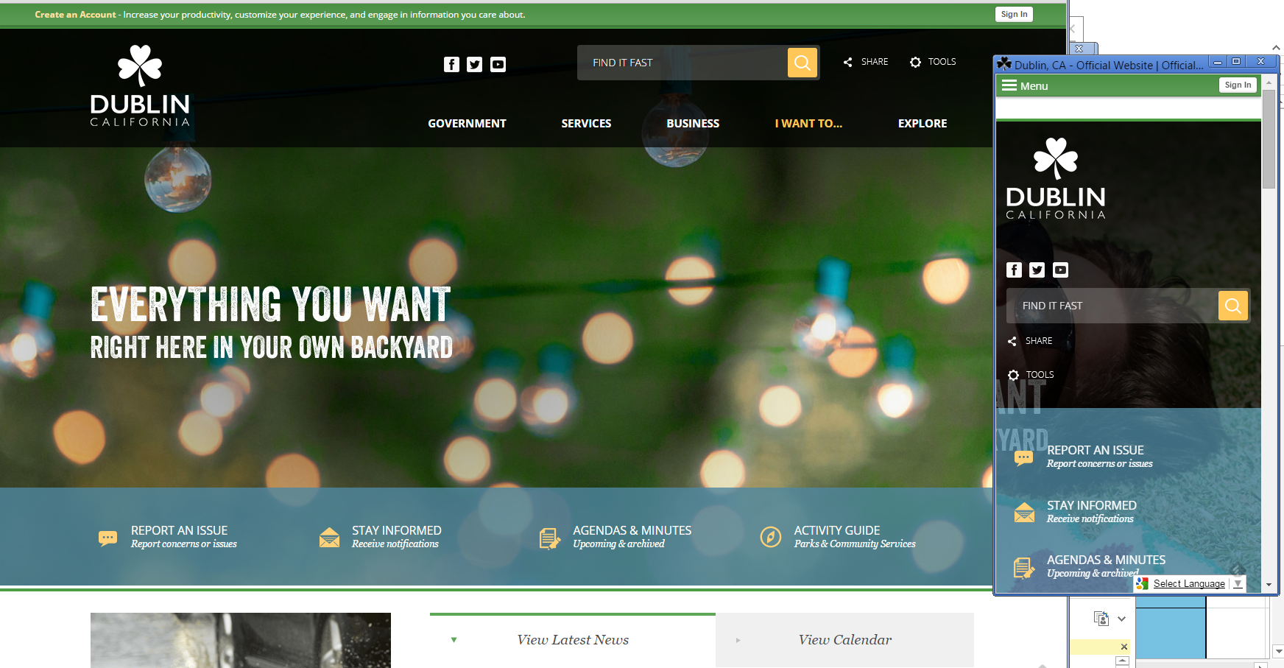

## Q&A from Lunch-n-Learn in December 2015

**Q:** How are we defining mobile?

*A: Any smart phone or tablet device.*

**Q:** What are our four key product themes?

*A: (1) Mobile; (2) Integration; (3) Accessibility; (4) Usability*

**Q:** How does our mobile experiences benchmark against industry standards?

*A: Against global tech leaders, probably around a five. When compared against our industry competitors, it is closer to an eight or nine.*

**Q:** How are we currently determining the need for responsive design?

*A: Media queries*

**Talking Point:** For the mobile editor, it is helpful to discuss the importance based on page layouts across devices. For example, desktop designs are typically 3-column layouts. The responsive mobile design will typically stack rank column one, then column two, and finally column three. The mobile editor allows users the ability to re-prioritize not only the column order, but specific content as well.

**Q:** Have we considered adding the ability to include (display) an item on mobile, but not on desktop?

*A: We may consider adding a “tablet” designer as tablet usage increases. We may also update the “designer” functionality to provide this additional flexibility from mobile to desktop, but we haven’t heard of a strong need to display additional widgets only on mobile views. We continue to update our understanding of the market and user needs and will be focusing on mobile improvements going forward, so this may be something to consider in the future.*

## What Resources are Available to Help You Sell?

* Marketing One Sheet
* What is Your Mobile Strategy Infographic
* Internal Talking Points
* Video of demo
* Script for demo
* Help Topics in visionCMS

## Where Do I Find the CMS Online Help Topic?

The configuration can occur at either the page level or page template level. You can find the Help topics at:

* Individual pages – Site Content > Pages > Preview/Edit Mobile
* Page Templates – Site Settings > Page Templates > Configure Mobile Settings

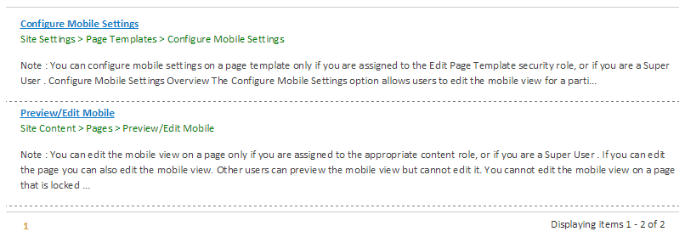

## Show Me a Specific Example of How to Update a Page

By default, here is how the widgets are organized on the City Government page in our demo. Note how the widgets are organized by default:

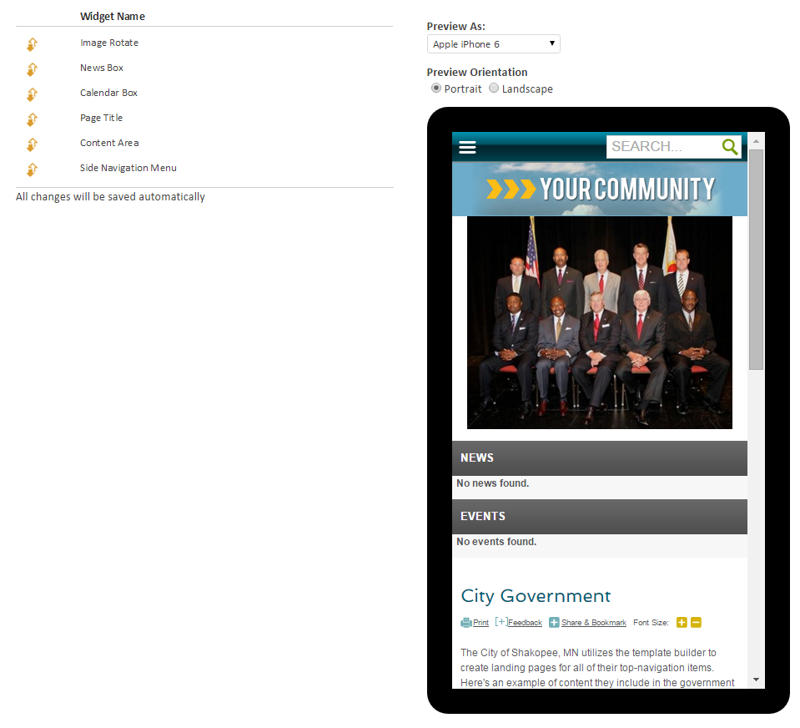

You can easily drag and drop the widgets to organize them in a more useful way. For example, it makes more sense to have the widgets in this order:

