Accessibility Compliance

1. Headers

Headers are responsible for breaking up content on the page in a way that screen readers can parse the different sections. Screen reader users are not able to scan the site visually, so this allows them to skip from section to section without having to hear all of the content read out loud first.

* **Break up blocks of content**
  + Matthew Kilgore Cemetery Rules and Regulations  
    <http://www.cityofranchocordova.org/residents/about-us/history/matthew-kilgore-cemetery/cemetery-rules-regulations>
* **Use bold, italics, and underline sparingly**Because these formatting tools are often used in lieu of headings, they are usually unnecessary. Also, if users are not careful about pasting in plain text into the CMS, then it will bring over tags that compromise the accessibility of the page. If you must use one of them, then apply it using the CMS toolbar. Example:
  + May is Bike Month*: <http://www.cityofranchocordova.org/i-want-to-/learn-about/may-is-bike-month>
* **Nest headers**Every page has Heading 1 already defined by default in the page title, so you must always use Heading 2 as the very first heading on every page. If using subheadings, they must be sequential: Heading 3 followed by Heading 4, followed by Heading 5...

Also, unless it is defined by another header, all content falling after a header is defined underneath it. Example:

* + Prompt for more information falls under the Holidays Heading. <http://www.cityofranchocordova.org/i-want-to-/learn-about/rancho-cordovan-shuttle-service>
  + Header was added here

Linda Budge*: <http://www.cityofranchocordova.org/government/city-council-/council-member-linda-budge>

2. Links­­

Links should always be descriptive. Users need to be able to figure out the link destination and its meaning without having to read all of the text around it. They should always be descriptive and include relevant information. This is so that users have the option to scan all of the links on a page before diving into the content.

* **Include context/purpose in links**Example 1:
  + Not Accessible – Click Here to see more infor­mation on water restrictions
  + Accessible - Click Here for more information on water restrictions

Example 2:

* + Not Accessible – Learn more about our town history.
  + Accessible – Learn more about our town history.

3. Bullet Points

Bullet points are often used for formatting purposes—however, to a screen reader they look like blocks of unparseable text.

* **Use bullet points only for lists**Screenreaders see paragraphs sorted by bulletpoints at blocks of text. This effectively disables a screen reader from skipping around to find information, and forces them to listen to the whole paragraph. Example:
  + Facilities Rental*: <http://www.cityofranchocordova.org/i-want-to-/hold-an-event-at-city-hall/facilities-rental>
  + Forms and Downloads*: <http://www.cityofranchocordova.org/government/community-development/building-and-safety/forms-and-downloads>

4. Images

Images must have some sort of description through the alt text or long description. Images with lots of text should be avoided.

* **Include alt text for images with contextual meaning**That way screen reader users will be able to benefit from the images included.   
  To add alt text:
  + Click on the image in the CMS editor
  + Under **ToolTip**, enter your alt text
  + Press **Enter** to apply the change

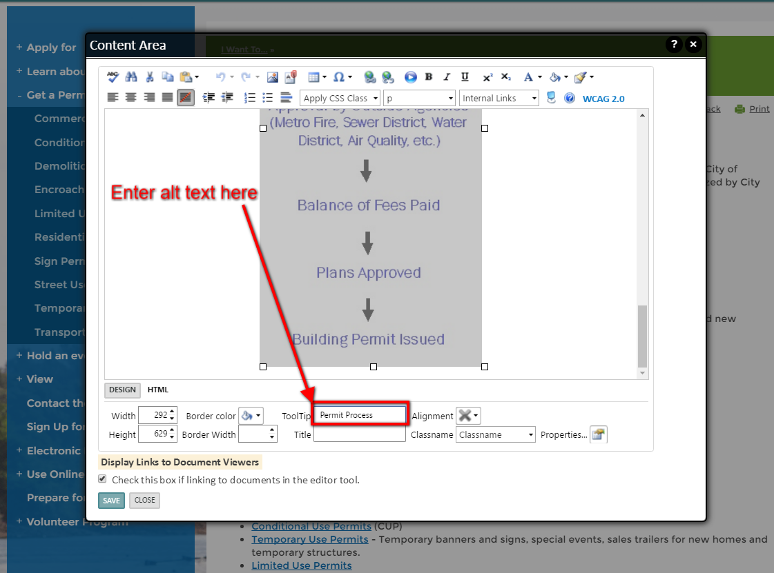

* **Avoid images with text**  
  Using images to convey information is against best practices, because screen readers cannot analyze images. Whenever possible, either convert it into text or use a tagged PDF that users can download. Examples:
  + This example could easily be converted to text  
    <http://www.cityofranchocordova.org/i-want-to-/get-a-permit>
  + This page would be better served by using a calendar widget, and filtering by category to only show trash days. Otherwise, the rest of the images should be transcribed on the page.  
    <http://www.cityofranchocordova.org/government/public-works/services-and-programs/city-residential-solid-waste-services>

5. Tables

Tables are a useful tool for organizing data—but when they are used for other reasons like page formatting, we run into accessibility issues. An easy way to ensure your tables are always accessible is to create them using VisionCMS—do not paste them in.

* **Use tables only for data organization**

When we use tables for data or formatting, it’s like swimming at the beach, and then having the sand drop out from under you. You don’t know what’s ahead of you, and there is no way of finding out without diving in. Example:

* + General Plan*: <http://www.cityofranchocordova.org/government/planning/general-plan>
  + Sunridge Specific Plan*: <http://www.cityofranchocordova.org/government/planning/zoning-specific-plans-and-special-planning-areas/specific-plans/sunridge-specific-plan>
  + Major Development and Projects Map*: <http://www.cityofranchocordova.org/government/planning/most-used-documents/maps/major-developments-and-projects>

An example of both:

* + - <http://www.cityofranchocordova.org/government/city-council>
    - <http://www.cityofranchocordova.org/government/leadership-team>
* **Always use headers and associate them with cells**

When we use headers and associate them with cells, screen reader users are able to reference the header that applies to the relevant cell. How do you check that headers are defined and associated with cells? The table is fully responsive <http://www.cityofranchocordova.org/government/human-resources>

To assign headers and associate them with cells:

* + Right click on the table > Table Properties

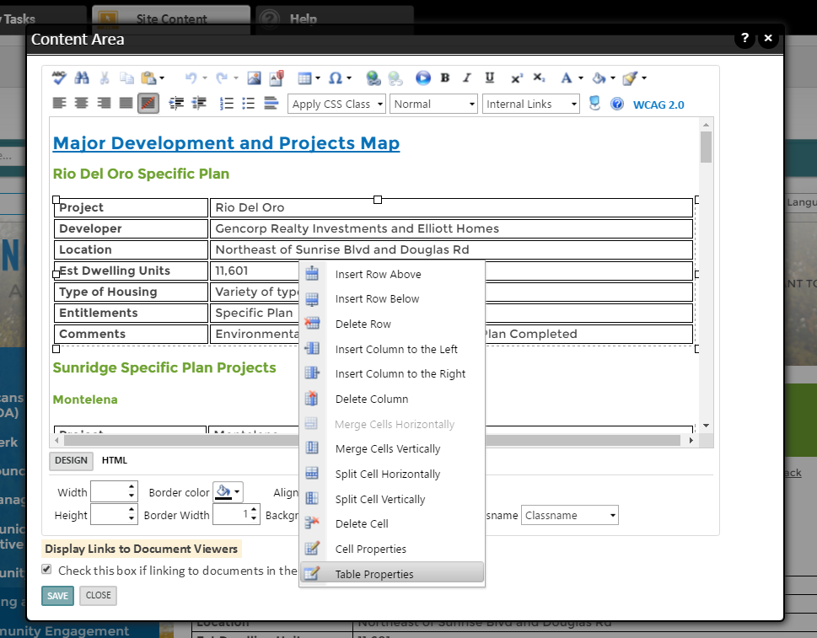

* + Go to the **Accessibility** Tab > Enter number of headings > Make sure **Associate cells with headers** is checked > Click **OK**

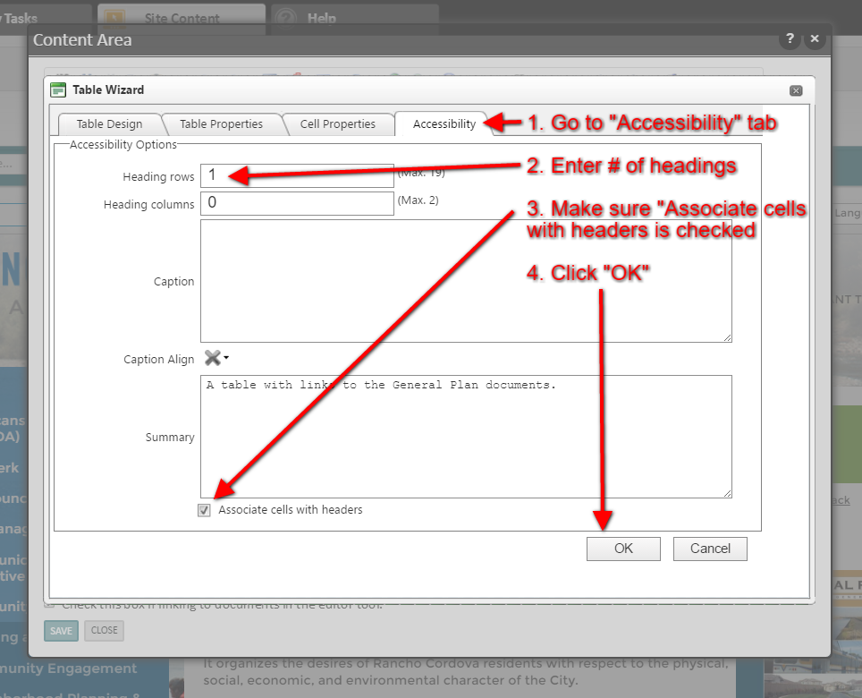

* **Always include a table summary**

Table summaries provide context when screen reader users encounter a table, allowing them the choice of reading the table or not.

To add a table summary:

* + Right click on the table > Table Properties



* + Go to the **Accessibility** Tab > Enter summary > Click **OK**

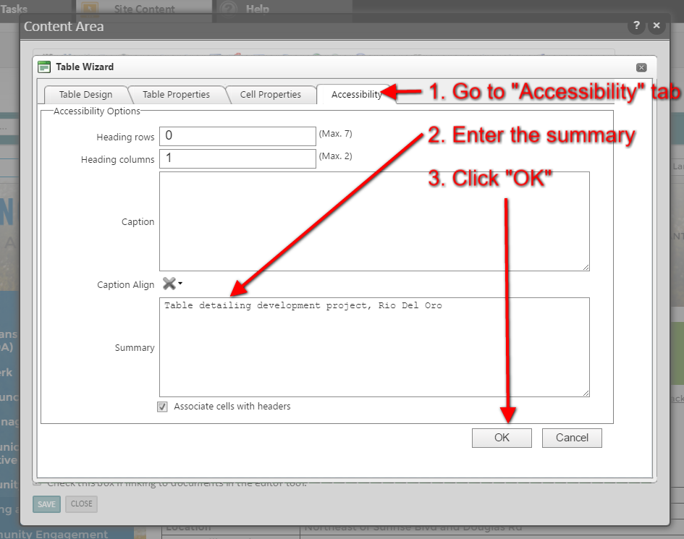

Utilize CMS Tools

VisionCMS has a lot of built-in functionality that is being underutilized, and would go a long way towards organizing content, keeping it visually engaging, fully responsive, and easily accessible for screen reader users.

1. Widgets

In some cases, widgets would better serve the purpose than what is currently being used, and reduce chances for user error that may be introduced in manually-entered content.

* **Calendar Widget**Useful for meeting notes and agendas. Provides template for organization, consistency and convenience. They would also not need to be manually updated. Examples:
  + <http://www.cityofranchocordova.org/what-s-new/community-enhancement-fund/town-hall-meetings>
  + <http://www.cityofranchocordova.org/government/planning/administrative-public-hearings>
  + Farmington, CT: <http://www.farmington-ct.org/government/town-plan-zoning-commission/minutes-and-agendas>
* **Staff Directory Widget**  
  Useful on departmental pages, as a side bar (staff directory example)
* **RFP Widget**  
  Instead of manually creating a table, use the RFP widget. That way whenever there is a new bid/RFP uploaded, it will update automatically.
  + Facilities*: <http://www.cityofranchocordova.org/government/facilities>
* **Document Library Widget**  
  This widget will display a list or box of documents you choose to share. They can be filtered by predefined categories.
  + Environment Document Library: <http://www.cityofranchocordova.org/government/planning/environmental-review/environmental-documents>

2. Templates

Instead of manually inserting tables into content areas, our interior page templates are highly customizable for all kinds of uses.

* **Side table template**Examples:
  + Council Member Linda Budge*: <http://www.cityofranchocordova.org/government/city-council-/council-member-linda-budge>
  + Council Meeting Agendas, Minutes, and Videos*: <http://www.cityofranchocordova.org/government/city-clerk/council-meeting-agendas-minutes-and-videos>