Contents

Background about Community Engagement 3

Citizens want to engage digitally with local government 3

Introducing visionPulse 4

What is visionPulse? 4

Is visionPulse a separate product? 4

How much does visionPulse cost? 4

When will visionPulse be available? 4

Why isn’t visionPulse included with visionLive? 5

What about archiving Topics and Comments in visionPulse? 6

Next Steps 6

How are we going to launch to customers? 6

How are we launching internally? 6

How do I get a preview of visionPulse for prospects and customers? 6

Does visionPulse have any customers yet? 6

How does someone get started with visionPulse? 7

What sales resources for visionPulse are available? 8

Competition 8

What are the leading civic engagement products? 8

How do we stack up versus the key competitors? 8

What makes visionPulse different? 10

Additional Competitive Comparisons 12

Provo Utah Civic Engagement Evaluation 13

What Vision customers are using a community engagement solution? 14

What other cities are doing a good job with other community engagement? 14

Community Engagement – Background Research 15

How many agencies are currently using a community engagement platform? 15

What are our customers saying about civic engagement? 15

## Background about Community Engagement

Traditionally, local government has thought about “engagement” in terms of how many people participated in official meetings or shared their opinions through means like circulating petitions or calling their representatives. In general, this has led to low levels of participation, because:

* It’s hard to get good feedback from open-mic sessions at public meetings and the same people seem to be dominating the discussion
* It is difficult and time-consuming for many residents to attend meetings in person and if they attend a meeting, it can be intimidating to speak in public
* Residents can’t find what issues are being discussed and don’t know how to provide feedback
* There isn’t an easy way to provide or gather online feedback
* There’s no follow-up to see how input has been factored into decisions

Advances in technology and the expanded use of social media by local government have opened the door to an expanded view of engagement by providing new ways for the public to learn about and share their thoughts on important issues. However, while some agencies are using online “engagement” platforms (Granicus SpeakUp, Peak Democracy, etc.), these solutions are not ideal either because:

* They operate independently of other official communication channels, like the website, blog and social media
* They are difficult for agencies to administer because teams have to learn and maintain multiple systems
* Isolating feedback to an independent, separate channel limits the exposure of issues to the public

The end result is in low participation and underrepresentation of key community voices in decision making.

### Citizens want to engage digitally with local government

In a 2015 [Accenture report on Digital Government](https://www.accenture.com/t20151014T210834__w__/us-en/_acnmedia/Accenture/Conversion-Assets/DotCom/Documents/Global/PDF/Dualpub_16/Accenture-Your-Digital-Citizens-Ready-Willing-Waiting-2.pdf), respondents were asked to name their top 3 activities that they would prefer to conduct digitally. Two citizen engagement activities were included in the list of the top 10 activities:

* share views and opinions (#7)
* participate digitally in public hearings (#9)

This means that citizens want to do more than just conduct basic transactions on their local government website and that connecting digitally is important to them.

In a 2013 [Pew Research Center study on civic engagement](http://www.pewinternet.org/2013/04/25/civic-engagement-in-the-digital-age/), survey results that showed that about 35% of adults were participating in either online or social media engagement activities.

Both the Accenture and Pew reports demonstrate that citizens want to engage with their local government and they want to use digital channels to do so.

## Introducing visionPulse

We assessed the problem – that local government wants to involve more people in decision making, but aren’t able to do so with existing solutions – and determined there was an opportunity for Vision to create a viable solution by integrating the engagement platform into other communication channels like the website, blog and social media. This approach would streamline administration for staff, ensure consistency between messages on each platform and make it easier for residents to participate.

### What is visionPulse?

visionPulse is a community engagement platform that enables local governments to gauge the public’s opinion on important issues and turn their feedback into actionable results.

In short, visionPulse helps our customers:

* + - Create Topics and Blogs to inform residents about important issues
    - Promote the Topics through email, social media and the website
    - Conduct polls and take comments from residents
    - Leverage insights to make better decisions

### Is visionPulse a separate product?

Yes – Though having visionLive is a prerequisite to purchasing visionPulse, it is a separate product.

To streamline updating content between the tools, they’re integrated and share users, permissions, security roles, Image Library and Document Central.

### How much does visionPulse cost?

|  |  |
| --- | --- |
|  | **Price** |
| Existing vLive Customers | $2,499/year |
| Customers currently in development | $2,499/year |
| New Customers in the Sales pipeline | $3,500/year |

These are introductory rates and are subject to change. visionLive is a pre-requisite to getting visionPulse and you cannot purchase visionPulse without visionLive.

### When will visionPulse be available?

visionPulse will be available after Thursday, November 17th (except for the blog feature which will be rolled out with the December release on Thursday, December 15th).

### Why isn’t visionPulse included with visionLive?

visionPulse is the first new product Vision has launched that’s outside the visionLive CMS. It includes functionality that goes far beyond website management and can actually replace third-party engagement products that cost two to three times as much. (Competing products cost between $3k - $10k/year on average) Though this does require an additional cost, our hope in offering this tool is to provide an affordable, more effective alternative to existing solutions on the market.

You can also think about it like this:

Vision now offers a 3-pronged approach to meeting the digital needs of our customers:

* visionLive CMS provides the tools and functionality to maintain a functional website and help residents conduct online transactions
* visionPulse adds another dimension, by incorporating feedback and collaboration with residents
* Vision Services go beyond the technology to enable clients and enhance our solutions

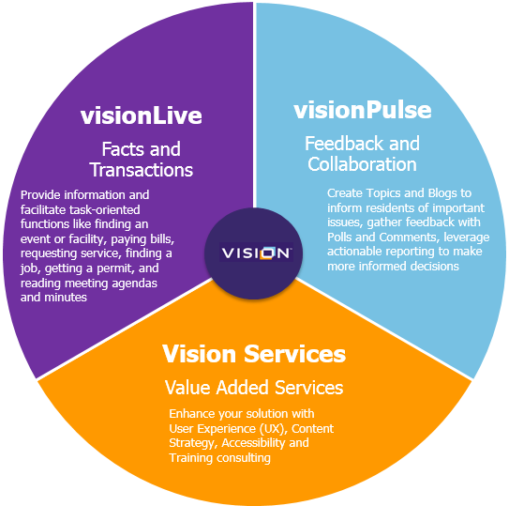

### What about archiving Topics and Comments in visionPulse?

Some states have strict archiving or transparency rules (specifically Washington and Florida) and it is important that visionPulse is in compliance.

To ensure compliance, visionPulse:

* Automatically archives published topic content to fulfill FOIA or other content requests
* Has the capability to export Topics, Poll results and Comments
* Includes exportable reports that can be included as part of meeting agendas

## Next Steps

### How are we going to launch to customers?

We are holding a preview webinar on Thursday, November 10th for customers only where we will officially announce and demo visionPulse, and provide information on the 60-day free trial program and how to purchase visionPulse.

### How are we launching internally?

The Products team will host internal training on November 3rd and 4th, and will hold an all-company Lunch and Learn on November 9th.

User guides, installation guides and a how-to video will also be created and shared on Insight.

### How do I get a preview of visionPulse for prospects and customers?

Currently, we have a clickable demo and script that can be delivered by any RSM. A live version of visionPulse on a Development server will not be available until early November. If a prospect requires a fuller demo before that time, contact Denise.

### Does visionPulse have any customers yet?

No, visionPulse is a brand new product offering.

The Products team will hold beta program featuring six customers and will work closely with them from November 21st through January 27th o make sure they are successful. We will also use these customers as our initial champions and will document their product use in case studies and webinars.

|  |  |  |
| --- | --- | --- |
| **Category** | **Product Review** | **Pricing** |
| Other existing customers  (about 270 customers) | We will offer a free 60-day trial for these customers to get a chance to review and test the product | $2,499 per year after the 60-day trial and |
| In-development and vLive update customers  (about 140 customers) | We will set up a demo environment for key users to review and test the product | $2,499 per year when their visionLive payments begin |
| Prospects | Sales will demo the solution | $3,500 per year when their visionLive payments begin |

### How does someone get started with visionPulse?

#### Existing customers

* Trial
  + **During webinar** - Customers who attend the November 10th webinar will be able to answer a poll question to initiate the 60-day trial process
  + **After webinar** - Customers may also contact [support@visioninternet.com](mailto:support@visioninternet.com) to initiate the trial any time before December 9th
  + Trial sign-ups submitted by Wednesday, November 16 will be installed and ready for use on Friday, November 18
  + Trial sign-ups submitted after Wednesday, November 16 will be processed and installed on a rolling basis every few days as requests are received
* Purchase
  + **Button** - There will be a button in the trial version of visionPulse that users can click, redirecting the user to a landing page where they can begin the formal sales process
  + **Online** - Alternatively, customers may go directly to [www.visioninternet.com/buypulse] to start the formal sales process
* Billing
  + The billing for visionPulse will start after the 60 day trial period and the details for the length of time will depend on their current contract terms

#### Existing customers currently in development

* Trial
  + **During webinar** - Customers who attend the November 10th webinar will be able to answer a poll question to sign up for trial access to a demo site
  + **After webinar** - Customers may also contact [support@visioninternet.com](mailto:support@visioninternet.com) to initiate the trial any time before December 9th
  + Trial sign-ups submitted by Wednesday, November 16 will be installed and ready for use on Friday, November 18
  + Trial sign-ups submitted after Wednesday, November 16 will be processed and installed on a rolling basis every few days as requests are received
* Purchase
  + **Button** - There will be a button in the trial version of visionPulse that users can click, redirecting the user to a landing page where they can begin the formal sales process
  + **Online** - Alternatively, customers may go directly to [www.visioninternet.com/buypulse] to start the formal sales process
* Billing
  + The billing for visionPulse will start when their visionLive payments begin

#### New prospects

* We should be including discussions of visionPulse in all new opportunities
* Adding visionPulse to deals provides us with a wider footprint and allow us to grow the size of our deals

### What sales resources for visionPulse are available?

* Internal Talking Points
* Clickable PowerPoint Demo and script
* One sheet marketing collateral
* Community engagement blog posts on Visioninternet.com
  + To build awareness and thought leadership
  + To share with customers and prospects

## Competition

### What are the leading civic engagement products?

The leading competing civic engagement products are:

* Granicus Speakup
* Peak Democracy
* EngagementHQ/Bang the Table

Our traditional local government CMS competitors (CivicPlus, CivicLive, Revize) do not have a civic engagement product, but:

* CivicPlus and CivicLive offer blogs that are not aggressively pushed or used
* CivicLive appears to have some forum and commenting functionality, but neither are featured prominently and we could not find any instances of it being used

### How do we stack up versus the key competitors?

|  | **vision** | **Granicus SpeakUp** | **Peak Democracy** | **Bang the Table** |
| --- | --- | --- | --- | --- |
| **Website** |  | <http://www.granicus.com/products/speakup/> | <http://www.peakdemocracy.co/> | <http://engagementhq.com/> |
| **Demo Site** |  | Not available | <http://www.peakdemocracy.com/portals/211/forum_home> | <http://demonstration.engagementhq.com/> |
| **Product** | visionPulse | SpeakUp | Peak Democracy | EngagementHQ |
| **Location** |  | Denver | San Francisco | Australia  Boulder, CO |
| **# of Employees**  **(from LinkedIn)** | 64 | 144 (total company) | 10 | 48 |
| **# of Customers** |  | 70 | 90 | 180-200  None in the US yet |
| **Cost** | $3,500 per year | $3,600 to $5,000 per year | $5,000 per year for cities < 25,000 in population  $7-$8,000 per year for mid-sized cities  $9-$10,800 for larger cities | $18,000 to $20,000 per year |
| **Focus** | visionLive CMS  visionPulse | One of 7 solution areas for company | Only product for company | Also have a citizen budgeting tool called budget allocator |
| **Integrated with CMS** | Yes | Not yet, will likely integrate with CivicaCMS in future | No | No |
| **Features** | Topics, Blogs, Comments, Polls | Discussions, Forums, Ideas, Surveys | Topics, Comments, Polls/Surveys | Discussion Forums - Surveys - Digital Mapping - Q&A - Public Submissions - Ideation - Stories - Guestbook - Blogs - Analytics & Reporting |
| **Strengths** | * Integrated with CMS and social media * Much lower price for more or same value * Includes tagging and blog functionality | * Part of larger company with a large installed base of other products * Large installed base of customers, plus captive audience of agencies using other Granicus products | * Large installed based * Have been in market for 9 years * Can have more than one poll/survey question on a topic | * Are thought leaders in the market and regularly publish blog posts and other material about civic engagement * They have more features in their product than other civic engagement tools * Who’s listening feature * Nice interface |
| **Weaknesses** | * **Survey** – not integrated, but can add from visionLive CMS * **Dashboard** – no integration with resident dashboard currently | * **Integration** – not integrated with CMS, admins have to learn and manage a different backend * **Surveys** – are not connected to a Discussion, but are separate * **Backend Console** – no backend console to respond to comments (admin has to register on frontend and comment like a resident would) * **Notifications** – no way to receive notifications when actions are taken on a topic. Makes management difficult. * **Topic owner** – it’s not possible to designate a topic owner * **Text-focused - f**ront–end UI makes it difficult to find topics of interest; may need to click many layers deep to find the interaction options * **Export capability** – is severely lacking, so reports are difficult to compile and put together * **Copy & Paste** – there’s a bug that converts content to Latin when copying and pasting * **Focus** – SpeakUp is one of 7 solutions for Granicus and it takes a back seat to flagship products | * **Integration** – not integrated with CMS, admins have to learn and manage a different backend * **Price** – nearly triple the cost to our existing customers * **Company size** - small company with only 1 product, so they don’t have many resources to enhance product or build market share * **Mobile**– iFrame on city websites are not responsive or mobile-friendly * **User comments** - Restricts users to only one comment per topic, restricting dialogue, questions, and clarification * **Backend** - Challenging backend UI – administrators forget where to start to create a topic, may have trouble navigating the system * **Editing** - Limited editing capabilities; once a topic is created, it is difficult to edit or update things like the category * **Frontend** - Text-focused front –end UI makes it difficult to find topics of interest * **Notifications** – no * **Export capability** – not sure | * **Integration** – not integrated with CMS, admins have to learn and manage a different backend * **Price** – nearly 6x the cost to our existing customers * **US customers** – the lack of customers in the US except for Aspen, CO |
| **Export options** | Yes | severely lacking, so reports are difficult to compile and put together | ? | ? |
| **Log in options** | Facebook, Google+, email | Facebook, email | Facebook, Google+, LinkedIn, email | Facebook, Twitter, email |
| **Social media integration** | Yes | No | Yes, but lacking in usability | Non |
| **Who’s Listening? feature** | Yes | No | No | Yes |
| **Outcome Status?** | Yes | No | Yes | Yes |
| **Mobile-friendly** | Yes | Yes | No, iFrames on city websites are not responsive | Yes |
| **Citizen Dashboard** | Not yet | Yes, shows Ideas, Votes and Comments from me | No |  |
| **Subscribe to Topics?** | Yes | No | Yes | Yes |

### What makes visionPulse differen**t?**

visionPulse includes several features that make it superior to other engagement tools on the market:

**Streamlined Administration:** Integration with visionLiveTM CMS and social media channels allows clients to update all systems with a single publish, making it simple to keep messaging clear and consistent.

* *This is important because other systems aren’t integrated with a content management system or social media channels – so editors have to log into multiple systems to make updates/changes. This has been cited as a key frustration by local government staff.*

**Guided Topic Creation:** Step-by-step cues guide editors through the process of creating a Topic, ensuring imagery, questions and polls are included to make the content compelling to residents.

* *This is important because other systems don’t provide prompts – and often the editors don’t know what questions to ask or what content to include. This kind of enablement is something that many clients asked for specifically.*

**Automated Monitoring:** Topics can be assigned to a designated staff member who will receive automatic notifications when residents add comments or submit a poll, simplifying the management of the engagement process.

* *This is important because the Granicus Speak Up platform specifically doesn’t allow staff to be assigned as owners of Topics – or to receive notifications when actions are taken on the Topic – so they have to constantly monitor the site for updates. It was cited by their clients as a major issue in the ability to maintain the platform.*

**Multi-Channel Promotion:** Integration with eNotification and social media allows Topics to be easily shared with residents, maximizing exposure and increasing the likelihood of more representative participation.

* *This is important because all other engagement platforms operate independently of the website and social media – so unless residents know exactly how to find the “engagement website”, they don’t see the issues that are open for discussion. This has led to low participation.*

**Contextual Linking:** Integration with visionLive CMS allows editors to tag Topics to associate them with specific departments, projects or themes, promoting issue visibility by displaying them alongside related content throughout the website.

* *This is important because it’s a feature ONLY Vision can offer right now because the Pulse engagement tool is integrated with our CMS. The ability to show related content throughout the website will allow more residents to see the Topics and participate.*

**Flexible Feedback Settings:** Poll and comment settings can be configured on a per-Topic basis, giving editors control over feedback mechanisms, such as allowing residents to submit multiple comments on a particular issue, up-voting and more.

* *This is important because other platforms have a single, system-wide setting to determine whether residents can submit multiple comments on issues. The flexibility will allow clients to customize the feedback on a per-issue basis.*

### Additional Competitive Comparisons

The key advantage of visionPulse is that it is integrated directly with the visionLive CMS.

This makes the resident experience better because:

* They don’t have to go to a separate website to see open topics or engage
* It will be easier to see the issues open for discussion as information can be published on different pages across the Vision website using widgets
* Their website account (holding their eNotification and other preferences) can be used for Pulse, too – so they don’t have to create separate log-ins/subscriptions

This will be advantageous to our clients because:

* They can update their engagement tool and website with a single publish, without having to log into multiple systems
* They can show content in context wherever they want to on their website to increase visibility and engagement
* They can share users, security roles, permissions and more with the visionLive CMS
* The conventions will be similar to visionLive CMS, so it will simplify training and enablement of staff
* They have one point of contact with a single vendor

In addition to the benefits outlined above, other advantages include:

* visionPulse generates nicely formatted reports that can be shared with council members or department heads. (We heard from clients that Granicus’s tool exports data, but it’s in an unusable format, so it takes a lot of staff time to build reports.)
* visionPulse automatically archives published topic content to fulfill FOIA or other content requests
* visionPulse is integrated with the website’s eNotification, which simplifies outreach
* visionPulse content can be published directly to social media and to email lists to drive awareness across the community
* visionPulse includes a variety of comment and poll settings to allow for specific types of interactions, increasing security or opening questions for broader reach and dialogue
* Daily digests of topic activity can be sent to specified distribution lists, such as council members or department heads

### Provo Utah Civic Engagement Evaluation

Provo, Utah went through a detailed evaluation of civic engagement products in October 2016. They had three companies on the shortlist and selected Peak Democracy for a one-year contract. Vision did not respond to the RFP which was issued in July 2016 as visionPulse was still on the drawing board.

Here is the summary of the analysis from the staff memorandum:

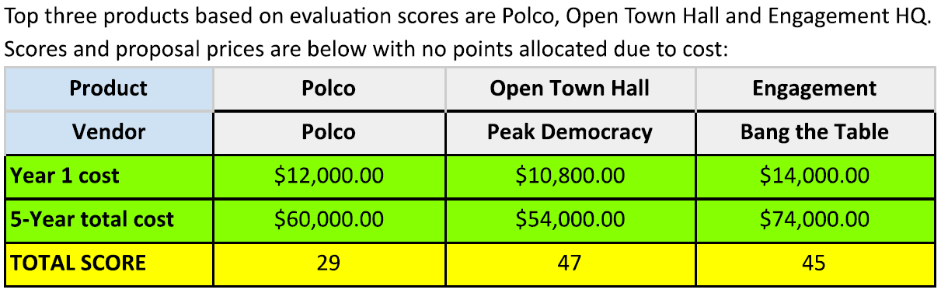

Here is the detailed summary of each competitor: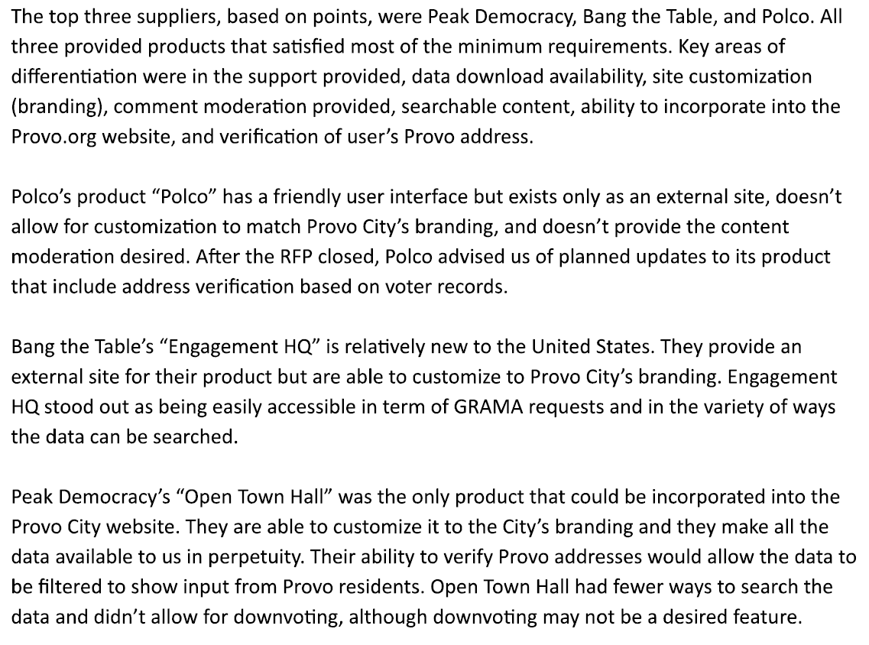

### What Vision customers are using a community engagement solution?

* Granicus
  + Eden Prairie, MN (City Connect - <https://eden-prairie.granicusideas.com/>)
  + Burbank, CA (<https://burbank.granicusideas.com/meetings>)
  + Bend, OR (<https://bend.granicusideas.com/> )
  + Hermosa Beach, CA (Speak Up, Hermosa <http://speakuphermosa.org/>)
    - News article on Speak Up - <http://tbrnews.com/news/hermosa_beach/hermosa-beach-calls-on-residents-to-speak-up-through-web/article_f954dbfa-9db6-11e4-b750-375b3c131f07.html>
* Peak Democracy
  + Manhattan Beach, CA (Open City Hall - <http://www.citymb.info/city-services/open-city-hall>)
  + Tempe, AZ (Tempe Forum - <http://www.tempe.gov/tempe-forum>)
  + Santa Clara, CA (<http://santaclaraca.gov/government/open-city-hall>)
  + Palm Desert, CA (<http://www.cityofpalmdesert.org/our-city/open-city-hall> )
  + Loveland, CO (<http://www.cityofloveland.org/services/open-city-hall> )

### What other cities are doing a good job with other community engagement?

#### Granicus/Speakup Customers

* Austin, TX - <http://speakupaustin.org/>
* Edina, MN - <http://speakupedina.org/>
* Oakland, CA - <https://oakland.granicusideas.com/>
* Colorado Springs, CO - <https://coloradosprings.granicusideas.com/>

#### Peak Democracy Customers

* Palo Alto, CA - <http://www.peakdemocracy.com/portals/5/forum_home?a=77>
* Salt Lake City, UT - <http://www.slcgov.com/opencityhall>
* Saint Paul, MN - <https://www.peakdemocracy.com/portals/113/forum_home>

#### EngagementHQ

* Aspen Colorado – <http://www.aspencommunityvoice.com/>
* Sydney - <http://sydneyyoursay.com.au/>
* Hawkesbury - <http://yourhawkesbury-yoursay.com.au/-services>
* Blue Mountain - <http://bluemountainshaveyoursay.com.au/>

## Community Engagement – Background Research

### How many agencies are currently using a community engagement platform?

Overall, the penetration in the market for a civic engagement tool is not very deep. We estimate that about 160 agencies are using either of the primary competitor products. When we looked at our customer base, we estimate that about 24 customers are using a civic engagement tool (11 SpeakUp and 13 Peak Democracy) – or less than 10% of our visionLive installed base.

Here is a chart that looks at penetration across our major CMS competitors:

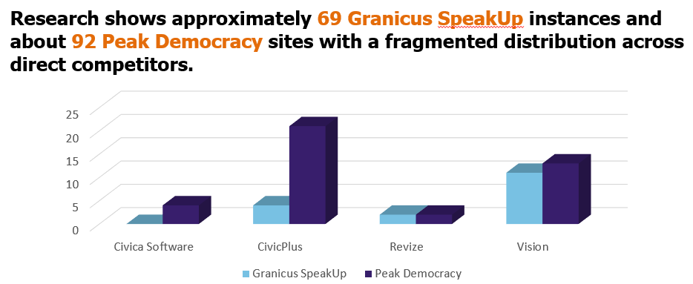

This means that civic engagement is a green field of opportunity. While we may take away business from existing competitors, we are essentially selling visionPulse to customers who are not currently using an engagement too.

### What are our customers saying about civic engagement?

The Products team conducted a customer survey in August and uncovered the following information:

#### For those that had already purchased one, what were the top reasons for buying a civic engagement tool?

This question was answered by agencies currently that have already purchased a civic engagement product:

* Dialogue – 35%
* Awareness – 16%
* Community feedback – 14%
* Transparency – 6%

#### What improvements compared to other competitive products would you like to see in a civic engagement tool?

* Ease of use
* Integrated system
* Get higher usage

#### What are the objections to buying a civic engagement product?

Some organizations have looked into civic engagement and either didn’t buy or stopped using the product:

* No or low budget – 32%
* Staffing concerns – 21%
* Low budget – 11%
* Low response rate – 11%
* Currently evaluating – 8%