Hi Jeanne –

I hope you are doing well, I got my revisions back today and I would love to share them with you, btw, I’m trying an awesome app that makes the design process so much fun and organized that I would like you to try it if possible, the only requirement is for you to have a modern browser (IE10, IE11, latest Firefox or Chrome) I am hoping we can use this tool so please let me know, otherwise I will just send you emails with the different revisions.

Hopefully these designs are close to your vision and you would like one more than the rest so that we can take that design as a base and build on it.

If you meet the browser requirements, then please visit this URL:

<http://invis.io/P6P7EB2A>

password: PK14

**Then browse through the 5 variations that we put together for you, one of the coolest features is while on a screen, you can activate the comments option:**



**Then you can click anywhere on the screen to leave a comment:**

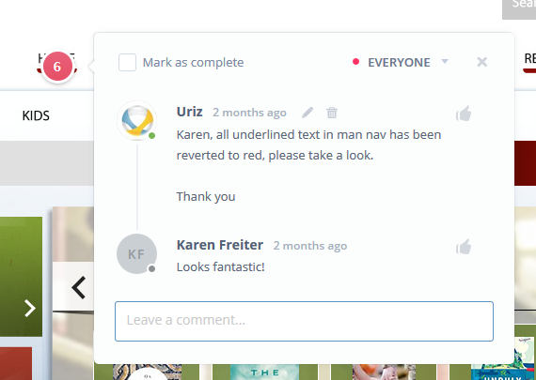

When you click on “Post Comment” you create a new threaded conversation and the application will send an email with the comment and the point that you exactly commented on – it’s is really cool!

**Activities:**

1. Choose one design concept that is closer to your Vision
2. Make your comments on the design
3. Send me a confirmation email as soon as you are ready commenting on the design so I can task out the revisions
4. We will iterate that design until everybody is satisfied

Please let me know if you have any questions – I am looking forward to hearing your thoughts!