Contents

Vendor Overview 3

Vendor Pricing Overview 4

Preliminary Thoughts 5

GovOffice 6

GovOffice - Overview 6

GovOffice Value Proposition 6

GovOffice – Illustrative Customers 7

GovOffice Example Project Quote – June 2016 8

GovOffice Premium Design 9

GovOffice Price Matrix 10

GovOffice CMS Analysis from Middlebury, Vermont – June 2016 11

GovOffice Services 12

eGov Strategies 13

eGov Pricing 13

QScend 14

Qscend Overview 14

Municode/Aha Consulting 15

Municode/Aha Consulting Overview 15

Revize 16

WebGen 16

Revize Value Proposition 16

Revize Quote for Kronenwetter, WI – Population 7,400 – Feb 2016 17

Revize Quote for Curry County, Oregon – Population 22,000 – August 2016 18

Revize Quote for Merrimac, MA – population 6,400 19

Revize Quote for Wilmar, MN – Population 20,000 – Sep 2015 20

Revize Pricing for Town of Middlebury, VT – June 2016 21

MunicipalCMS 22

Pricing Plans 22

Pricing for Greenwood, MO – Population 5,400 – April 2016 22

EvoGov 23

EvoGov CMS 23

EvoGov Pricing 24

EvoGov Themes 26

CivicPlus 27

CivicPlus Example Pricing – July 2015 – Population 8,600 27

CivicPlus Pricing – Goddard, KS – Population – 4,500 – May 2016 28

CivicPlus – Pacific WA - Population 7,000 – May 2016 29

CivicPlus CP Lite – January 2013 – Population 5,500 30

CivicPlus Georgetown KY Pricing – Population 30,000 - March 2016 31

## Vendor Overview

Here is a summary of vendors and the number of customers they have in the under 15,000 population segment of the market. The population was further broken into three different bands.

This information was derived from Yuliang’s spreadsheet and summarized with a pivot table.

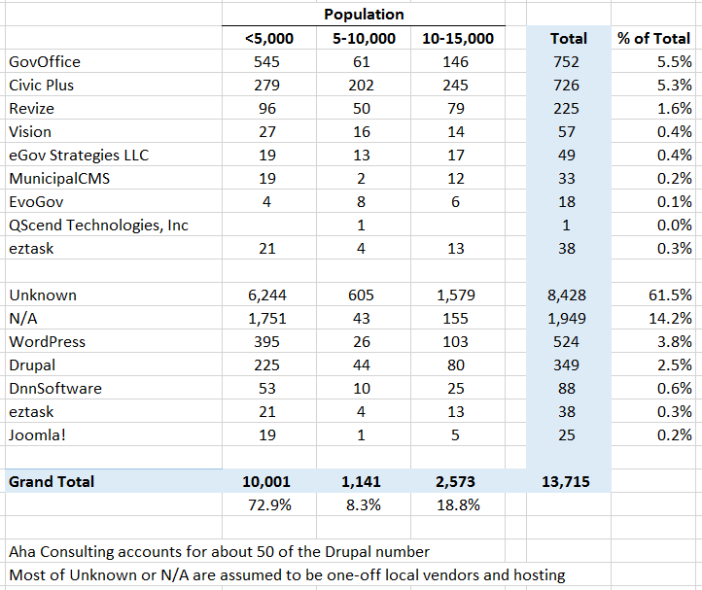

## Vendor Pricing Overview

Here is a summary of recent vendor pricing:

|  |  |  |
| --- | --- | --- |
| **CivicPlus** | Upfront Annual | $9,000 - $9,990 $2,000 - $4,000 |
| **Revize** | Upfront Annual | $3,500 - $9,000 $1,500 - $2,700 |
| **GovOffice** | Upfront Annual | $0 - $9,000 $1,500 - $2,000 |
| **eGov Strategies** | Upfront Annual | $11,758 $1,800 |
| **Municipal CMS** | Upfront Annual | $4,900 - $12,895 $2,400 |
| **EvoGov** | Upfront Annual | < 10k Pop - $8,850 $1,500 - $2,000 |
| **Municode/Aha** | Upfront Annual | Didn't find any pricing in this population range |

## Preliminary Thoughts

Vendors to take advantage of:

* GovOffice
  + With 752 customers, they have the most customers in this category
  + Their designs are dated and most sites have not been updated for a while
  + Their CMS is also older and limited in what users can do
  + Their parent company is involved in other verticals, so government is not the only focus
* Revize
  + They have the 2nd most customers in this category with 225
  + Their designs are not very good, but their CMS has received good reviews
  + Company is small and seems to have only 1 or 2 on the business dev/marketing team

Vendors to watch:

* EvoGov
  + EvoGOv is the most aggressive on pricing and has promised to beat any competitor price by 20%
  + Their CMS is newest and built from the ground up in 2015
  + Their design templates are the freshest and they even include a parallax/anchor scrolling option
  + But they are relatively small, don’t appear to have deep resources and based on typos on their website, are not paying attention to details
* CivicPlus
  + Their pricing has been aggressive even in agencies with populations from 15,000 to 50,000
  + For Georgetown, KY (population 30,000), their upfront cost was $9,000 with $4,100 annual cost

Our offering should consider:

* Simple, straightforward proposal and pricing (CivicPlus CORE proposal is 10 pages)
* Clear options for upgrading to a premium or custom design as some agencies are willing and have the resources to spend more money
* Option to spread upfront costs over term of contract
* Unlimited or very large storage as default (some vendors limit to 1 G which is petty)
* Ability to develop and deliver website in 2-3 months

## GovOffice

### GovOffice - Overview

Website - <http://govoffice.com/>

### GovOffice Value Proposition

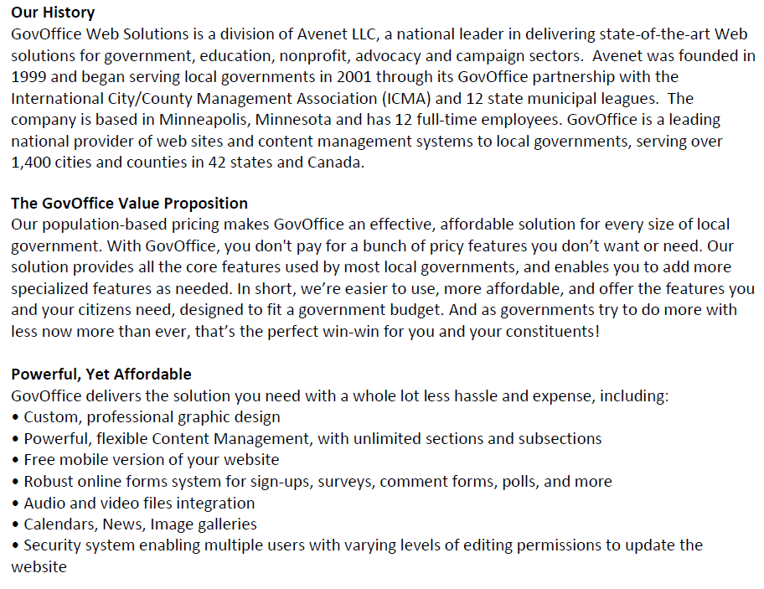

### GovOffice – Illustrative Customers

Claim 1,400 local government websites

Screenshots of [featured sites](http://govoffice.com/index.asp?SEC=A175C416-5B3E-4666-94F0-98EE47A40E4D&Type=B_BASIC)

Tagline - “powered by GovOffice.com”

Really small customers don’t even have own URL, but use one of the following URL structures:

* [www.cityst.govoffice2.com](http://www.cityst.govoffice2.com)
* [www.cityst.govoffice3.com](http://www.cityst.govoffice3.com)

Majority of customers are in Minnesota, Wisconsin, Iowa, North Carolina and South Dakota

Population range is normally between 1,000 and 10,000, but they have served larger customers (Benecia, CA, Summerville, SC and Pennington County, SD)

|  |  |  |
| --- | --- | --- |
| **Agency** | **URL** | **Population** |
| Benicia, CA | http://www.ci.benicia.ca.us/ | 33,000 |
| Buckley, WA | http://www.cityofbuckley.com/ | 4,300 |
| Cape Canaveral, FL | http://www.cityofcapecanaveral.org/ | 10,000 |
| Summerville, SC | <http://www.summervillesc.gov/> | 46,000 |
| Petersburg, AK | <http://www.ci.petersburg.ak.us/> | 3,000 |
| North Oaks, MN | http://www.cityofnorthoaks.com/ | 4,600 |
| Turtle Lake, WI | http://www.turtlelakewi.com/ | 1,042 |
| Canyon Lake, CA | http://www.cityofcanyonlake.org/ | 11,000 |
| Red Springs, NC | http://www.redsprings.org/ | 3,500 |
| Stillwater, MN | http://www.ci.stillwater.mn.us/ | 19,000 |
| Pennington County, SD | <http://www.pennco.org/> | 105,000 |
| Pickens, SC | http://www.cityofpickens.com/ | 3,200 |
| Belle Fourche, SD | http://www.bellefourche.org/ | 5,700 |
| Perham, MN | http://www.ci.perham.mn.us/ | 3,100 |
| Storm Water Assoc. of NC |  |  |
| Wanaque, NJ | http://www.wanaqueborough.com/ | 11,200 |
| Western Springs Park Dist. |  |  |
| Brunswick, MD | http://brunswickmd.gov/ | 6,100 |
| Mauston, WI | http://www.mauston.com/ | 4,500 |
| Luverne, MN | http://www.cityofluverne.org/ | 4,700 |
| Rockaway Beach, OR | http://rockawaybeachor.us/ | 1,300 |
| Fergus Falls, MN | http://www.ci.fergus-falls.mn.us/ | 13,138 |
| Chisago City, MN | [www.ci.chisago.mn.us/](http://www.ci.chisago.mn.us/) | 5,000 |
| Shellsburg, IA | [www.shellsburg.com/](http://www.shellsburg.com/) | 1,000 |
| Chisolm, MN | [www.ci.chisholm.mn.us/](http://www.ci.chisholm.mn.us/) | 5,000 |
| Sleepy Eye, MN | [www.sleepyeye-mn.com/](http://www.sleepyeye-mn.com/) | 3,500 |
| Bellevue, ID | [www.bellevueidaho.us/](http://www.bellevueidaho.us/) | 2,300 |
| Keystone, SD | [www.keystonesd.govoffice3.com/](http://www.keystonesd.govoffice3.com/) | 350 |
| Fairfax, MN | [www.cityoffairfax-mn.gov/](http://www.cityoffairfax-mn.gov/) | 1,100 |
| Pagosa Springs, CO | <http://www.pagosasprings.co.gov/> | 1,700 |

### GovOffice Example Project Quote – June 2016

* Pay first year of upfront
* Option to spread payments over 3 annual payments

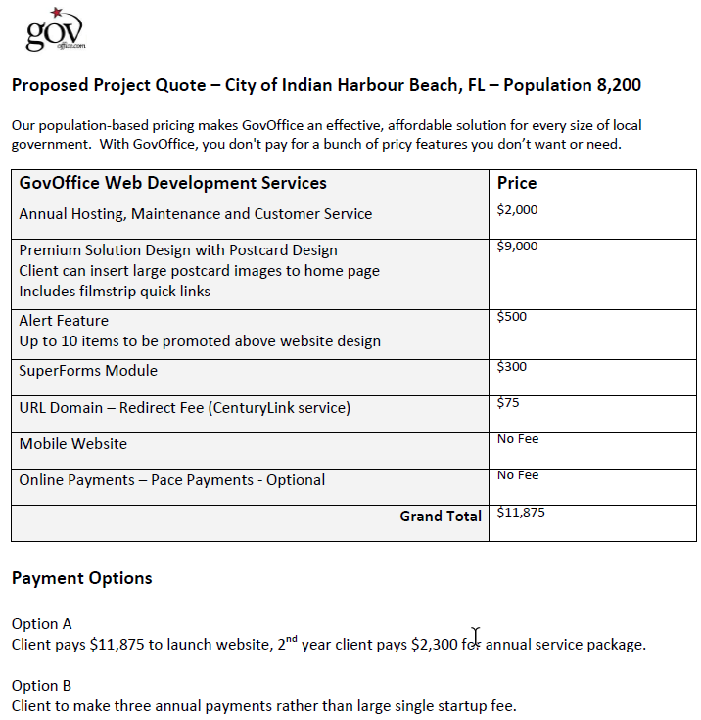

### GovOffice Premium Design

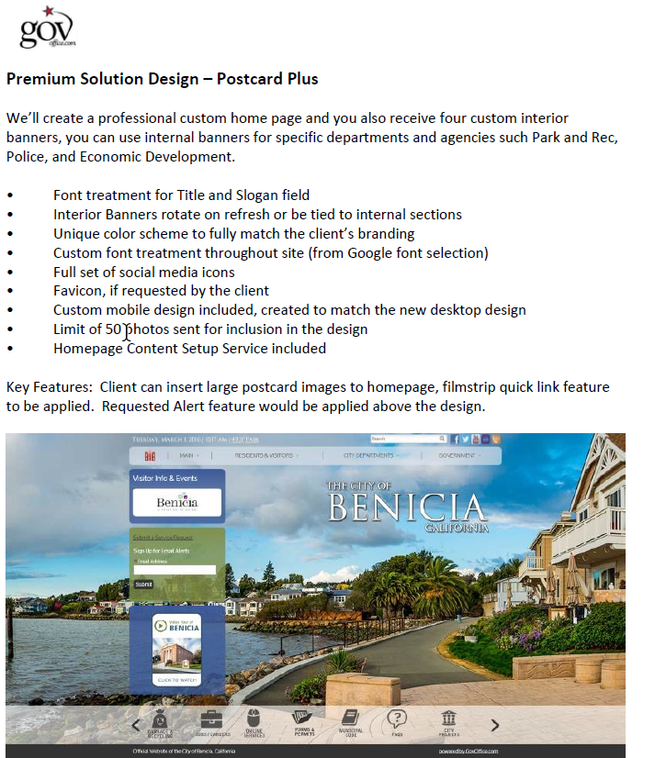

### GovOffice Price Matrix

More details at <http://govoffice.com/vertical/sites/%7BBCFB22A6-B1E9-45C1-9BFA-9877FF56B4EC%7D/uploads/GO_Custom_Design_Services(1).pdf>

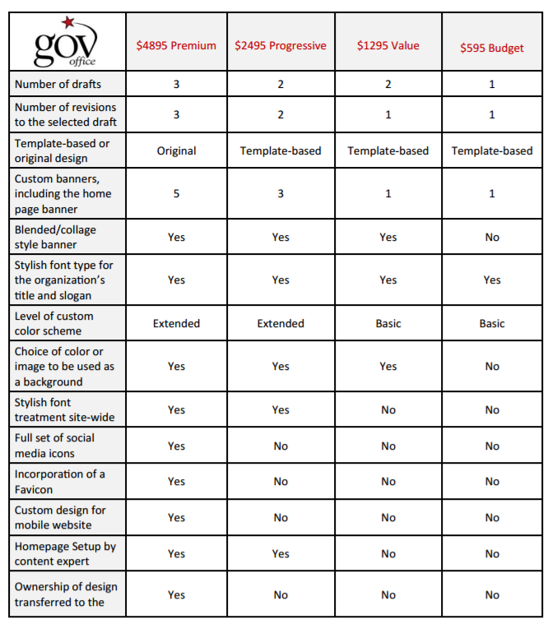

### GovOffice CMS Analysis from Middlebury, Vermont – June 2016

<http://www.townofmiddlebury.org/>

Town choose to go with Revize instead of staying with GovOffice

Highlights:

* CMS is outdated and rigid
* Limited options for configuring and displaying on-screen content
* Usability hampered by website’s cumbersome navigation scheme
* Static main page design severely constrains ability to reconfigure content to reflect changing priorities

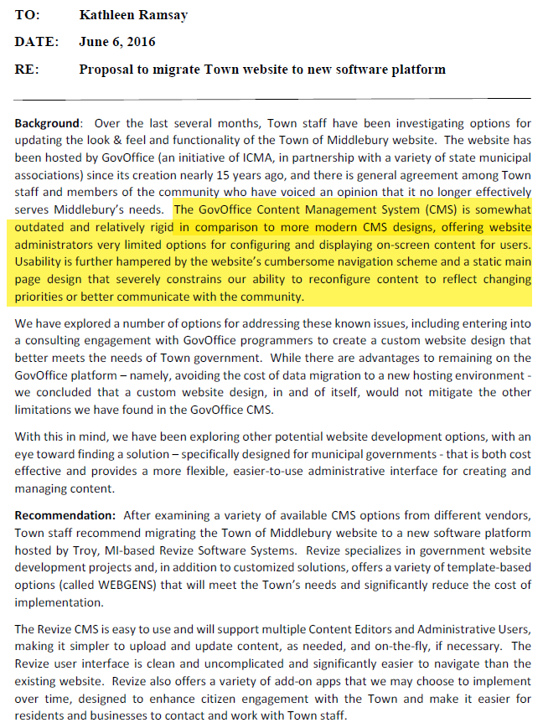

### GovOffice Services

* Custom Designs - GovOffice will present an array of solutions sure to satisfy your design goals and budget
* Content – Homepage Makeover, Navigation Architecture, Writing & Content Creation, Content Transfer
* ePayment (powered by PACE)
* Webmaster Service
* SuperForms – Interactive Online Forms
* Video On Demand
* Customized Mobile Design
* Social Media Launch Service – create Facebook and Twitter pages and add links on website
* Email Service – hosted email service

More info at <http://govoffice.com/services>

## eGov Strategies

Website - <http://www.egovstrategies.com/department/division.php?structureid=18>

Location – Indianapolis, IN

### eGov Pricing

[Princeton, Indiana article](http://www.pdclarion.com/news/city-goes-with-egov-for-website-overhaul/article_830dabd4-a5c0-11e6-b1a9-033d55f47556.html) – town of 8,600

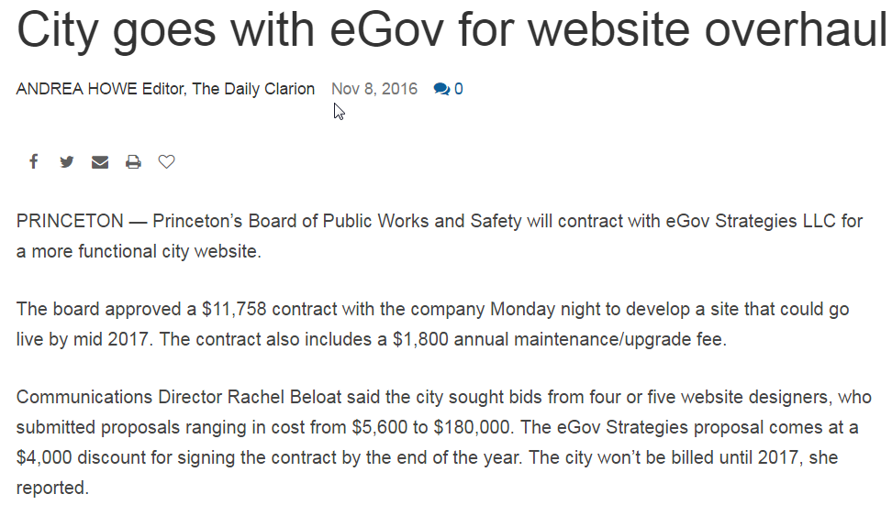

## QScend

### Qscend Overview

Waterbury, CT

Website - <https://www.qscend.com/>

LinkedIn - <https://www.linkedin.com/company/267147>

* 18 Employees
* QScend Technologies, Inc. is an industry leader in Web-based software solutions and services for municipalities. More than 200 municipalities and more than 10,000 users across the country access the company’s series of “Q” products for a variety of citizen service related functions, including website content management, citizen service request management, and 311 call center functionality.

Tagline in website footer - Powered by QScend Technologies, Inc

Demo site - <http://anytown.qscend.com/>

|  |  |  |
| --- | --- | --- |
| **Agency** | **URL** | **Population** |
| La Crosse, WI | <https://www.cityoflacrosse.org/> | 52,000 |
| Keyport, NJ | <http://www.keyportonline.com/> | 7,200 |
| Hackensack, NJ | <http://www.hackensack.org/> | 44,000 |
| Lacy Township, NJ | <http://www.laceytownship.org/> | 25,000 |
| Darien, CT | <http://www.darienct.gov/> | 21,000 |
| Hamilton Township, NJ | <http://www.hamiltonnj.com/> | 88,000 |
| Montgomery County, VA | <http://www.montva.com/> | 96,000 |
| Old Bridge Township, NJ | <http://www.oldbridge.com/> | 66,000 |
| Avalon, CA | <http://www.cityofavalon.com/> | 4,000 |
| Englewood, NJ | http://cityofenglewood.org/ | 27,000 |
| North Hempstead, NY | <http://www.northhempsteadny.gov/> | 226,000 |
| Aberdeen, NJ | http://www.aberdeennj.org/ | 18,000 |
| Danbury, CT | <http://www.ci.danbury.ct.us/> | 83,000 |
| New London, CT | <http://www.ci.new-london.ct.us/> | 28,000 |
| Fairfield, CT | <http://www.fairfieldct.org/> | 61,000 |
| Tinton Falls, NJ | <http://www.tintonfalls.com/> | 18,000 |
| Agawan, MA | <http://agawam.ma.us/> | 28,000 |

## Municode/Aha Consulting

### Municode/Aha Consulting Overview

Municode (<https://www.municode.com/>)

Aha Consulting (<http://www.ahaconsulting.com/>)

Municode acquired Aha Consulting in April 2016

<https://www.municode.com/blog/municode-acquires-industry-leading-government-website-designer-aha-consulting/>

Municode is still a rather small company with only 29 employees listed on their LinkedIn Company Page, but they claim to work with over 4,100 municipal customers and now have offerings in:

* Government websites
* Codification services – legal publishing
* Electronic payments – end-to-end billing
* Electronic records – largest Laserfice reseller

Aha! Consulting lists 16 employees on LinkedIn – and here is their short summary, “Aha Consulting is a market leading consultancy providing Drupal-based web content management solutions for large organizations.”

Municode customers

* Fruita, CO
* McMinnville, OR
* Kodiak, AL
* Miami Springs, FL
* Lowell MA Retirement
* Chehalem, OR Parks & Recreation District
* Woodstock, IL
* Clatsop County, OR
* Sherwood, OR

Aha website have this tagline – “[Site Design by Aha Consulting](http://www.ahaconsulting.com/)”

* McMinnville, OR - <http://www.mcminnvilleoregon.gov/> - and it looks pretty good (population 33,000)
* Fruita, CO - <http://www.fruita.org/> (population 13,000)

## Revize

### WebGen

<http://www.revize.com/revize_webgen/index.html>

As a result of years of close collaboration with clients in these markets, Revize has created Revize® WebGen (Web Site Generator) a turnkey, corporate-class Web Site solution that is integrated "out-of-the-box" with the powerful Revize® CMS Web Content Management System.

Revize developed Revize® WebGen using state-of-the-art web site and web page design concepts.  This solution reflects efficient, flexible organization of information and uses very effective presentation techniques including adherence to Section 508 Compliance standards.

### Revize Value Proposition

From their proposal:

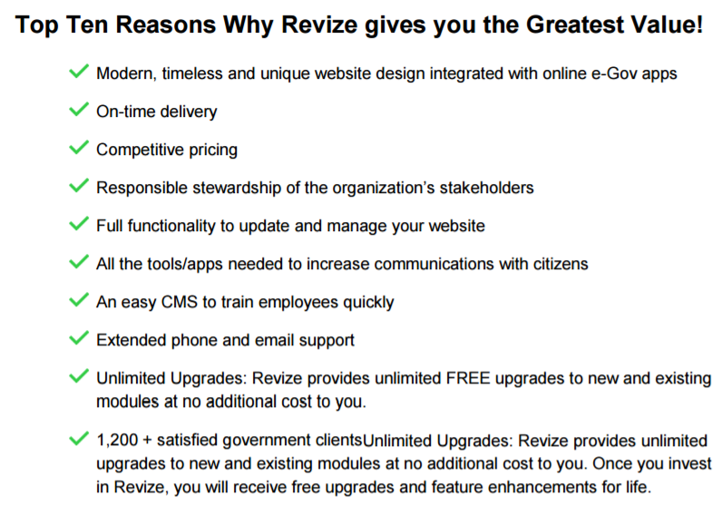

### Revize Quote for Kronenwetter, WI – Population 7,400 – Feb 2016

This is the internal report recommending Revize over CivicPlus and GovOffice. Entire package with proposals from all vendors is available at <http://www.kronenwetter.org/wp-content/uploads/2016/02/2016-02-09_VB-Packet.pdf>

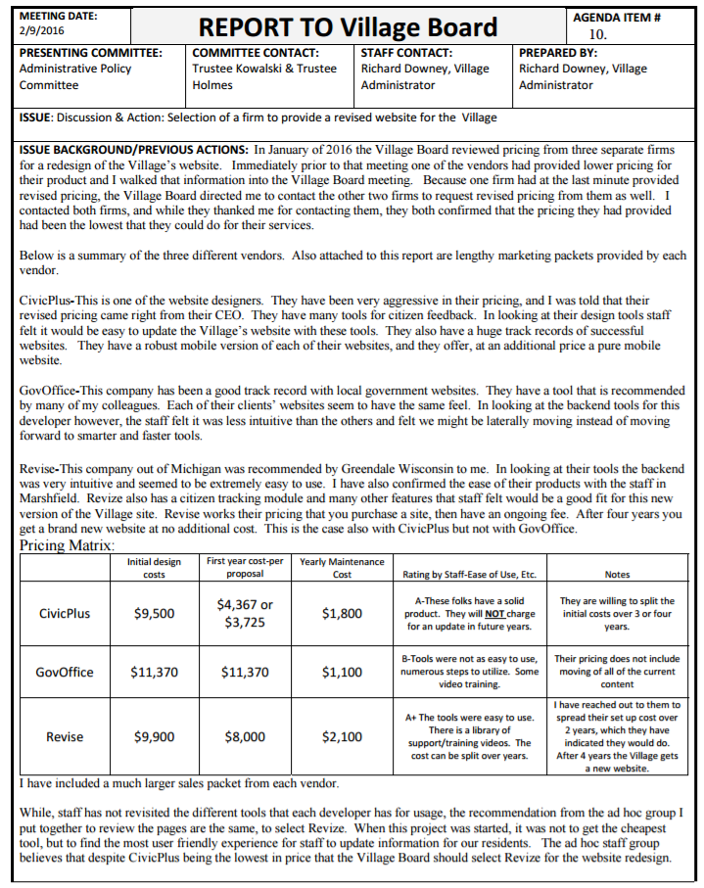

### Revize Quote for Curry County, Oregon – Population 22,000 – August 2016

Population – 22,000

Dated August 2016

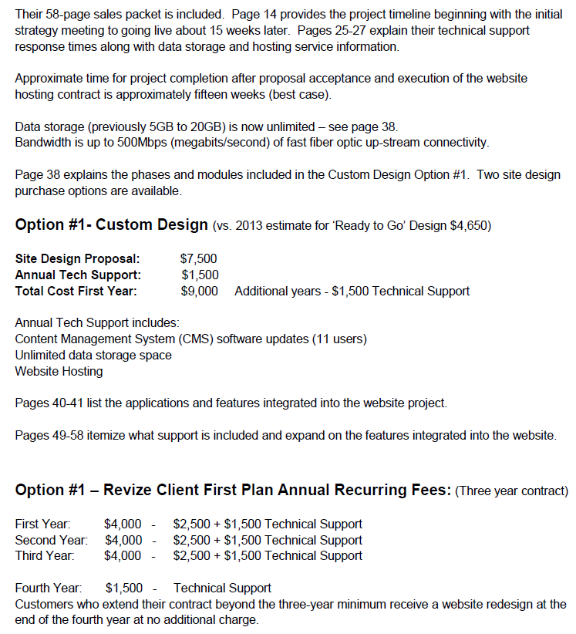

### Revize Quote for Merrimac, MA – population 6,400

Despite a low quote from Revize, they choose to go with CivicPlus. This quote with a special new client discount effectively refunded the upfront costs.

<http://www.merrimac01860.info/>

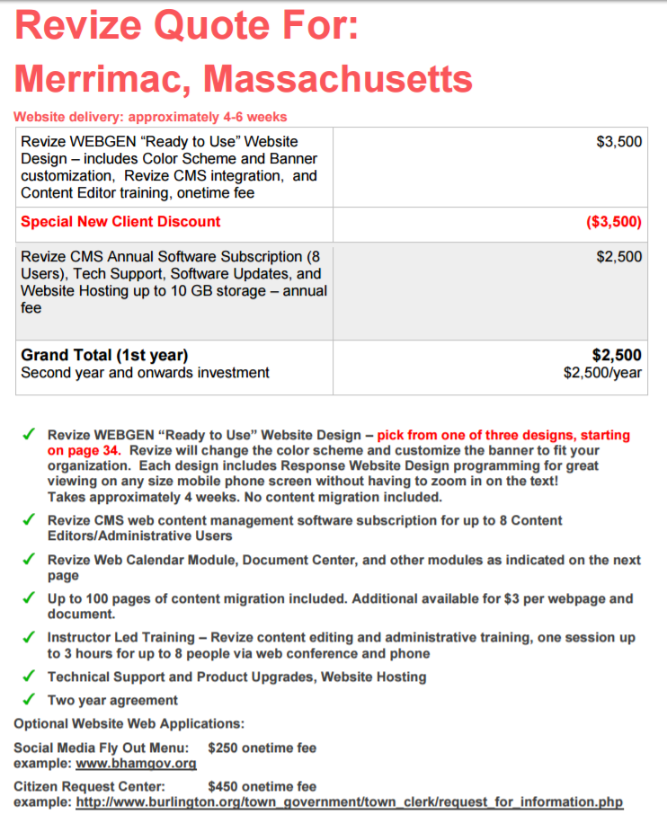

### Revize Quote for Wilmar, MN – Population 20,000 – Sep 2015

Revize beat out GovOffice on this quote. This is interesting in that they built in a fee of $7,900 for 5 years of annual fees ($1,580 per year).

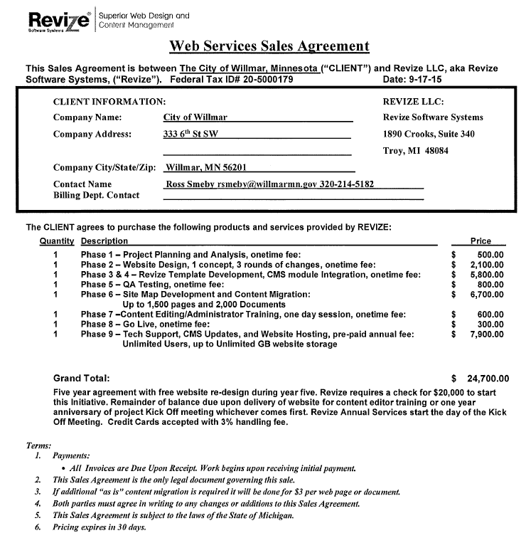

### Revize Pricing for Town of Middlebury, VT – June 2016

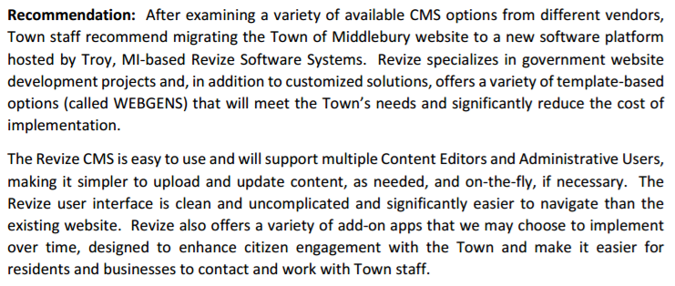

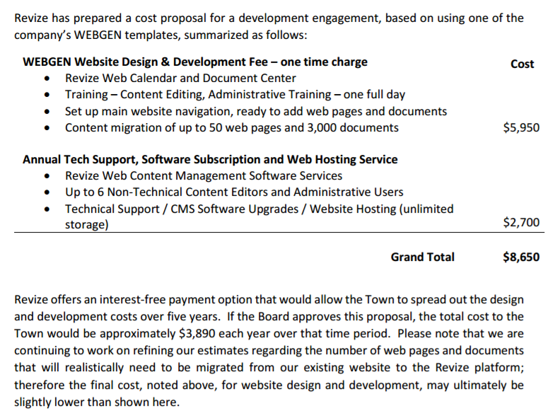

## MunicipalCMS

Website - <http://www.municipalcms.com/>

* Uniquely Yours
* Easy to Update
* Built to Last
* Free Design Refresher

### Pricing Plans

<http://www.municipalcms.com/pview.aspx?id=1466&catid=25>

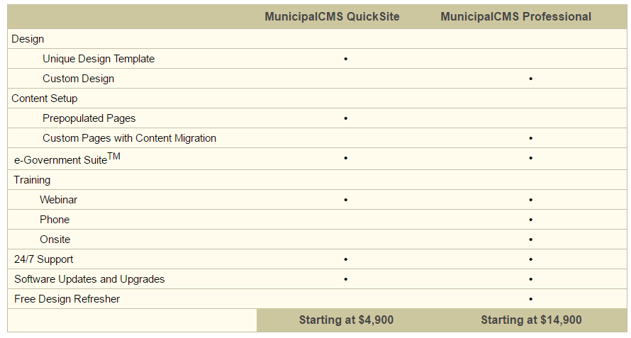

### Pricing for Greenwood, MO – Population 5,400 – April 2016

<http://www.greenwoodmo.com/files/documents/042616agenda-min76.pdf>

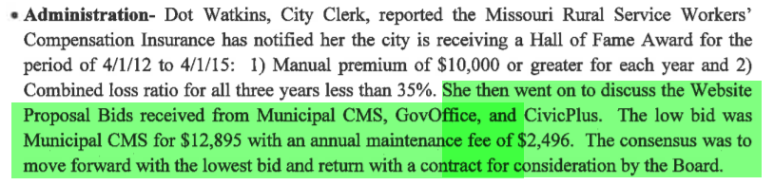

## EvoGov

### EvoGov CMS

2015 - Our New CMS Platform is Launched

In March of 2015 we launched our new CMS platform and we moved its development from Heroku to Amazon AWS. Since then, we have added many applications and features to this system that we include at no extra charge. Our new EvoGov.com website is build on this new platform. We are opening our source code and utilizing open datasets (like open311.org) for our data. Our competition will not open their code and be this transparent . The features of this new platform alone are winning us more projects than ever. You can't choose a municipal web design company without seeing the applications behind them.

EvoCMS - all new drag-and-drop CMS that is built on Python, and has many client-side technologies (using Angular.JS). See our technology page for more information on the techncial details.

Complete Code Access - with our CMS, you can manage your page templates, layouts, themes, tokens, widgets, and scripts directly from our CMS. You don't need to be held hostage by your CMS any longer when you want to make design changes. Our competition cannot offer you this.

EvoBids - a new completely web-based bid management system.

Evo311 - a new request tracking system that combines web, mobile, social, and mapping technologies to deliver a next-generation citizen service system.

Intranet System

2016 and Beyond

Today, EvoGov serves many municipalalities, special districts, utilities and associations from across North America and is growing. We intend to expand into more services areas, and build solutions for more customers in Canada. We are always interested and open to industry partherships, talented staff additions, and business development opportunities.

### EvoGov Pricing

**Price Beat Promise**

We feel that our services and software do not have to be sold on price, and we are happy to compete head-to-head with any other provider.

However, we will also don't want to lose on price alone to a municipal website provider.   
So, here is our guarantee to you - we guarantee that we will beat ANY proposal from CivicPlus by at least 20% .

This includes multi-year proposals, and proposals that include redesigns after multiple years of hosting.

In addition to beating CivicPlus on development costs, we will also beat them by at least 20% (sometimes MUCH more) on service fees.

**These discounts also apply to the following providers; Vision Internet, Revize, and CivicLive.**

Note: Once a project is awarded to us, it will not have it's price reduced to match another vendor's quote.

**Annual Hosting Discount**

Since the beginning, we have offered twelve months of service for the price of ten if you pre-pay for you service fee annually.

**Small City Plan (new for 2016)**

Available for cities under 10,000 citizens, and under 100 employees only.   
Development fee under $10,000.

Monthly fee of $150 (or $1500 annually) includes hosting, live support, and application updates.

Free design refresh after two years with two year hosting commitment.

**Turn-Key Sites for Tiny Cities (new for 2016)**

We have always prided our company on designing custom websites and not going the cookie cutter template route like most companies.

However, with our new cloud platform, we can now offer mobile-ready turn-key websites that are terrific in a fraction of the time that it used to take to build them.

For these entities, a traditional custom website design project with a very formal process might be overkill and out of reach of their budget.

We have had many smaller cities call us and tell us that they WANT a turn-key site using best practices if it can keep them within their budget.    
So now we offer it.

We have created a bunch of great mobile-first design layouts using best practices that we can launch in 30 seconds on the cloud. Really.

So no matter what your size is, what your budget is, we can help you.

Some restrictions apply, so contact us for more information.

**VIP Promotion**

Existing customers of EvoGov that wish to upgrade their websites can save as much 50% or more. 

### EvoGov Themes

Bootstrap Website Themes for Use with Evo.cloud - <https://www.evo.cloud/themes>

We created these themes because there are limited resources online for finding quality Bootstrap themes that have best practices built into them.

Custom-designed websites can start out using a grid framework to layout website design elements more quickly, which saves time and money for everyone.

The current trend towards photo-rich design requires you to focus more on your photography, color schemes, content, and branding than ever before.

The days of creating graphics out of thin air in Photoshop for months on end is over. You need to build websites quickly that look amazing, and that have an amazing platform behind them. EvoCloud IS that platform. All design themes are mobile-ready. Projects that we build don't have to use one of these themes at all, as we also do custom work. However, a lot of time can be saved using a proven design with custom graphics, content, and branding. We also want to see what themes our EvoCloud users come up with.

## CivicPlus

### CivicPlus Example Pricing – July 2015 – Population 8,600

Clarendon Hills, IL – Population 8,600

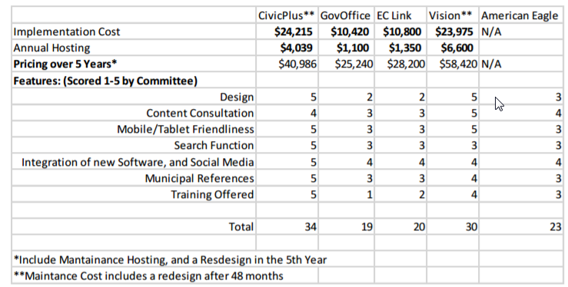

### CivicPlus Pricing – Goddard, KS – Population – 4,500 – May 2016

Excerpt from Council minutes:

CivicPlus of Manhattan, Kansas submitted the most capable, cost competitive proposal of the three vendors, particularly due to their up-front cost structure and strong municipal work history. CivicPlus offers two distinct packages: Premium and Core. The Premium package provides the City with greater design flexibility and essentially allows the City to redesign the new website from scratch with the assistance of an assigned art director. The one-time development cost for the Premium package is $13,992. The Core package allows the City to choose from several different pre-created template options and is priced as a one-time development fee of $8,992. Both options have an annual hosting and service fee of $1,985.

### CivicPlus – Pacific WA - Population 7,000 – May 2016

From May 2016

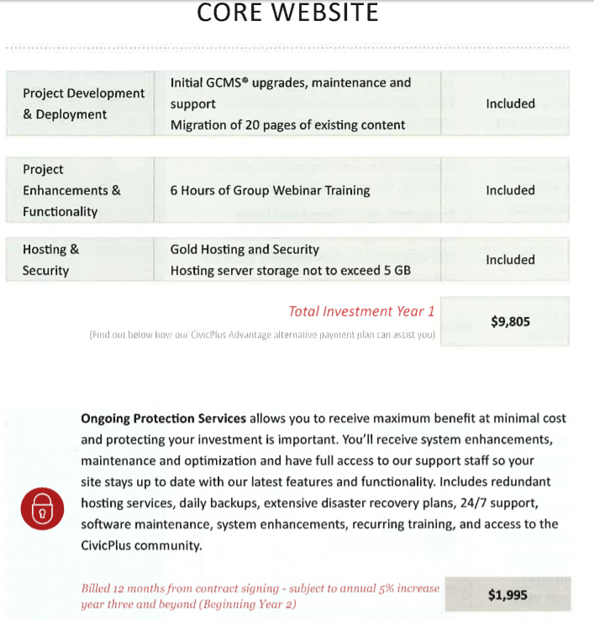

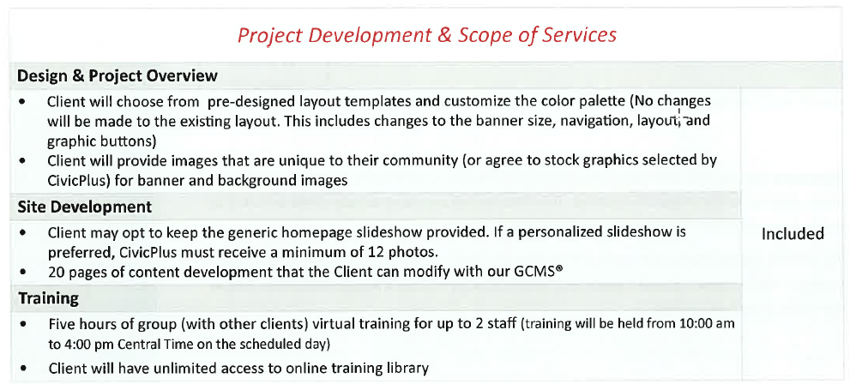

### CivicPlus CP Lite – January 2013 – Population 5,500

Monticello, IL – Population 5,500

Contract from January 2013

CivicPlus used to call their low cost offering, CP Lite, but this term is no longer used.

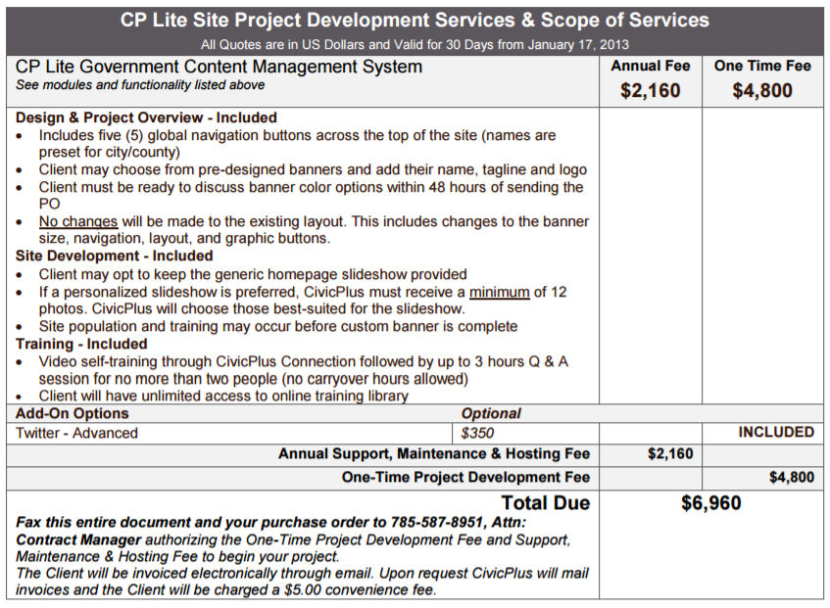

### CivicPlus Georgetown KY Pricing – Population 30,000 - March 2016

Population - 30,000

<http://www.georgetownky.gov/Assets/Files/Agenda%203-28-16.pdf>

* 1st year - $9,500
* Annual - $4,100
* 2 month implementation timeframe
* 3 days virtual training

