Contents

What is visionSocial? 2

Getting Started with visionSocial 4

Add Social Media Account 5

Facebook 6

Twitter 7

View Social Media Accounts 8

Token Renewal 8

Edit Account 9

Delete Account 9

Add a Social Media Post - Facebook 10

Add a custom message 12

Add a URL and Shrink it 12

Customize Post 13

Image Sizing for Facebook 14

Add Additional Posts for this Account 14

Post Now, Post Later or Make Recurring 15

Save and Publish 16

Examples of Facebook Social Media Posts 17

Add a Social Media Post – Twitter 22

News Item 22

Calendar Event 24

Add Additional Posts for this Account 25

Post Now, Post Later or Make Recurring 25

Save and Publish 26

Reviewing Social Media Posts 27

List View of Social Media Posts 27

Calendar View of Social Media Posts 28

Delete or Post Now Selected 29

Social Media Post Quick Add 30

Export Social Media Posts 32

Social Media Variables 33

System Variables 33

Content Roles 34

Security Roles 35

## What is visionSocial?

visionSocial is a new feature to visionCMS that allows users to post to social media accounts directly from visionCMS.

Based on discussions with customers and prospects, we discovered that most users responsible for social media are overwhelmed with managing their social media accounts and activity.

Universally, they all want to:

1. Create better messages that will engage their communities
2. Increase the efficiency of posting to their social media accounts.

visionSocial addresses these needs by giving users the power to **post directly from the visionCMS** and:

1. Customize messages with text and images to make them more visible and engaging
2. Schedule posts so they appear when they are more likely to be seen
3. Create multiple posts to multiple social media accounts at the same time

The specific features of visionSocial include:

* **Posting** – post directly from visionCMS to save time and energy
* **Account setup** – set up and post to an unlimited number of Facebook or Twitter accounts
* **Customization** – deliver the message you want by customizing the message and image
* **Scheduling** – schedule posts so they show up in your social media newsfeeds when you want them to appear
* **Multiple posts** - create multiple posts to both Facebook and/or Twitter at the same time
* **Calendar and List views** – view social media posts (scheduled, past and pending approval) from a convenient dashboard
* **Approval** – leverage the approval process from visionCMS for your social media posts
* **Security** – minimize the number of people who need to have administrative access to social media accounts by leveraging the user rights in visionCMS; once accounts are set-up in visionCMS, there is no need for anyone to know the log-in information or to have administrative access

What this means is that you can:

* Post to Facebook and Twitter directly from the CMS for both Events, News and Blogs (when available)
* Set up multiple Facebook and Twitter accounts
* Post to multiple Facebook and Twitter accounts at the same time
* Customize both the messages and images in the post
* Schedule posts at any time and date in the future
* Set up recurring posts to post at any time and date in the future
* Copy and clone previously created posts
* Track posts in list or calendar view
* Allow the person who posts to social media to be different than the person who creates the Event or News item
* Use Content Roles to limit who can post to social media accounts and set up approval flows to approve all posts made through visionCMS

## Getting Started with visionSocial

The Social Media Posts, Accounts and Settings are currently located under the Site Settings Menu under Site Configurations -> Social Media.

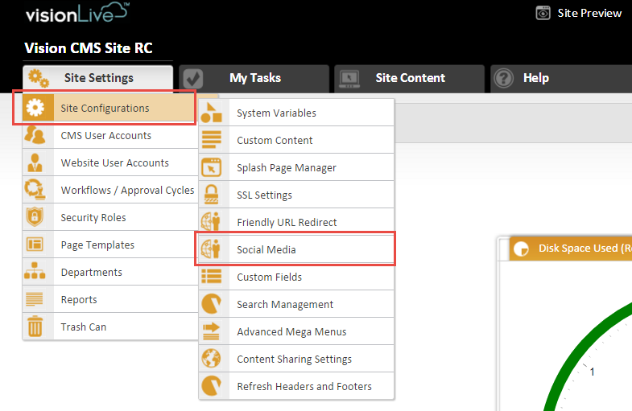

There are 3 tabs under the Social Media Accounts:

* **Social Media Posts** – this is where you can get a list or calendar view of all past, scheduled or posts awaiting approval; you can filter by content type, content groups and time period
* **Social Media Accounts** – this is where you can add or view current social media accounts; you can filter by Status, Content Groups, and Social Media Type
* **Social Media Settings** – this is where you can view the API Key and Secret Key for your social media accounts; this tab is only visible for webmasters and higher permissions and the keys should not be edited or changed.

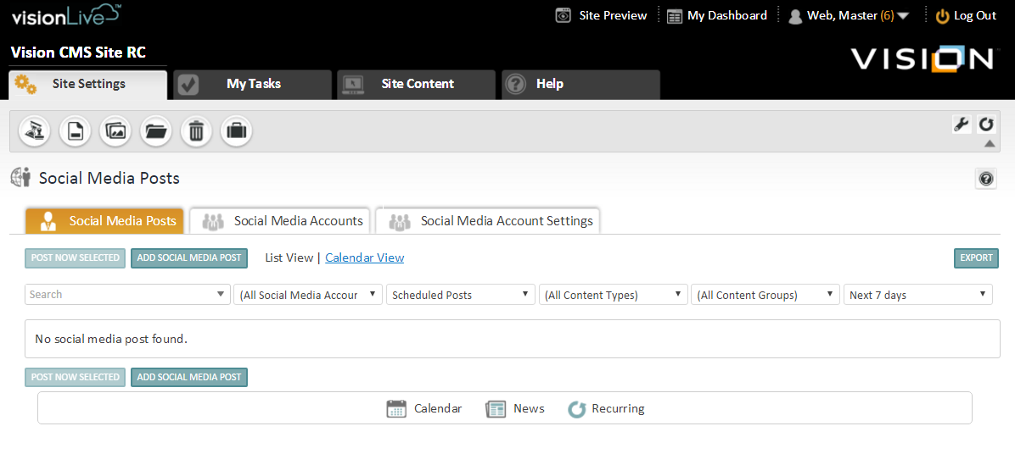

## Add Social Media Account

Before you add social media accounts, you should either:

* Be signed into the social media accounts you want to add
* Have the username and passwords available for the accounts you want to add

To add a new social media account, go to the Social Media Accounts tab and click on the Add Social Media Account.

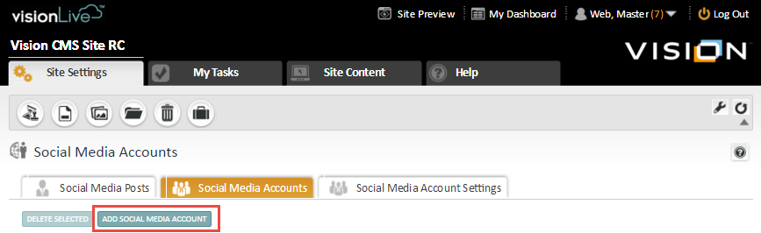

On the Add Social Media Account dialogue box you will have to:

* Type in the Account Name – be specific and include FB or Twitter in the account name so you can easily identify the account when you are posting to it
* Add your email address – this is so you can be notified when your access token is expiring; note the expiring token only applies to Facebook accounts
* Select your social media account type – select Facebook or Twitter
* Select your Content Groups
* Complete the description field

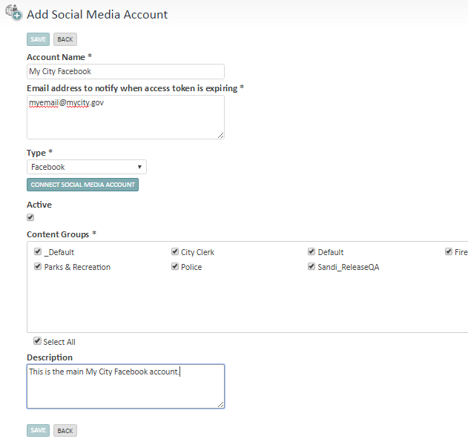

After you complete the information, click on the Connect Social Media Account button.

### Facebook

If you are signed in to your accounts, you will receive this option to select which page you want to post to. Because you can have multiple pages associated with your Facebook account including the social media account associated with your Profile, you have to select which page to associate with the specific Social Media Account on the CMS.

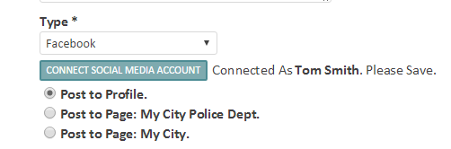

If you are not signed in, you will get the option to sign in to your account:

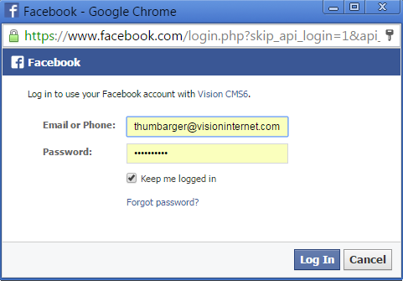

### Twitter

If you are signed in to your accounts, you will receive this authorization screen from Twitter. Click on Authorize App to let Twitter associate this account with your Twitter account on the CMS.

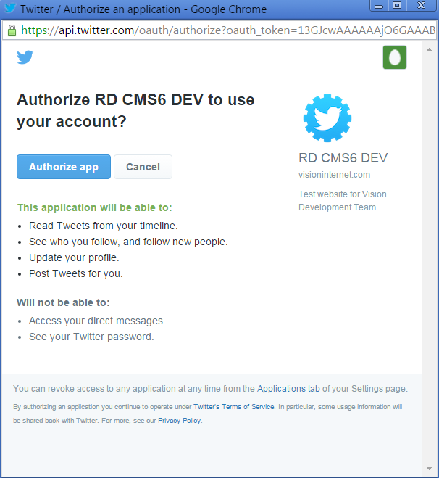

If you are not logged into Twitter, you will have an option to add your username and password – and then you can click on the Authorize App button to associate your account.

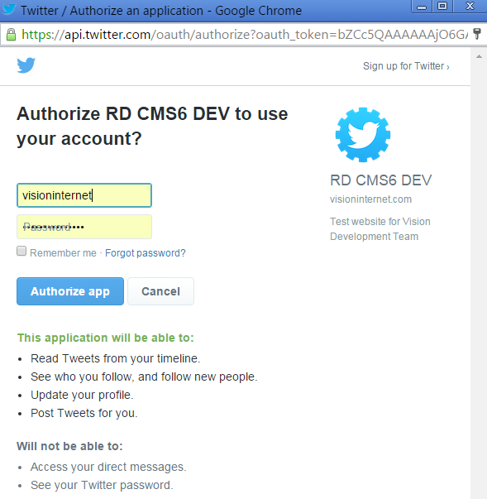

When you successfully connect a Twitter account, you will get confirmation from the system and it will tell you the Twitter username that is connected. To complete the process, click on the Save button at the top of the screen.

### View Social Media Accounts

After you set up social media accounts, you can go to the Social Media Accounts tab to view all of the accounts that have been set up in your system. You can search for specific accounts or filter by status, content groups or social media types.

This screen also provides a dashboard identifying the number of Past Posts, Scheduled Posts and Posts Awaiting Approval. Clicking on any of the numbers in these columns will take you to a list of related social media posts from the Social Media Posts tab.

To view the social media account tied to an account, click on the View Account button in the far right column and the related social media account will appear in a new browser window or tab.

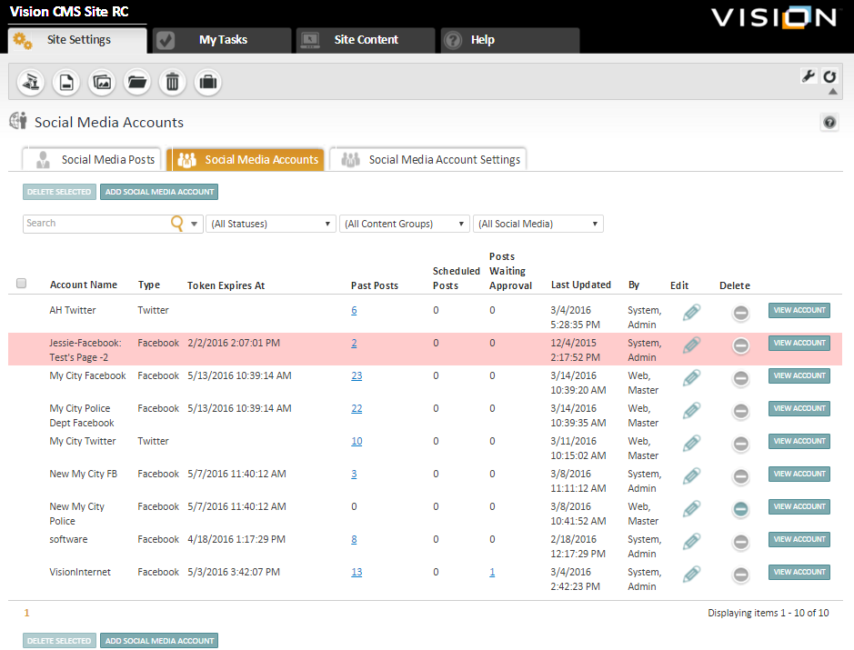

### **Token Renewal**

Note that Facebook tokens need to be renewed every three months by reconnecting the social media account. When the token expires, it will appear in a red bar and you will not be able to post to the account until you have renewed the account by reconnecting to the account.

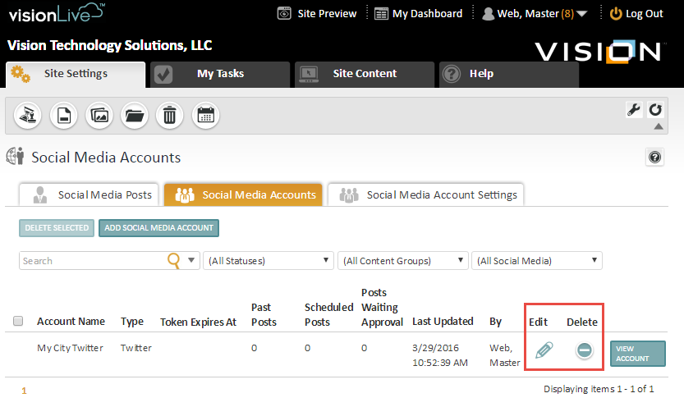

### **Edit Account**

You can edit a social media account after it has been set up. You can update the Account Name, notification email address, Content Groups and Description.

### **Delete Account**

You can also delete an account as long as you haven’t posted to the account. Once you post to a social media account, you will not be able to delete the account even if it is no longer used. If you want to move the account to the bottom of the account list, you can edit the name and put a “Z-“ in front of the name which will push the account to the bottom of the account listing.

## Add a Social Media Post - Facebook

You can create the post at the same time as when you create a calendar event or news item – or you can add a social media post to an existing calendar event or news item.

To create a social media post at the same time you create an event, go to Site Content, select Calendar and Add Calendar Event.

On the Add Event screen, you will have a new column on the right hand of the screen labeled “Share on Social Media”. This is where you create your social media posts.

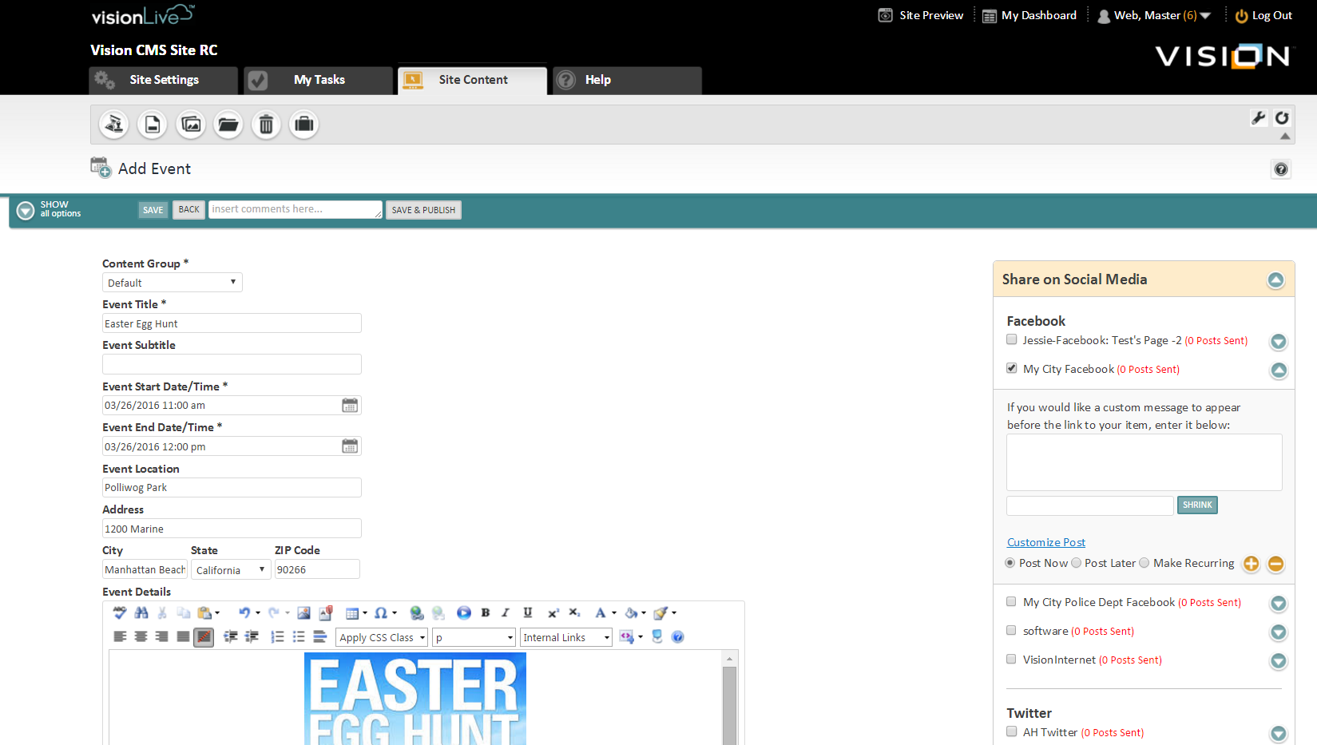

When you view the Share on Social Media options, you are first presented with a list of social media accounts that have been added.

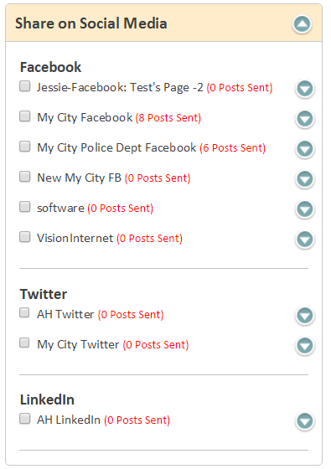

You can select one or multiple accounts. When you click on a Facebook Account, you are presented with several options:

* Add a custom message
* Add a URL and shrink it
* Customize Post link
* Post Now or Post Later or Make Recurring radio buttons
* Add additional posts for this account (orange plus button)

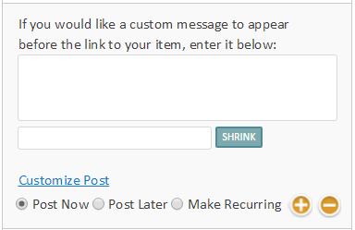

### Add a custom message

To add a custom message, type anything you want to in the box. It is recommended that you add a custom message to all Facebook posts as this is what appears above the image. Later in this section, we will show you where the custom message will appear on Facebook.

### Add a URL and Shrink it

In the box to the left of the Shrink button, you have the option to copy a URL and then include the shortened version of the URL at the end of the custom message. When you create a Facebook post, the URL is associated with the image, title and description. Clicking anywhere on these elements will take you to the event or news item.

In some cases, you may want to include a clickable URL in the custom message area and this is when you would use the Shrink URL option.

Real life example - You have a news item on your site announcing that the City Police department has just joined Facebook. Your Facebook post will link back to your news item, but you also want to include the URL to the new Police Facebook page.

This example is further explained in Scenario 2 on page 15.

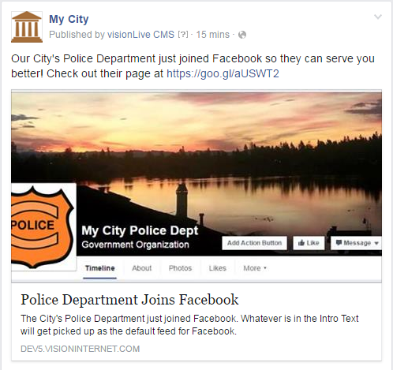

### Customize Post

To fully customize a post, you can click on the Customize Post option which opens an additional window where you can customize the Event Title, Description and Thumbnail image. You can customize one, two or all three options.

Here are what the thumbnail options will product:

* **Use Event Thumbnail** – if you have a Thumbnail image for your event, you can let the CMS use that image for the Facebook post and it will appear as a large rectangle in the Facebook Desktop News Feed; if your event thumbnail is 200 pixels or less in width, the image that will display will be a thumbnail sized image
* **No Image** – this is not recommended as Facebook is a visual platform and posts with images are going to receive more engagement from your users
* **Select an Image** – your post will include a large image and it will appear as a large rectangle in the Facebook Desktop News Feed

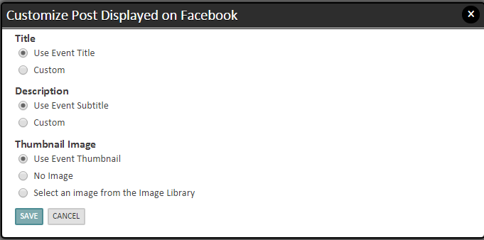

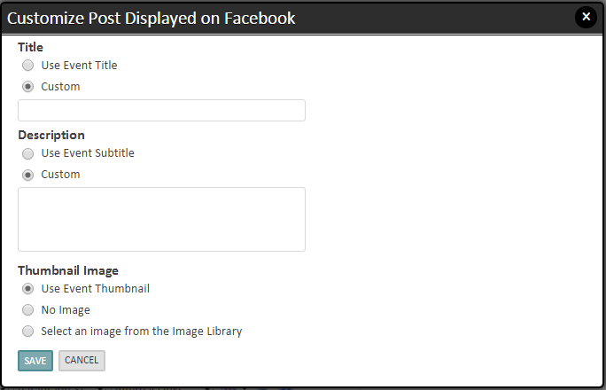

### Image Sizing for Facebook

Based on our testing, we have determined that optimum image for posting to Facebook through visionCMS is 470 pixels wide by 245 pixels tall.

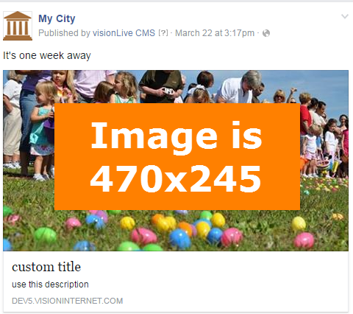

**Different than 470x245** - If your image is either larger or smaller, Facebook will automatically crop your image to the 470x245 size.

**Smaller than 300 pixels** - If the image is less than 300 pixels wide, the image will appear as a 158x158 pixel square.

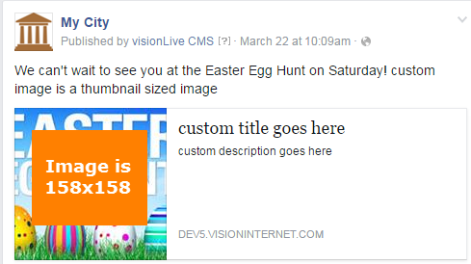

### Add Additional Posts for this Account

You can also create additional posts at the same time. To create additional posts, click on the Plus button. If you create more posts than you need, you can use the Minus button to delete the extra posts.

Here is a use case for creating multiple posts, you may want to:

* One month before the event – a month before it happens
* Two weeks before the event – send out a reminder post
* Two days before the event – send out a post with final instructions

Each message could be customized individually with different messages, titles, descriptions and images.

If you discover that you clicked on the plus button too many times, you can use the minus button to delete the extra post options.

### Post Now, Post Later or Make Recurring

You have three options for when you want to post the item – post now, post at a later date or make a recurring post.

To post at a later date, select the Post Later radio button and a calendar icon appears:

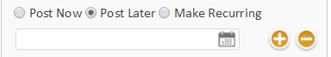

When you click on the calendar icon, a calendar widget will pop up:

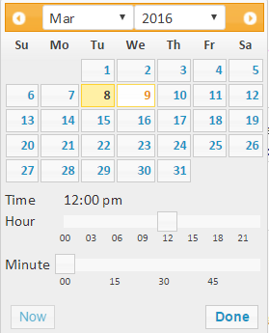

After you click on the Done button, the post later date will appear in the box. You can edit the date and time directly in the box or click on the calendar icon again.

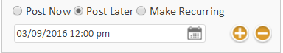

If you click on the Make Recurring radio button, you get a window that gives you many different options:

* Hourly, Daily or Weekly pattern
* Every x number of days starting at a certain time
* Select the Start Date
* End after a certain number of occurrences or on a specific date

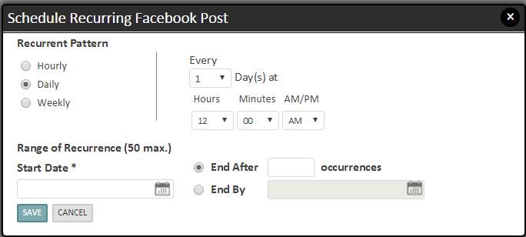

### Save and Publish

After you have set up the social media posts for the event or news item, click on the Save & Publish button in the green bar at the top of the page to publish the social media post.

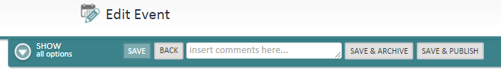

### Examples of Facebook Social Media Posts

Scenario 1 (recommended) - The scenario represents the best practice for posting to Facebook which would be to add a customized message, title and description – and include a picture. If the news or calendar item has a thumbnail picture, that image will be used. You also have the option of adding a custom image.

The custom message should be something that draws in your audience and grabs their attention. The image you select as a thumbnail or custom image should do the same. There have been numerous studies that have demonstrated the importance of images in social media posts, and posts with images garner more engagement and interaction.

As a recap, this scenario has a:

* Custom message
* Custom title
* Custom description
* Image – either thumbnail from event/news or a custom image

When a user clicks on the image, custom title or description, the news or calendar item on your website will be opened in a new browser or window.

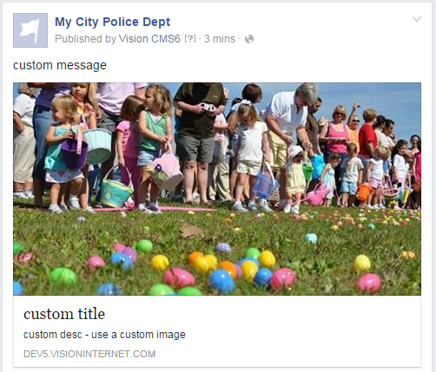

Scenario 2 **–** In this scenario, we used the default options on a news item and calendar event. The Intro Text from a news item will appear as the message for Facebook.

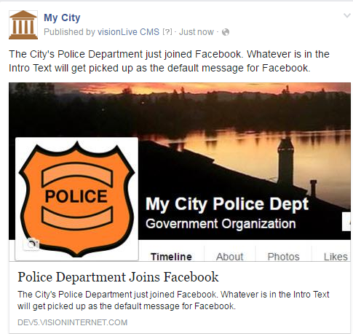

This is what happens when you use the default options for a calendar event. Note that the Event Subtitle becomes the custom message.



Scenario 3 **–** In this scenario, we added custom image, shortened URL and used default title and description from the news post. For the URL, we copied the URL for the City Police Facebook page into the box to the left of the Shrink button. After you click on the Shrink button, the shortened URL is appended to the end of the custom message.

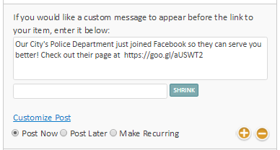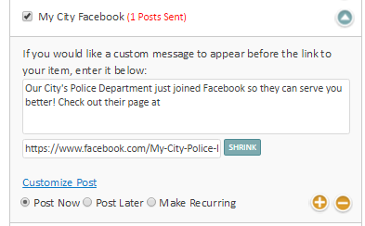

The end result is copied below. Clicking on the image or description will take the user to the news posting on your website. Clicking on the shortened will take the user to the City Police Department’s new Facebook Page.



Scenario 4 **–** This scenario demonstrates what happens when you use an image that is less than 400 pixels wide.

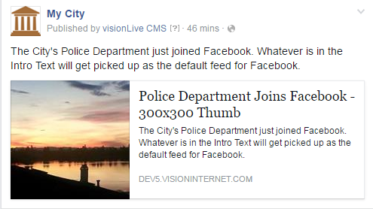

Scenario 5 – This last scenario is not recommended and does not follow social media best practices, but is included to show you the results of not having an image in your Facebook post. This posts are not visually appealing and will likely draw minimal attention. In these examples, there is no thumbnail on either the news post or calendar event, and we didn’t add a custom image.

**News Post**

In this scenario, the Intro Text on the news item becomes the message. The News title is the title on the lower box and the Intro Text is repeated below the title in the lower box. Note that even though there isn’t a thumbnail, Facebook will leave a placeholder in their post.

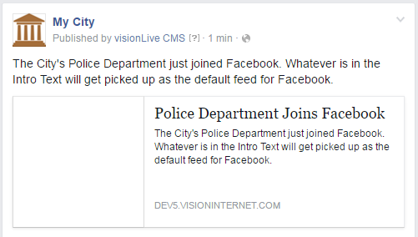

**Calendar Event**

A calendar event shows in a similar manner and the Event Subtitle becomes the default message.

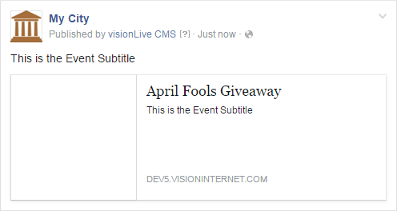

If you do not include an event subtitle, here is the result:

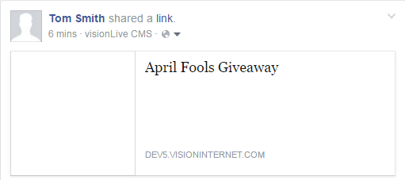

## Add a Social Media Post – Twitter

With Twitter, there are fewer options for customizing because of the limitations of how Twitter messages are limited to 140 characters.

Note, there is not an option to add an image to a Twitter post at this time – but will be added as a feature in a later release of visionSocial.

### News Item

The default message for Twitter posts will include the News Title and a Link or shortened URL. Here is how a Twitter post looks like in the CMS and when it is posted to Twitter.

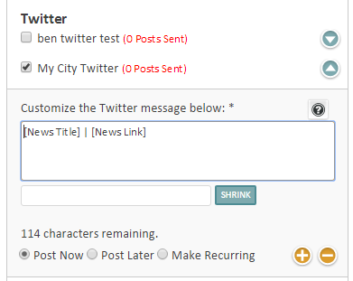

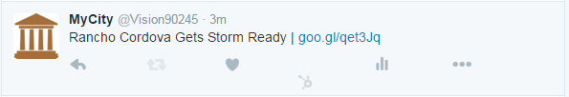

You can also add your own message and/or delete the News Title completely. Since you want to get people to click on the link to your news item, it is not recommended to delete the [News Link]. The customized message can go before or after the default items of [News Title] | [News Link]. When you are adding your own message, the CMS shows you how many characters you have remaining.

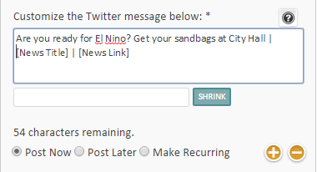

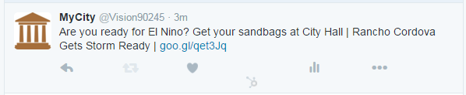

There are times when you may want to add an additional URL to your Twitter post. For example, here is a news post about the police department joining Facebook. The first URL is the default link to the news post and the second URL is a shortened link to the actual Facebook page.

After the default News Title and News Link, add a customized message and then paste your URL into the box to the left of the Shrink button. Click on the Shrink button to past the URL into the Twitter post.

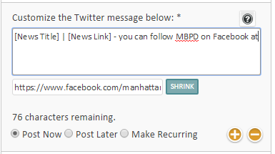

When the tweet is posted to Twitter, the end result looks like the following.

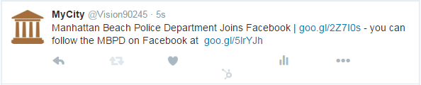

### Calendar Event

For Calendar Events, the default items include Event Title, Event Date and a shortened link to the Event Page.

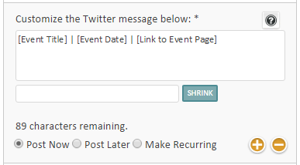

The default tweet will look like this:

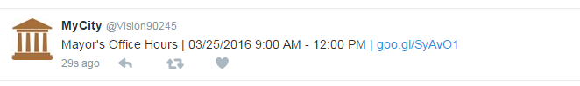

Note when you add a custom message that is too long, you may inadvertently delete part of your [Event Date] and more importantly the [Link to the Event] as shown below. In this instance, we typed a very long message before the default [Event Title]:

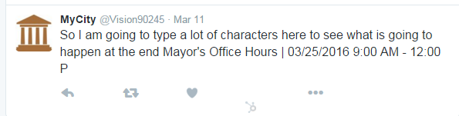

You should check always check your message if you are not sure if your message is too long.

Best Practice for Posting Events to Twitter - One way to avoid this issue is to follow our best practice for tweeting events, which is to first delete the [Event Title] and [Event Date] and then customize your message.

Be sure that you include the title and date in your customized message:

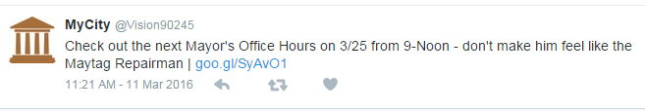

### Add Additional Posts for this Account

You can also create additional posts at the same time. To create additional posts, click on the Plus button. If you create more posts than you need, you can use the Minus button to delete the extra posts.

Here is a use case for creating multiple posts, you may want to:

* One month before the event – a month before it happens
* Two weeks before the event – send out a reminder post
* Two days before the event – send out a post with final instructions

Each message could be customized individually with different messages, titles, descriptions and images.

### Post Now, Post Later or Make Recurring

You have three options for when you want to post the item – post now, post at a later date or make a recurring post.

To post at a later date, select the Post Later radio button and a calendar icon appears:



When you click on the calendar icon, a calendar widget will pop up:



After you click on the Done button, the post later date will appear in the box. You can edit the date and time directly in the box or click on the calendar icon again.



If you click on the Make Recurring radio button, you get a window that gives you many different options:

* Hourly, Daily or Weekly pattern
* Every x number of days starting at a certain time
* Select the Start Date
* End after a certain number of occurrences or on a specific date



### Save and Publish

After you have set up the social media posts for the event or news item, click on the Save & Publish button in the green bar at the top of the page to publish the social media post.



## Reviewing Social Media Posts

To view you Scheduled, Past or Waiting Approval Posts, you can return to the Social Media Posts tab. You can select List View or Calendar View, and there are several drop-downs that you can use to filter the posts:

* Specific Social Media Accounts
* Scheduled, Past or Waiting Approval posts
* Content Types
* Content Groups
* Time Period

The information on this tab includes:

* Type of post (based on the Calendar, News or Recurring icon)
* Title – clicking on the Title links lets you view the post
* Account name – this is the social media account that will be posted
* Content type – will identify Calendar, News or Blog
* Scheduled Post Date
* Last Updated Date
* By – who created the post

### List View of Social Media Posts

This is the list view of your social media posts. The list view of your posts provides you with a listing of past, scheduled and awaiting approval posts. You can search for specific posts and you can filter by account type, content type or content groups.

Clicking on one of the hyperlinked posts will let you review the social media post. If the post has not been posted to Facebook or Twitter yet, you will have the option to edit the post.

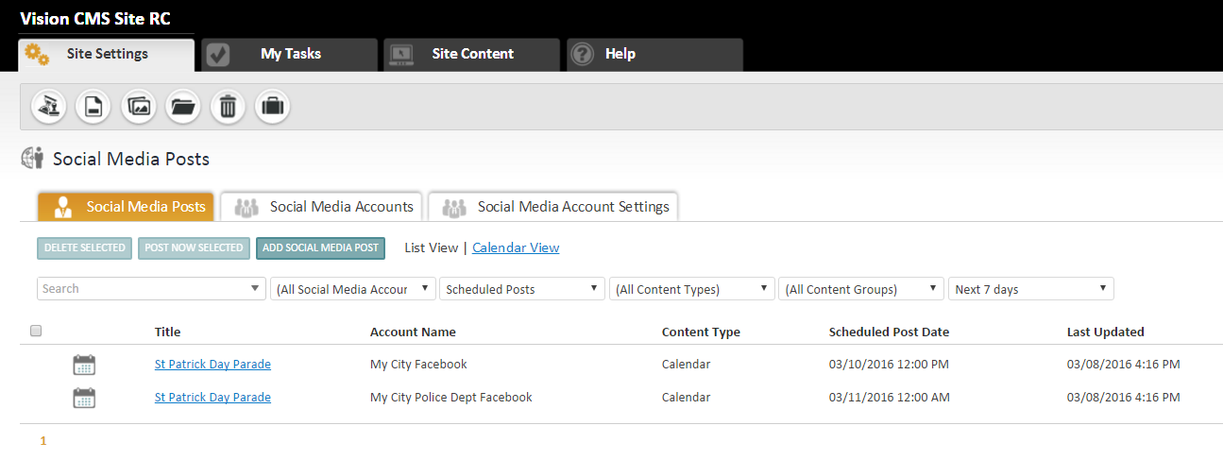

### Calendar View of Social Media Posts

This is the calendar view of your social media posts. The calendar view of your posts is a great way to have a visual calendar representation of listing of past, scheduled and awaiting approval posts. You can search for specific posts and you can filter by account type, content type or content groups.

Clicking on one of the hyperlinked posts will let you review the social media post. If the post has not been posted to Facebook or Twitter yet, you will have the option to edit the post.

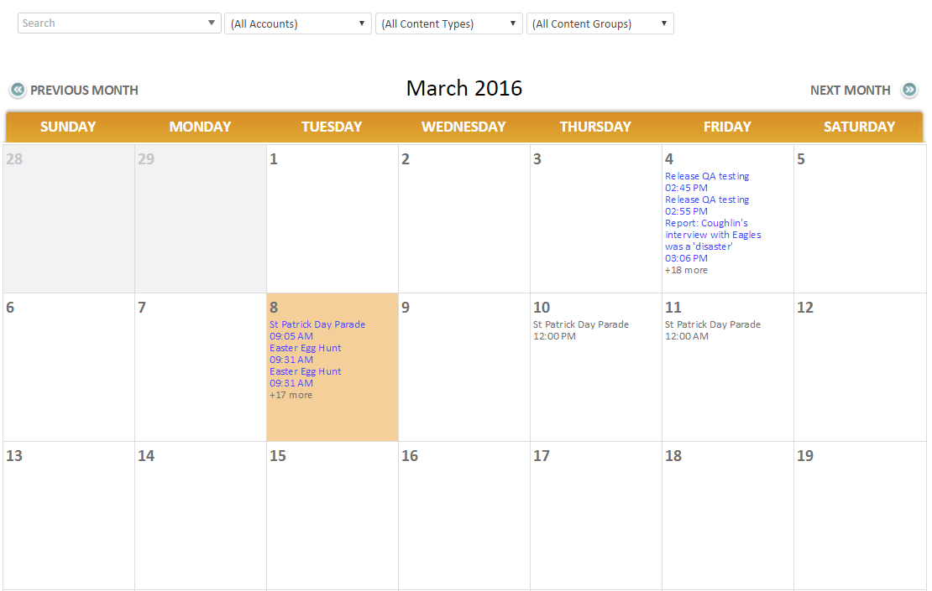

### Delete or Post Now Selected

From the List View, you can also select all or some of the posts to either delete or post now.

Deleted Selected – Note that you can only delete posts that have not been posted to social media.

Post Now Selected – You can select posts that are scheduled to be posted and have them posted now. Note that there are two types of posts that appear as Scheduled Posts. “In the queue” posts means they will post in the next 15-20 minutes, but you can post them now if you want them posted immediately. Scheduled Posts will have their date and time, and if you can also select these posts to be posted immediately.

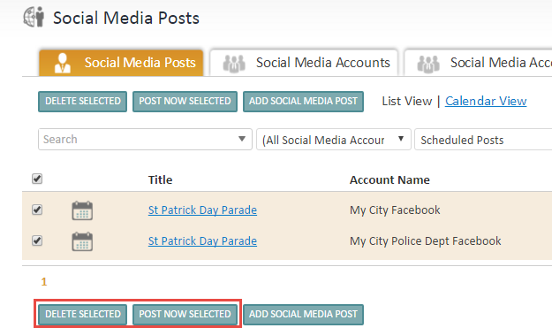

### Social Media Post Quick Add

The Social Media Post Quick Add is an option for users who want to edit or create additional posts without going to the event or news detail screen. The same options are available for posting include customizing message, post now, later or recurring, and add additional posts.

To do a Social Media Quick Add, select the Add Social Media Post button to the right of Post Now Selected.

You will get another screen where you can identify Content Type, Content Group and News or Event. Note that you will need to click on the Apply Filters button to activate the Social Media Posts.

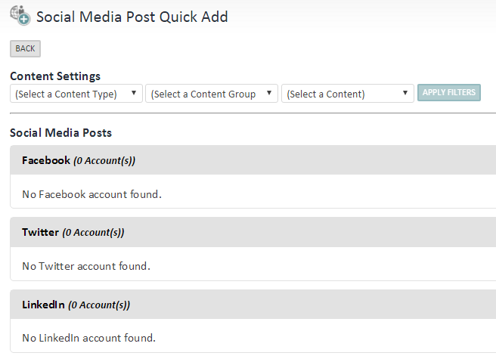

After you select your Content Settings and Apply Filters, you will be able to add a new post or edit previously unpublished posts.

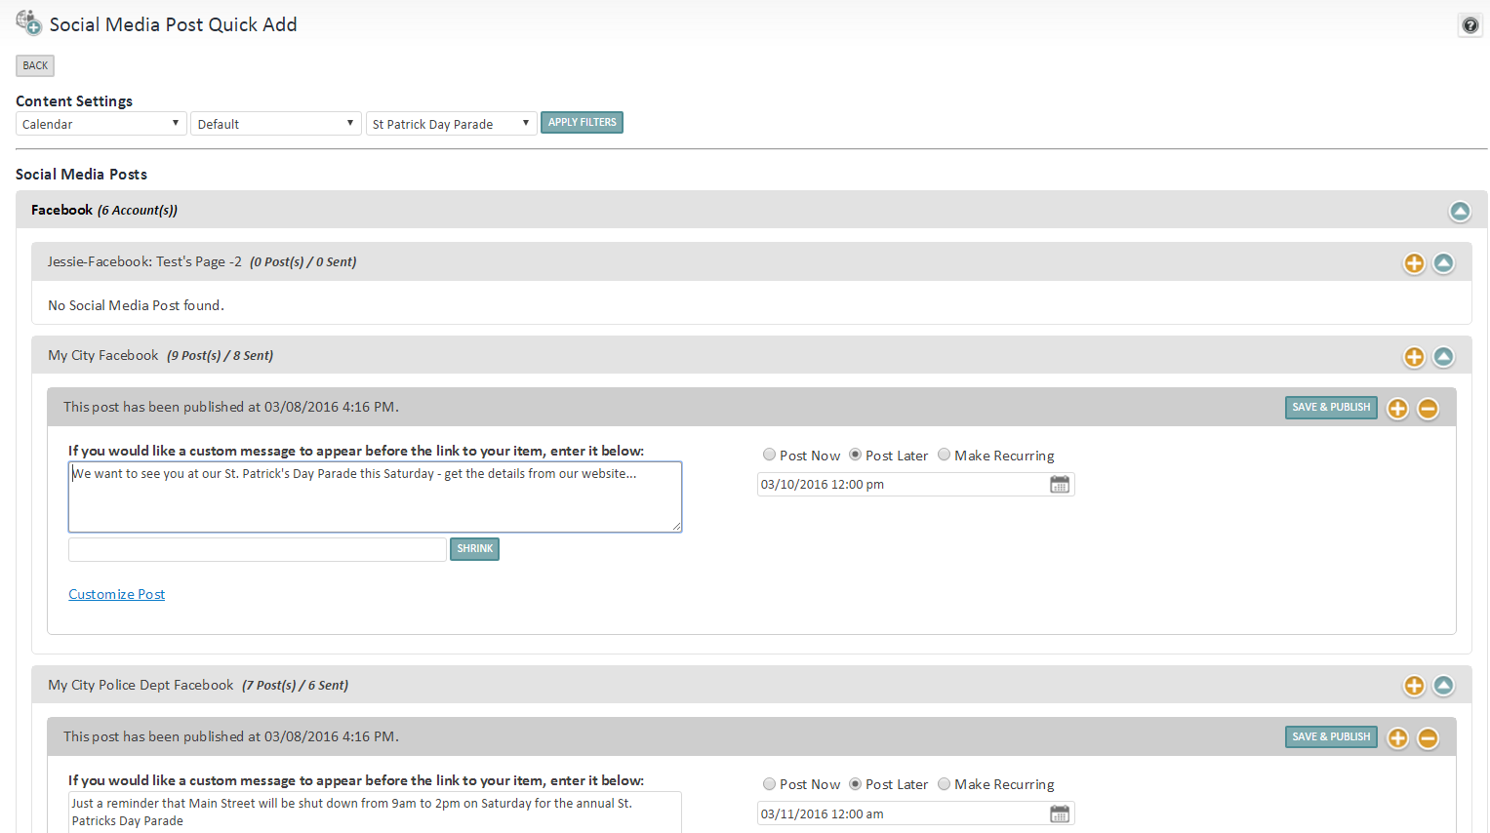

## Export Social Media Posts

Another option on the Social Media Posts tab is to Export your posts. You can filter the export by Account, Content Group, Content Type and Date Range.

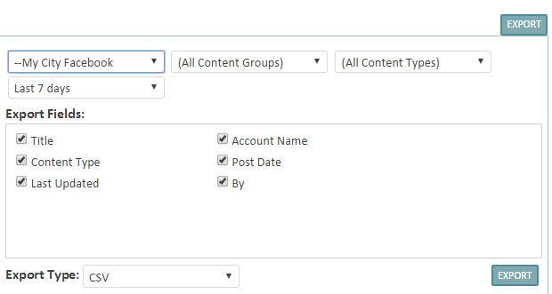

The exported fields include:

* Title
* Account Name
* Content Type
* Post Date
* Last Updated
* By

Here is an example export file:

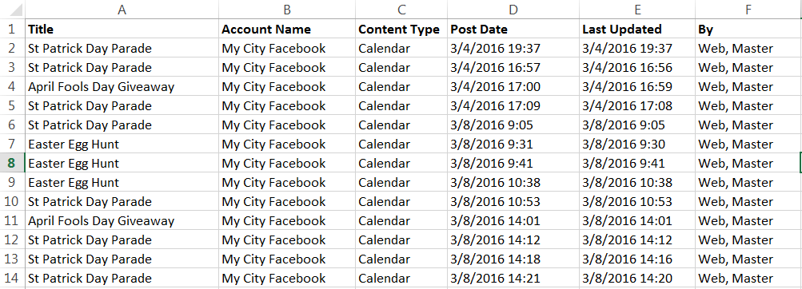

## Social Media Variables

### System Variables

There are 3 Social Media System Variables:

* **Social Media Account Limit** - This sets the maximum number of social media accounts. The value must be a number between 1 and 30.
* **Social Media Max Posts** - This sets the maximum number of posts to the social media account that can be scheduled in a single click.
* **Social Media Workflow** - Checked means that the person identified as the social media approver will need to approve social media posts before they are to be posted to social media. Unchecked means that posting to social media will occur when the related item (e.g., News or Calendar event) is published, and does not need separate approval to post to social media.

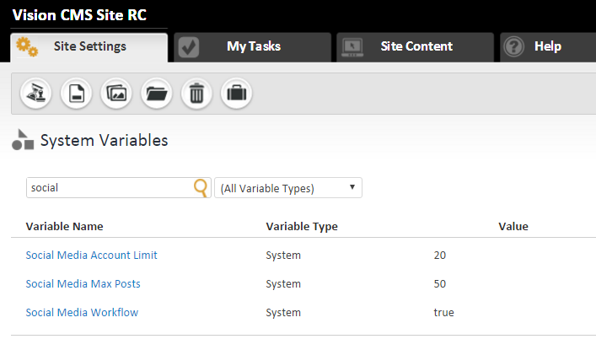

### Content Roles

Under Content Roles, you can edit or create new content roles to add Social Media Sharing roles.

Under both Calendar and News, there is now a box labeled Social Media Sharing that can be checked or not checked. When it is checked, the user will be able to see the Review Shared Social Media or Share on Social Media dropdowns to the right of Review or Edit screens for Calendar and News.

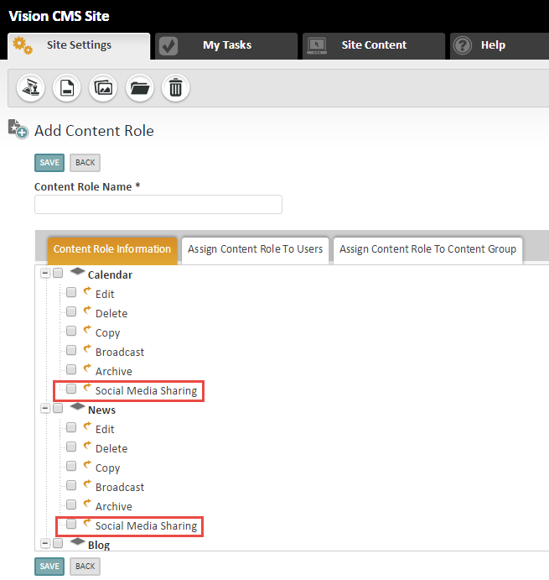

### Security Roles

There are also Security Role System Level Permissions for Social Media that can be assigned to any Security Role.

